Olimus Student Portal User Guide

Table of Contents
Login / Logout 2
Music Composition 3
Progress Report 6
My School 8
Moomba Profile 11

Pre-requisites:
- Internet Connectivity
- Internet Explorer 8.0

Introduction
This user guide will describe how to navigate and use the functionalities in the student’s portal.

Login / Logout
- Browse to ‘www.moombamusic.com’.
- Click on the ‘Student’ icon, depicted by character ‘Penta’.
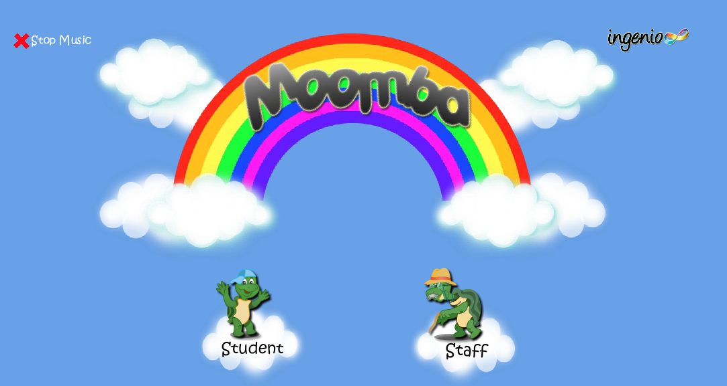
- You will arrive at the Login page. Type your username in the textbox at the left.
- To enter your password, click on the panels on the rainbow bridge. Each panel represents one password character. Your password will look something like:
‘ABCDE’ ‘FEABD’ ‘DEDAD’
- Click on the panel which shows the correct alphabet mapping to log in. Then, Click ‘Submit’ to login. The screenshot below demonstrates how to login. 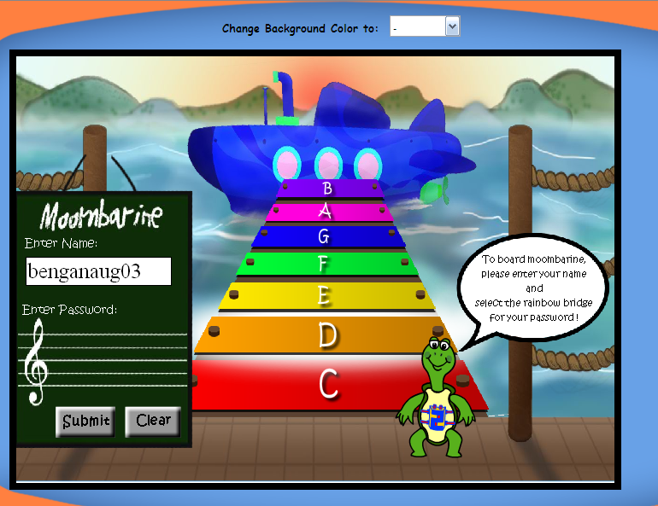

- To logout of the portal, click on the ‘Door’ icon.
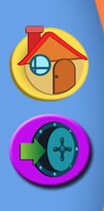

Music Composition
- You will arrive at the Moomba Main Page. Click on the ‘Games Room’ tab at the top right hand corner.
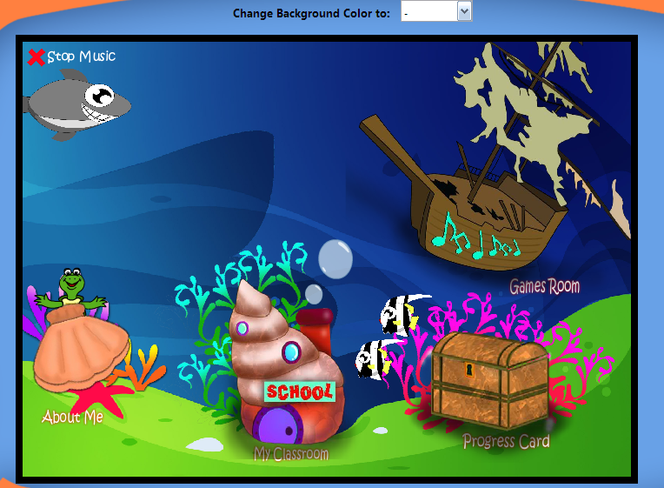

- You will arrive at the Music Composition Level 1 Game page. Read Panta’s instructions and click ‘Play’.
  - Click ‘Hear’ to listen to music composition
  - Click ‘Clear’ to clear the sea shells in the boxes and reset game
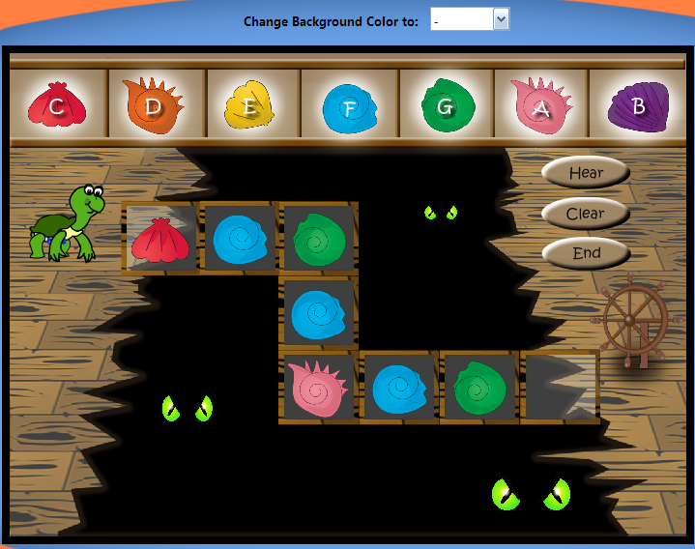
- Hover over the sea shells to listen to the individual note tones.
- Drag and drop the sea shells from the top into the boxes in the middle. In the meanwhile, design how you want to position each sea shell.
- After all boxes have been filled, click ‘End’.
- A popup will appear asking if you want to proceed to Level 2.
  - Click ‘’ to proceed to next level.
  - Click ‘Play’ to play the Level 1 game again
  - Click ‘Listen’ to listen to your music composition
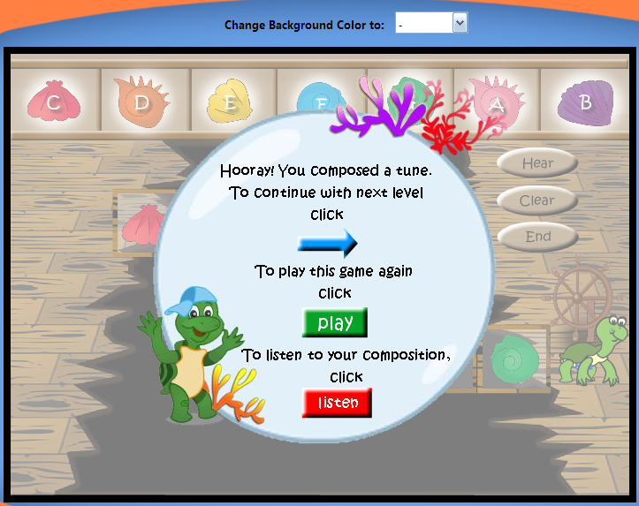

- After clicking ‘’, you will arrive at the Music Composition Level 2 page.
- Once again, read Panta’s instructions and click ‘Play’.
- Similar to the Level 1, drag and drop the sea shells into the boxes. However, this time round, there are more boxes to fill. After completely filling ALL boxes, click ‘End’ to save music composition.
  - Click ‘Hear’ to listen to music composition
  - Click ‘Clear’ to clear the sea shells in the boxes and reset game.
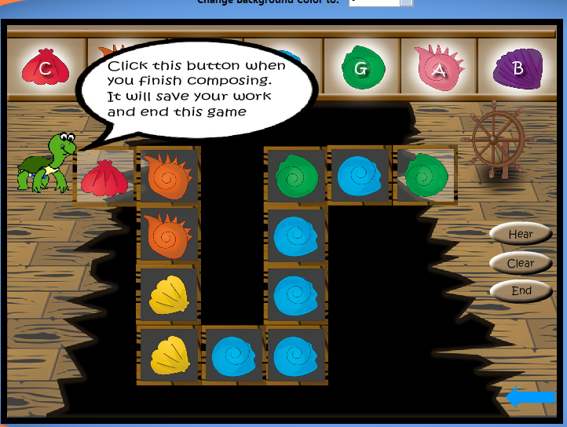
- Click on the ‘Home’ icon at the right to return to Moomba Main Page.

Progress Report
- At the Moomba Main Page, select ‘Progress Card’ to view your child’s music progress in school.
- You will arrive at the Progress Report page. You may click onto each ‘medal’ to view individual progress report card for each music section. The sections are as follows:
  - Rhythm and Expression
  - Pitch and Harmony
  - Music Design
  - Musicology
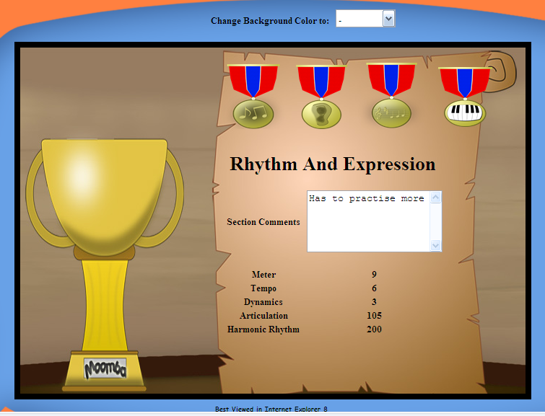

My School
- Click on the ‘Home’ button to return to the main page. Click on ‘My Classroom’ icon on the main page to download course materials.

- Next, you will see 10 Sea Shells split according to individual weeks. Click on the ‘Week 5’ Sea Shell to access course materials for ‘Week 5’.

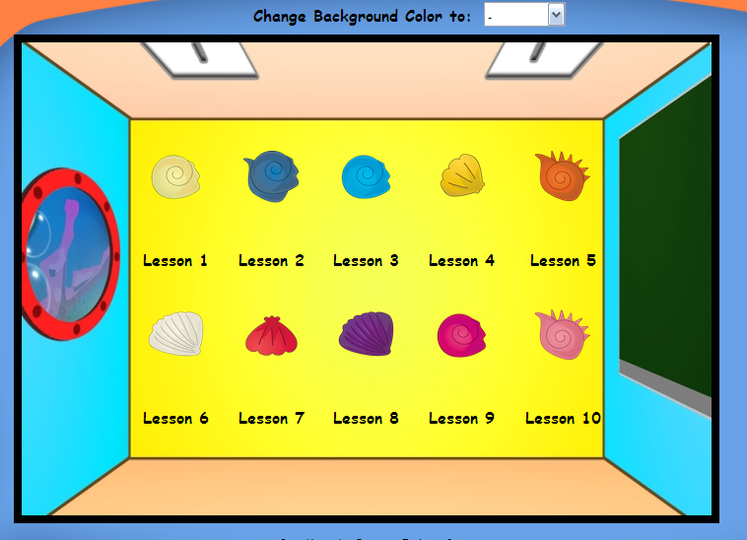

- You will arrive at the course materials view, save and hear page. You can view audio/video files, save audio/video/document files and hear audio files on this page. To view video, click on one video in the list box as shown below, and click ‘View Video’ icon. Next, click on the ‘Play’ button on the embedded media player.
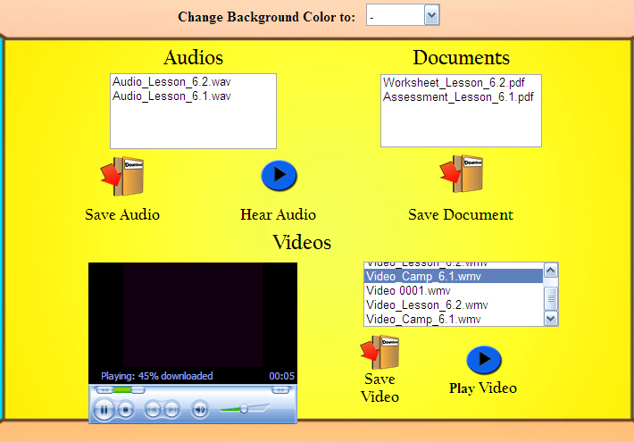
- To hear audio files, click on any item in the Audios list box. Click the ‘Hear Audio’ icon to listen to the audio.
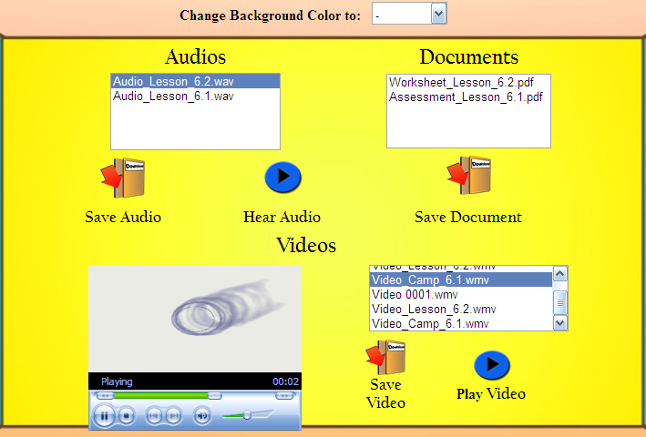

- To save document, click on the item in the list box. Click ‘Save Document’. Then, click save when the ‘File Download’ popup appears.
- You may click on the ‘Back’ button to change the week for downloading course materials.
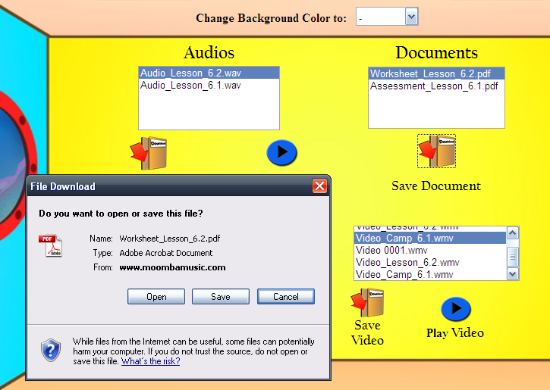
- Return to home page by clicking on the ‘Home’.

Moomba Profile
- Click on the ‘About Me’ Sea Shell to access your Moomba profile.

- Click the ‘Play’ icon to play your music composition. Then, click ‘Play’ in the embedded media player to play your music composition.
- To download your music composition, click on the ‘Download’ icon. Click ‘Save’ when the ‘File Download’ popup appears.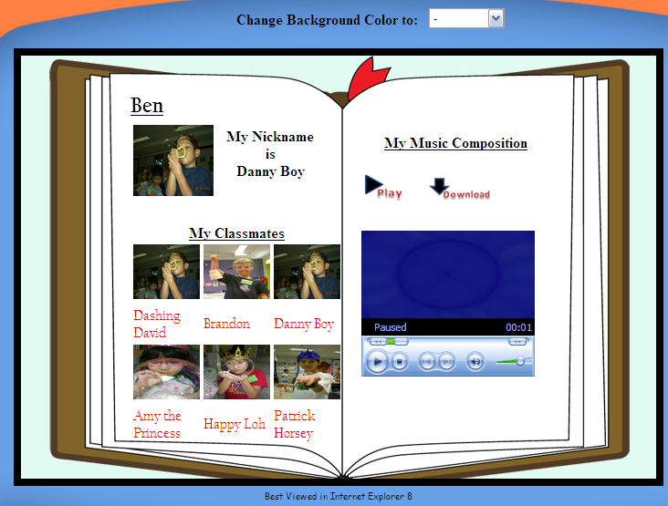
- To view your friend’s Moomba Profile, click on any picture in the ‘My Classmates’ section
- To edit your Moomba profile, click on the ‘Edit Profile’ icon at the right panel.
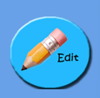
- You will arrive at the Edit Profile page. You can choose your preferred Music Composition by choosing the music icons as shown below. You may wish to listen to the music composition by clicking on the ‘Play’ button on the embedded media player.
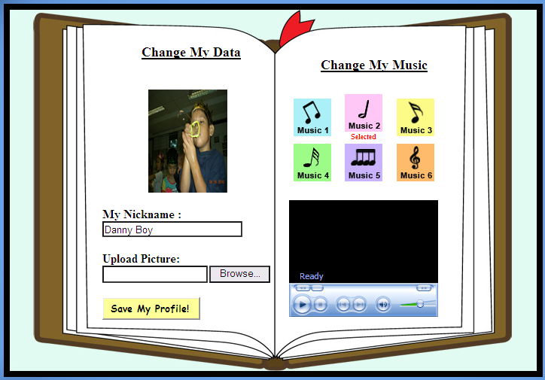
- To edit your Moomba nickname, type your nickname into the textbox below the ‘My Nickname’ label.
- To upload a new Moomba picture, click the ‘Browse’ button below the ‘Upload Picture’ label. Choose your preferred picture when the ‘Choose file to upload’ popup appears.

- Click on the ‘Save My Profile!’ to save your Moomba Profile. Click on ‘Display Profile’ to return to your profile page.
- Click on the ‘Home’ button to return to Moomba Main Page.
- To logout, click on the ‘Logout’ door at the right panel.
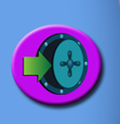
- You will be directed back to the login page. Thank you.
- To change color of page background on every page, click on the drop down list beside ‘Change your background color to’ and select the color of your choice.

