Hey guys,

Remember to read the individual feedback section as it is most important.
Current progress of Sprint 3 is ideal, it is right smack at the ideal line. This is mostly credited to Wen Rui and Nik for their extra hours put into their tasks. All of us should do the same too if you think you need to put in more effort to get things completed. Remember, this is week 8, there is no better time to make up ground than this period of time.

Note to Nik and Yik Sean: You guys have tasks that are dependencies to the front end. The important ones now are:
- Bookings
- Manage Bookings
Try to clear this off first so that the front end is able to continue work :).

Sprint Velocity Chart
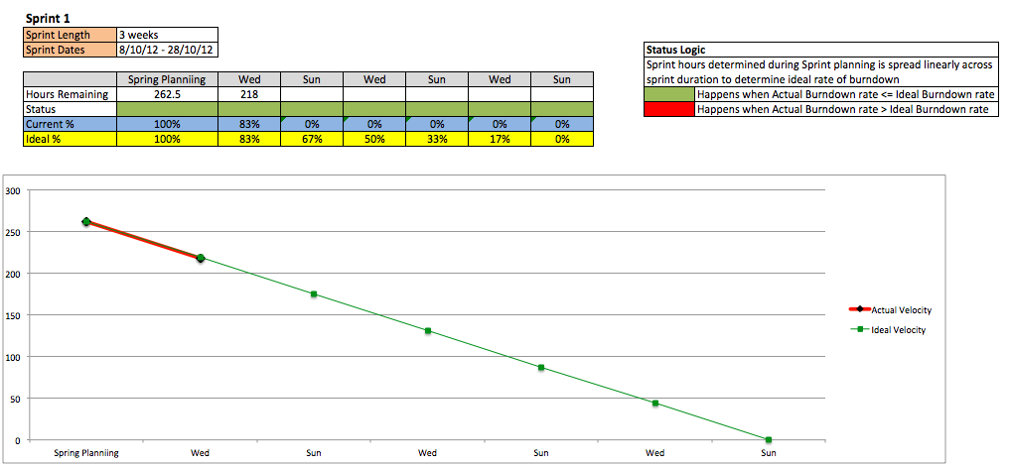

Current Status: Good. Can be better if all of us put in more time.

Individual Progress and Feedback
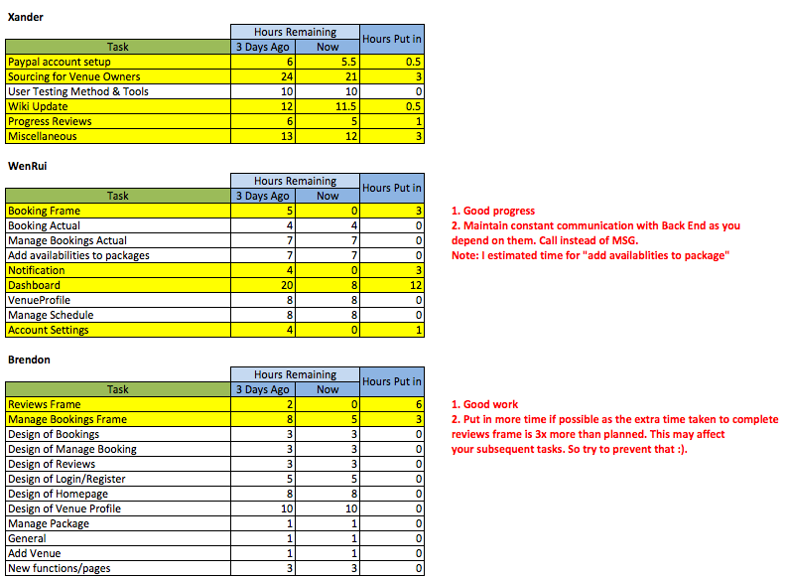
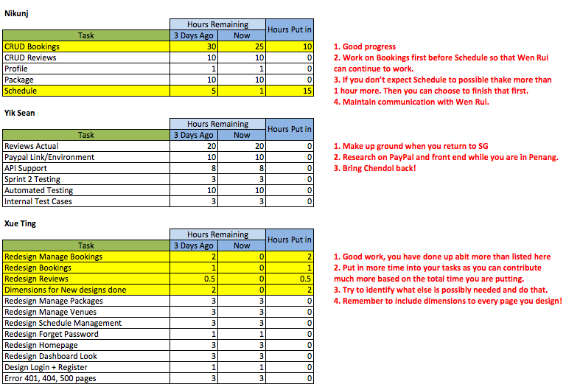

Side note: Check in on time and be more detailed.

Best Regards,
Xander
Your Friendly Project Manager

