INTERNAL MEETING 11
Date | 27th Jan 2018
Time | 12 pm – 6 pm
Venue | SOL Library 4.03
Attendees | Chew Chin Rui  Ervin Chong  Huang Mingrui  Ricky Putra Franslay  Wang Qimin
Absentees | Amelia Lee
Agenda | - Gamification layout  - Consolidate answers for Jamie to mark  - Discuss NLP model and architecture  - Update schedule and prepare for supervisor meeting

AGENDA
No. | Task | Follow-Up
1 | Gamification layout  - Work on general layout of the game  - Liaise with Jamie to finalize changes, such as the timer etc | Qimin and Mingrui to work on this
2 | Consolidate answers for Jamie to mark  - Push Jamie to get students to do the cases  - Ensure that cases are stored in the Database  - Write API to extract the answers in excel format for Jamie to mark | Ricky to work on this.
3 | Discuss NLP model and architecture  - Decide on architecture of the server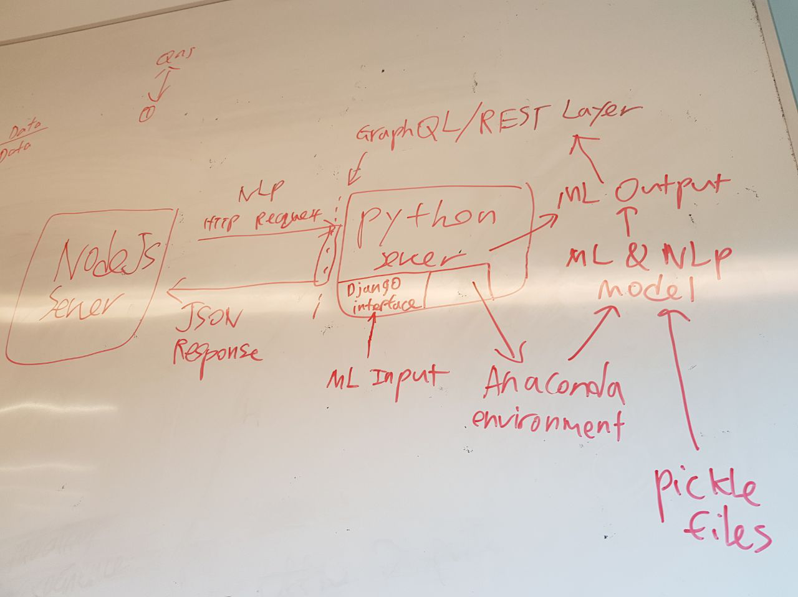  - Find suitable model to implement (try to find models that utilized GPU for the machine learning part) | Chin Rui and Ervin to work on this
4 | Prepare for supervisor meeting  - Update schedule and metrics  - Prepare slides for meeting | Amelia to update

The meeting was adjourned at 6 pm. These minutes will be circulated and adopted if there are no amendments reported in the next three days.
Prepared by,
Ervin Chong

Vetted by,
Ricky

