Date & Time |  | 31 Aug 2012, 5pm -7pm.
Members Present |  | All members present
Members Non-present
Next Meeting (Tentatively) |  | 4th August 2012, 7pm onwards
To-do list
Leonard | - BRING DSLR NEXT MEETING!
Max | - Do up team wiki by Sat
Rachel | - Tie up loose ends with (potential) FYP clients
Ximin | - Tie up loose ends with (potential) FYP clients
All | - Look through past FYP teams and consolidate what needs to go onto wiki (due date: Sat, 1st Sept)  - To look through project description and edit it by Sat night  - Go think of 3 scenarios (CEO, Mktg Director, User) by next meeting  - Continue fact-finding and fill up the Google Spreadsheet by next meeting  - Do Personal Wiki Page (due Sat)  - Look pretty next meeting (:
Agenda | - Proposal work timeline  - Use Cases — Client Email  - Consolidate scenarios by team mates  - AOB

Agenda Of Meeting
- Update of 5th Group member | 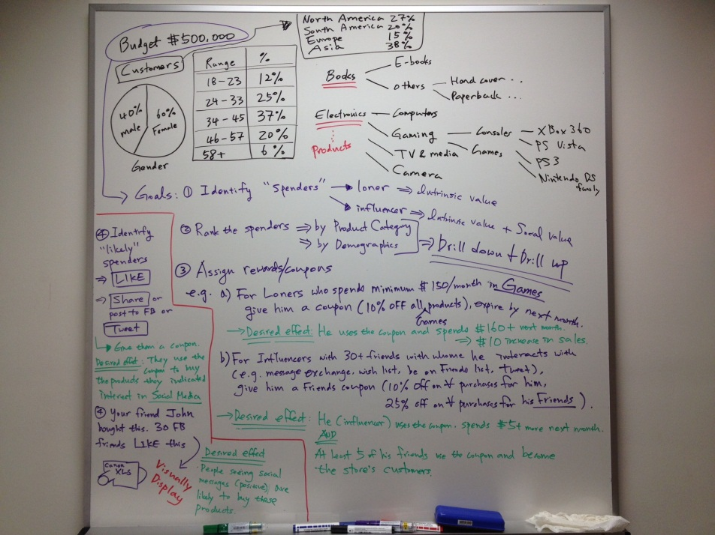  - Introduction to 5th group member, Joseph  - KI current status of the chosen project
- Project Description & Project Scope | - FB API to be used  - Plugin needs to be downloadable  - Tentatively REST api  Project Description  Shopping page  - To show all the products listed on the page  - Connect SQLs database to populate the list of products onto magento in order to create the shopping page  - Magento sits onto of the SQL database  - FB API to be implemented with the page  Consumer page  - To track all customer-selected products  - View the shopping cart where it shows the products and be able to check-out the products selected  - Keep track of wishlists by friends and view the products of these friends  - Mouse-over  - FB API  - View lists of coupons allocated  - Scenario 1: All customers will have 1 coupon each  - Scenario 2: Customers will be able to use 1 coupon from product category  - View e-wallets  - Keep track of financial status (is there sufficient money?)  Reporting UI  - To show all data collected from consumer behaviours  - Track the demands of users  - CRUD campaigns  - Right side reward coupon  - Left side (types of) spenders  - Colour code types of spenders (high, medium, low, none)  - Detail the strategy names and show the campaign summary  - Keep track of the financial state  - Colour coded to show if the campaign is within budget
- Proposal Work Allocation | - The 2 page proposal provides basic project information and for early feedback.  Add detail information and update your project status in the IS480 wiki.  - Once you have been assigned a supervisor, please review your proposal with your supervisor for feedback.  Teams must have confirmed the project, understood the problem/domain/industry and decided on basic development technology (such as programming language, CMS framework, database, etc).  Project requirement may change as the project progress but team members, project and sponsor are confirmed.
- AOB | - Backbone technologies  - D3 to “design” the data format

