Time: | 1400 - 1500
Location: | SIS GSR 2-5
Attended by: | Timothy,Michelle, Jonathan, Jianxin, Xinchu, Kum Hung

Absent with Apologies

No. | Agenda: | Action by:
1  2  3  4  5  6  7  8  9  10  11  12  13  14  15  16  17  18 | User Testing:  Need to know which computer is for what station. Everything was chaotic in the beginning. Now, instead of outdoor testers doing survey on iPad outside, they should come back to HQ instead.  Label the computers.  Book a bigger room for next week’s testing. Need to plan web on one side, mobile on the other and center reserved for outdoor testers.  Cannot change task list till we make changes to the respective apps  Need to upload all the responses to wiki  Maybe we can have a script to use to describe the project to testers. Minimise confusion  Continue with the attendance excel sheet.  Give out sweets/drinks at the end of the test  Need to help users with orientation of the map. Improve navigability  Force close in the search event function is due to uncaught exception. App close because data parameter was null, empty message.  Need to have organisers 1 and 2 to solve the issue of 2 users trying to edit the same account. Need to plan who is going to which station.  Run a screen capture program during user testing. Video record for outdoor testing. Need to see their reactions and how long they take to perform tasks. One person will focus on recording and the other guides the user.  Need to prepare a consent form for recording etc.  Current iPhone storyboard is not intuitive. Needs revision.  Each event cell will have a ‘star’ to act as a favourite icon and a join button. Once star is clicked, event is added to the ‘favourites list’. Default view will be “Events near you” with a refresh button next to it. On the left of each row will be a logo of the event.  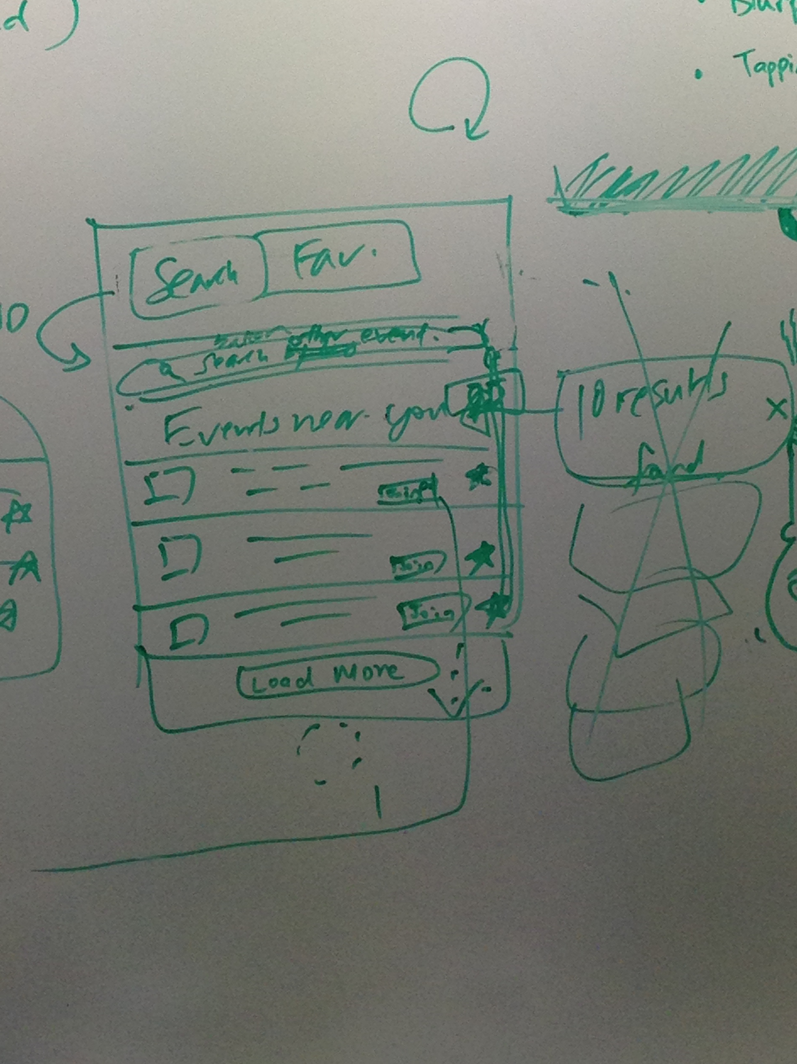  Join button will changed to ‘Joined’ upon click and bring user to the map view. This will be a tab navigator with ‘map’,’connect’ and a misc tab. Connect will lead users to a view with all blurp functions such as blurp feed and post. There will also be a button to go back to live view.  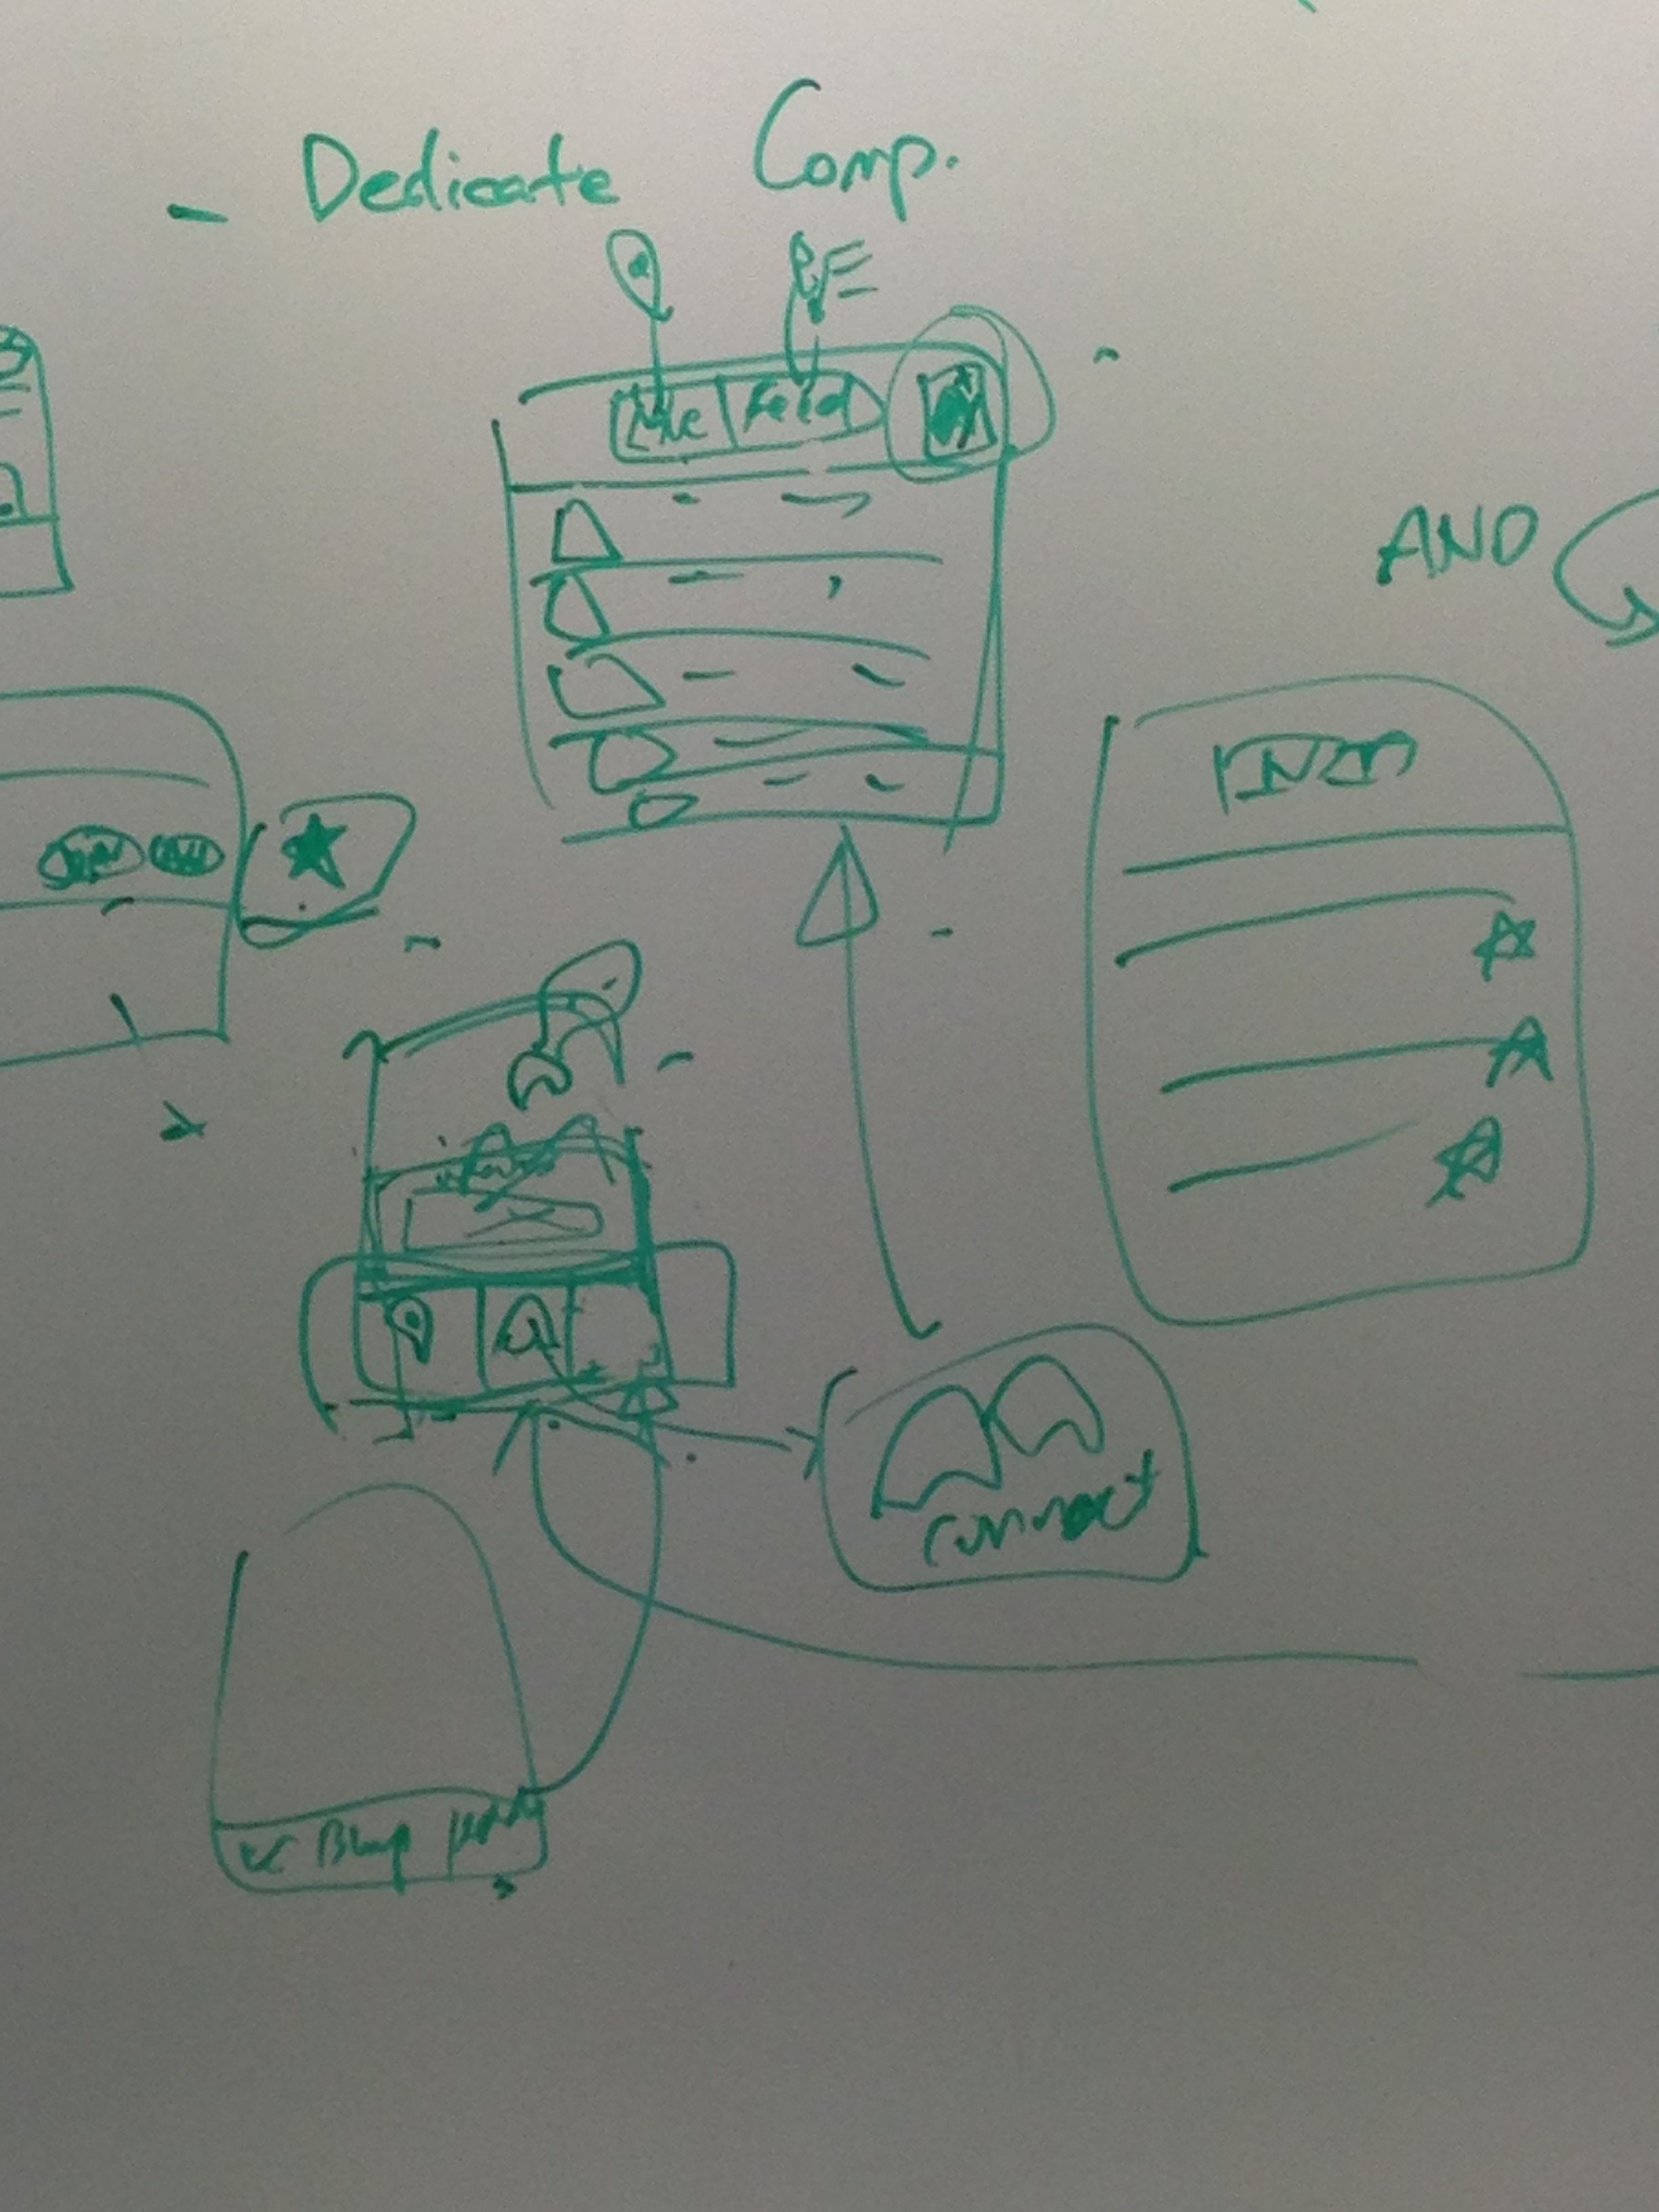  People are confused about ‘save’ and ‘join’  Users are confused about which Blurp icon they are on the map.  For next user testing, ask testers if they want to see a map with all the blurps. We will do paper prototype to let them see first.

Prepared by:
JianXin

