Meeting Agenda
Date: 27 Feb 2013

Issue Tracking
Assigned
- Matching of Questions (ID: 39)
- What fields are going to show up in the Empact profiles? (ID: 45)
- Volunteer Management – What action buttons do you want to see in the Volunteer Management tabs? (ID: 49) (See diagram 1)
- Volunteer Management – What statuses do you want to see for each volunteer who is currently accepted and signed up? (ID: 50) (See diagram 1)
- Match Algorithm to be refined (ID: 52)
- Handing over of System (ID: 53)
- Should the website of the NPO be a compulsory field in the NPO profile? (ID: 55)
- Exporting of search results (ID: 56)
- How does Empact want the NPO management page to look like? (ID: 57)
- Profile Picture – Where do we upload the picture to? (ID: 59)
- NPO – Can NPO change their own organization name? (ID: 60)

Completed
- Volunteers are able to edit their own skillsets (ID: 47)
- What does Empact want to do with the “Other Languages” field? (ID: 48)
- Task Review - Require clarification for the status of the task when volunteer reviewer has submitted and is in progress of review by Empact staff (ID: 51)
- NPO would be able to see another NPO (ID: 54)

In Progress
- Name of Application (ID: 17) – Name: Volunteer Matching System (Waiting for Competition)
- Question – Matching of Question (ID: 39)

Open
- What is the review of the task when it is accepted? (ID: 61)
- User Manual – What user manual does Empact wants? (ID: 62)
- Documentation – What documentation does Empact want? (ID: 63)
  - What information is needed to maintain the system
- Exporting of Data – What data does Empact want to export for their volunteers, NPOs, staff, task and questions? (ID: 64)

Project Status
- Iteration 11/13
- 2 Weeks – 24/02/2013 – 10/03/2013
- Focus:
  - Finish up Volunteer Record
  - Finish up the Feedback Form
  - Change server host
Next Iteration
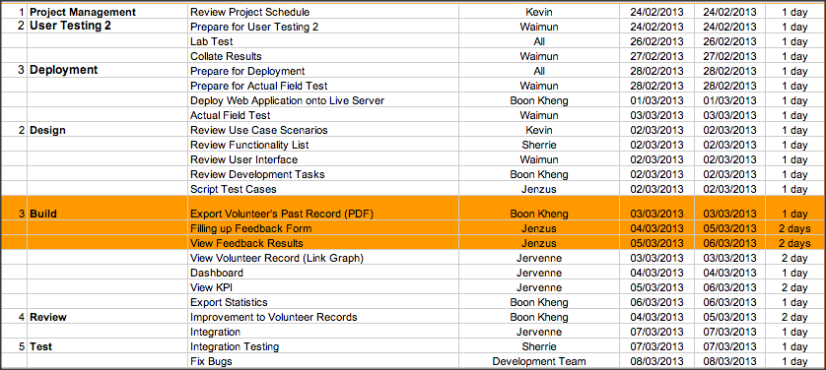
Preview for Iteration 11 (24/02/2013-10/03/2013)
- Deployment – Depends on results from User Testing 2
- Development:
  - Statistics
  - Dashboard
  - Complete Volunteer Record
  - Complete Feedback Form
- User Testing 2

Preview for Iteration 12 (11/03/2013-24/03/2013)
- Development:
  - Email Notifications
  - Any improvements to make
Project Issues
- Technical Documentation
  - Get a technical documentation that is being put together
- Handing Over of Project
  - Process of Handing over the Project
  - Sign off document of the User Acceptance Test - Functionality
- Deployment for Actual Test
  - After the Feedback Form has been done
  - After the Timesheet has been accounted for

Diagram 1: Volunteer Management – Action Buttons (ID:49)
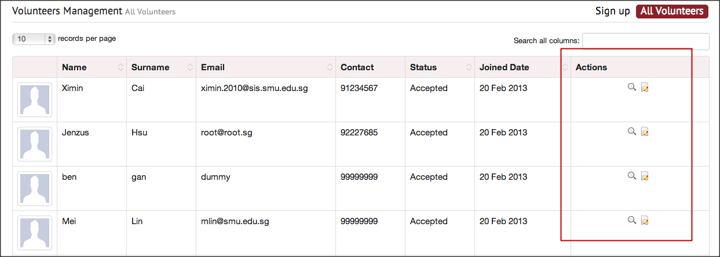

Diagram 2: NPO Management
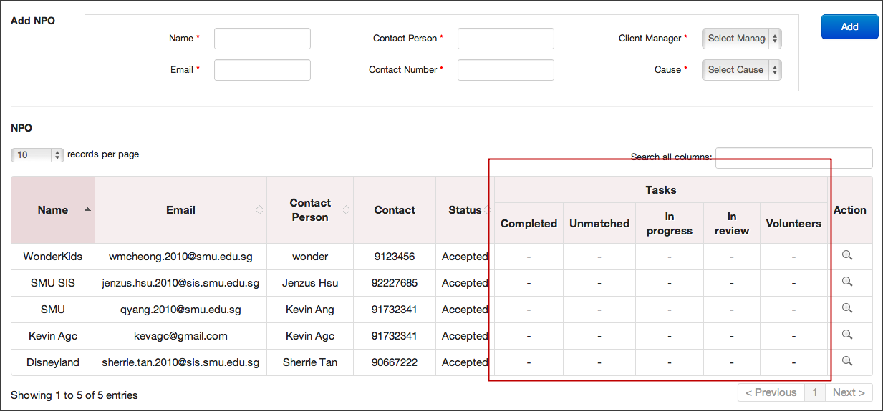

- List of issues that are to be met must be shared

