Microsoft Singapore
Innovative Singapore Website

User Requirement Specifications
Doc ID: IS480-SPEC-001 Version 6.0.0
Prepared by | Gabriel Yee (PM)  Lee Heng Pei  Lim Dit Ching  Nguyen Thi Tam  Poh Seow Theng
Commencement | 03 December 2010
Approved by | MingFei Yan  Matthew Lim
Approval Date | 10 December 2010
Document Control
@ Copyright Microsoft Singapore 2011. This copyright in this work belongs to Microsoft Singapore. The information contained in this work is confidential and must not be reproduced or disclosed to others without the prior written permission of Microsoft Singapore. The information contained in this work is confidential and must not be reproduced or disclosed to others without the prior written permission of Microsoft Singapore.

Version | Date | Prepared By | Changes From Previous Version
4.0.0 | 01 Jan 2011 | Gabriel Yee  Lee Heng Pei  Lim Dit Ching  Nguyen Thi Tam  Poh Seow Theng | New release
5.0.0 | 01 Feb 2011 | Gabriel Yee  Lim Dit Ching | Replaced Silverlight Video Banner with Highlight Article Banner
6.0.0 | 04 Feb 2011 | Lim Dit Ching | Replaced Highlight Article Banner to Video Banner  Removed Entry Post with Video Attachment

Table of Contents
1 Purpose 4
2 Reference 4
3 Assumptions 4
4 Constraints 4
5 Overall Use Case Diagram 4
6 Detailed Use Case Description 6
6.1 Registration 6
6.1.1 New User Registration (Create an INSG Account) 6
6.2 Login 7
6.2.1 Login via INSG Account 7
6.2.2 Login via Twitter 7
6.2.3 Login via Facebook 8
6.3 Account Management 8
6.3.1 View User Profile 8
6.3.2 Change Password 9
6.3.3 Reset Password 9
6.3.4 Connecting User’s Twitter and INSG Accounts 10
6.3.5 Connecting User’s Facebook and INSG Accounts 10
6.4 Wall 10
6.4.1 View All Posts and Attachments on Wall 10
6.4.2 Rate Post 11
6.4.3 Sharing a Post 11
6.4.4 View Own Posts 11
6.4.5 Create Entry Post (Text Only) 12
6.4.6 Create Entry Post with Picture Attachment 12
6.4.7 Create Entry Post with Link Attachment 13
6.4.8 Create Entry Post with Document Attachment 13
6.4.9 Edit Post 14
6.4.10 Delete Post 14
6.5 Video Banner 14
6.5.1 Select Video on Video Banner 14
6.5.2 Play Video on Video Banner 15
6.5.3 Pause Video on Video Banner 15
6.5.4 Adjust Volume of the Video Banner 15
6.5.5 View Video in Full Screen 15
6.6 Community Management 16
6.6.1 View Members’ Profiles 16
6.6.2 Ban User 16
6.6.3 Delete User 16
6.6.4 View Badges 17
6.6.5 Add New Badge 17
6.6.6 Manually Assign Badge 18

Purpose
The purpose of the user requirement specifications is to detail the stakeholder needs, expectations and interfaces. The stakeholders are lecturers and students. All models constructed in this document follow the standard UML notations.

Reference
The following references are used as sources of requirement analysis:
- Project proposal
- Formal meeting and informal discussion
- Innovative Singapore Website

Assumptions
The followings are the specific conditions to be satisfied in order to validate the requirements against the system developed:
- Users targeted to create requirements have a good understanding of the workflow.
- There is a backup if any admin accidentally deletes important data(s) from the system.
- The system doesn’t come up with unpredictable errors like MySQL server error, etc.
- Users targeted to create requirements have good understanding of some Drupal knowledge in case any errors are found.

Constraints
The followings are the constraints identified:
- The client module should be able to run on a majority of personal computers.
- The system should use MySQL as database.
- The server must be able to support PHP and Drupal.
- If there are minor errors like fields having spelling errors. The admin must edit the codes manually.
There may be possibility that the Tomcat server is corrupted and down, resulting in program unable to be deployed.

Overall Use Case Diagram
The overall use case diagram is to illustrate the scope of the project. The diagram shows the actors (both human and external systems) to be interacting with the system and all use cases identified. (PTO)
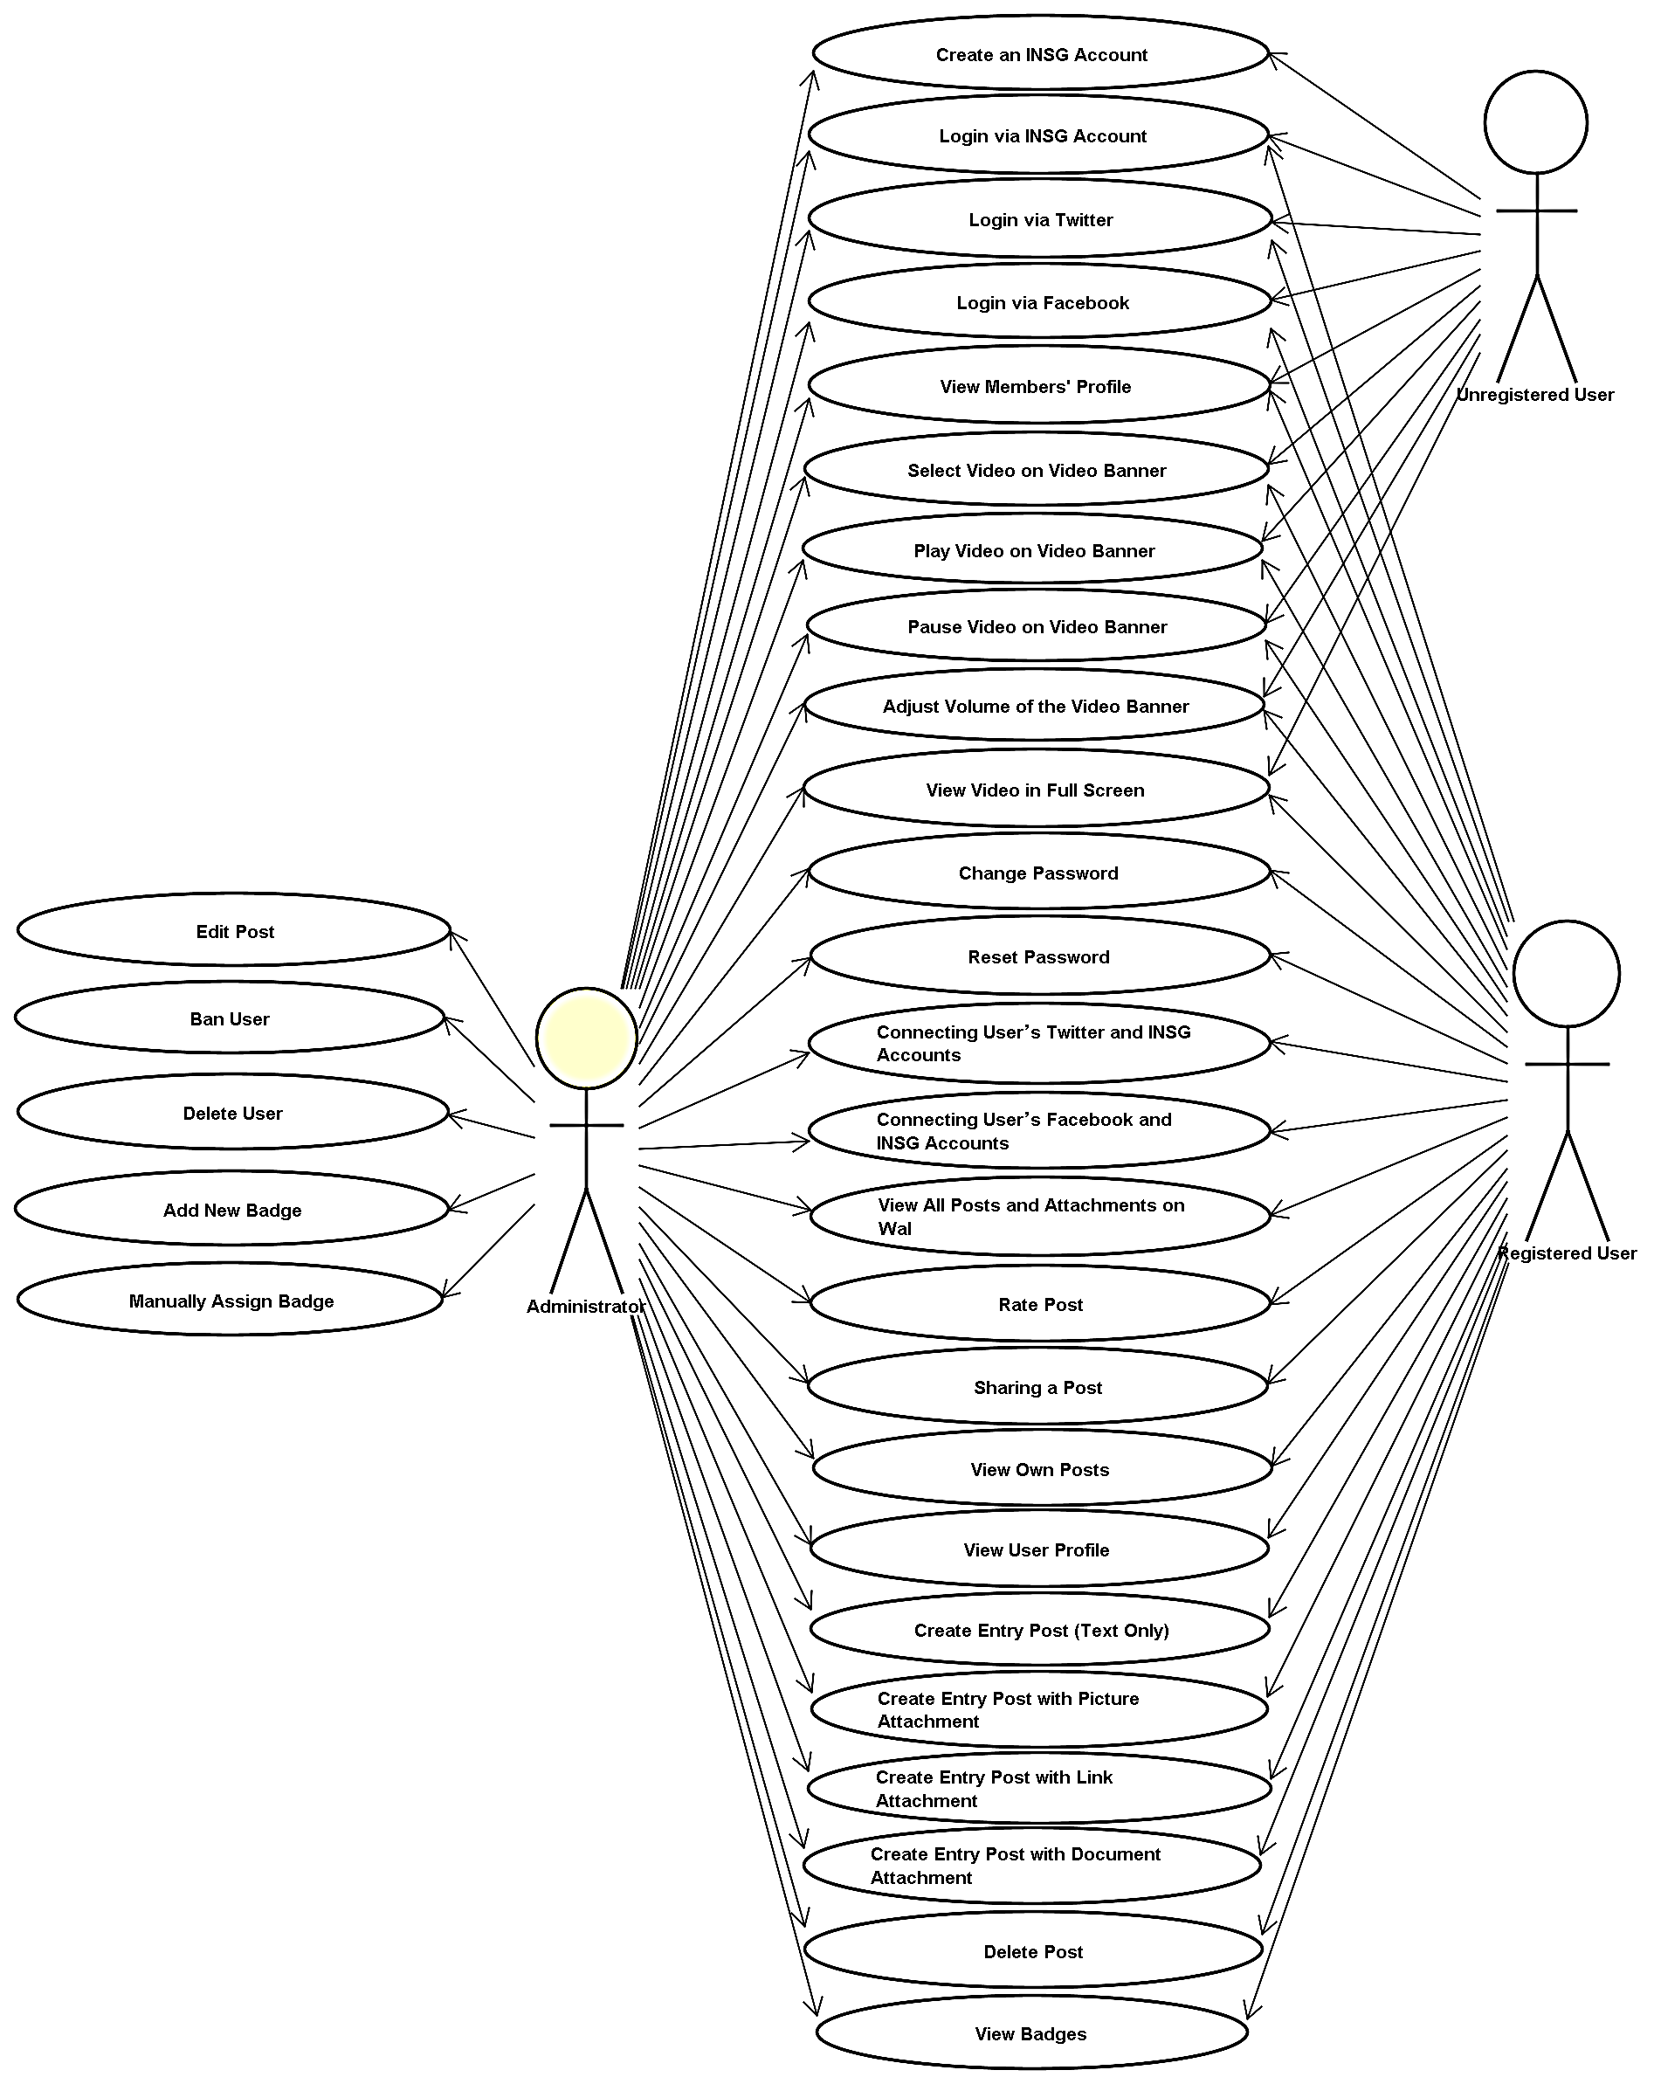

Detailed Use Case Description
The detailed use case description explains the operational concepts and its associated scenario. The description of each use case includes the basic flow and alternate flows. The basic flow outlines the execution sequence and the expected outcome when it is executed successfully. The alternate flows identify the exception handlings.

Registration

New User Registration (Create an INSG Account)
Actor(s): | Administrator, Unregistered user
Brief Description: | Allows new user to register for an INSG account.
Pre-condition: | -
Basic Flow: | - User clicks on ‘Register’.  - The user enters registration details:  - Username  - Password  - Email address  - The System sends account activation details to the user’s email address.  - The user account will only be activated upon user’s activation by clicking on a link in the email (email verification).
Alternate Flow: | 2a. Username/ email address/ password/ birth date are not entered: The System displays error message(s):  - “Username field is required.”  - “Password field is required.”  - “Email address field is required.”  - “E-mail address field is required.”
- In case he/she forgot username and/or password, he/she can request the current username/new password to be sent to his/her registered email.
- Upon creating an account, users would be able to connect their accounts with their Facebook or Twitter account, and thereafter, log in via their Facebook or Twitter accounts.
- If a user logs in via Facebook or Twitter and is not tagged to an INSG account, he/she will be prompted to create an INSG account or to log in to an INSG account to complete the connection.
- (Late Stage) Registered users should be able to see a list of other online Registered Users.
- (Late Stage) Registered users should also be able to log in via MSN Live.

Login

Login via INSG Account
Actor(s): | Administrator, Registered user
Brief Description: | Allows users to login into the System.
Pre-condition: | User has registered for an INSG account successfully.
Basic Flow: | - This use case starts when the user chooses to login to use the System.  - The System displays the login page.  - The User enters the username/email address and Password and submits them.  - The System will then process the validation of the User’s submission.
Alternate Flow: | 4a. Username/email address and password are not entered: The System displays error messages:  - “Password field is required.”  - “Username is required.”  The System alerts the user and advises the user to re-enter. The use case resumes at the basic flow step 2.

Login via Twitter
Actor(s): | All users (with Twitter accounts)
Brief Description: | Allows users to auto-register and/or login into the system via their Twitter account.
Pre-condition: | User has an existing Twitter account.
Basic Flow: | - This use case starts when the User chooses to login to use the System.  - User will be redirected to Twitter application for verification.  - Upon successful verification, user is auto-registered an INSG account.  - Page redirects to INSG website.
Alternate Flow: | 3a. Verification fails and user will be prompted to re-enter Twitter username and password correctly.

Login via Facebook
Actor(s): | All users (with Facebook accounts)
Brief Description: | Allows users to auto-register and/or login into the system via their Facebook account.
Pre-condition: | User has an existing Facebook account.
Basic Flow: | - This use case starts when the User chooses to login to use the System.  - User will be redirected to Facebook application for verification.  - Upon successful verification, user is auto-registered an INSG account.  - Page redirects to INSG website.
Alternate Flow: | 3a. Verification fails and user will be prompted to re-enter Facebook username and password correctly.

Account Management

View User Profile
Actor(s): | Administrator, Registered user
Brief Description: | Allows user to view their profile information.
Pre-condition: | User has to log into INSG successfully.
Post-condition: | -
Basic Flow: | - The System displays the user’s profile page.  - The user can view his/her collection of badges and personal posts.  - There would be a notification area to notify users of new developments. For example, achieving a new badge.
Alternate Flow: | -

Change Password
Actor(s): | Administrator, Registered user
Brief Description: | Allows the user to change his/her old password.
Pre-condition: | - The user must log in to the system successfully before this use case begins.
Basic Flow: | - User goes to his profile page to change password.  - User enters old password, new password and a confirmed new password.  - User clicks save.
Alternate Flow: | 2a. If new passwords are mismatched, user prompts user to re-enter new passwords.

Reset Password
Actor(s): | Administrator, Registered user
Brief Description: | Allows the user to reset his/her password.
Pre-condition: | - The user must log in to the system successfully before this use case begins.  - The user clicks on the “Request New Password” link. The System displays the request new password page with his/her username.
Basic Flow: | - The user enters his/her email address that is registered in the INSG account.  - The System displays a message that further instructions have been sent to your email.  - The user will then receive an email with a link that allows a one-time log in.  - After login, the user will be directed to a page to change their password.  - The System displays a message that the password has been changed successfully.
Alternate Flow: | 4a. Unregistered email address is entered: The System displays an error message, “Sorry, X is not recognized as an email address.”

Connecting User’s Twitter and INSG Accounts
Actor(s): | Administrator, Registered user
Brief Description: | Allows user to connect his Twitter account to INSG account.
Pre-condition: | 1. User has INSG and Twitter accounts.  2. User has logged in successfully.
Basic Flow: | - User navigates to his account.  - User adds a Twitter account.  - Page redirects user for Twitter verification.  - Upon successful verification, page redirects to user’s account where user tweets can be retrieved and displayed at his INSG account.
Alternate Flow: | 4a. When verification fails, user is prompted to re-enter his Twitter username and password correctly.

Connecting User’s Facebook and INSG Accounts
Actor(s): | Administrator, Registered user
Brief Description: | Allows user to connect his Facebook account to INSG account.
Pre-condition: | 1. User has INSG and Facebook accounts.  2. User has logged in successfully.
Basic Flow: | - User navigates to his account.  - User adds a Twitter account.  - Page redirects user for Twitter verification.  - Upon successful verification, page redirects to user’s account where user tweets can be retrieved and displayed at his INSG account.
Alternate Flow: | 4a. When verification fails, user is prompted to re-enter his Twitter username and password correctly.

Wall

View All Posts and Attachments on Wall
Actor(s): | Administrator, Registered User
Brief Description: | Allows user to rate post by clicking on “Like” or undo this by clicking “Un-Like”.
Pre-condition: | The user has login into the homepage successfully.
Basic Flow: | - User clicks on the page main page where it displays all of the wall posts.
Alternate Flow: | -

Rate Post
Actor(s): | Administrator, Registered User
Brief Description: | Allows User to rate post.
Pre-condition: | The User successfully login into the website.
Post-condition: | -
Basic Flow: | - This use case starts when the User chooses to rate a post.  - The user selects “Like” or “Dislike” to rate a post.
Alternate Flow: | -

Sharing a Post
Actor(s): | Administrator, Registered User
Brief Description: | Allows user to share a post via AddToAny service.
Pre-condition: | User logs into INSG successfully.
Basic Flow: | - User goes to the main page to view on the wall posts.  - User clicks on “Share” button to share post via social network.
Alternate Flow: | -

View Own Posts
Actor(s): | Administrator, Registered User
Brief Description: | Allows User to view his past posts.
Pre-condition: | User logs into INSG successfully.
Basic Flow: | - User goes to “My Account” to view all previous posts.  - The page displays all previous posts that the user has made in the past.
Alternate Flow: | -

Create Entry Post (Text Only)
Actor(s): | Administrators, Registered User
Brief Description: | Allows user to create wall contents.
Pre-condition: | -
Post-condition: | User logs into INSG successfully.
Basic Flow: | - The user goes to “My Account” to post on the status wall.  - User keys in the text into the status textbox  - User clicks “Share”.  - The status is saved into MySQL and reflected on user past post as well as “Latest Status Updates”.
Alternate Flow: | -

Create Entry Post with Picture Attachment
Actor(s): | Administrator, Registered User
Brief Description: | Allows user to create wall contents with an attached picture.
Pre-condition: | -
Post-condition: | User logs into INSG successfully.
Basic Flow: | - The user goes to “My Account” to post on the status wall.  - User keys in the text into the status textbox.  - User clicks on picture icon to upload a picture.  - User selects pictures and clicks “Attach”.  - User clicks “Share”.  - The status is saved into MySQL and reflected on users past post as well as “Latest Status Updates”.
Alternate Flow: | 5a. The attached file is not a valid file and the page returns an error message to inform user on the appropriate file to be attached.

Create Entry Post with Link Attachment
Actor(s): | Administrator, Registered User
Brief Description: | Allows user to create wall contents with an attached link.
Pre-condition: | -
Post-condition: | User logs into INSG successfully.
Basic Flow: | - The user goes to “My Account” to post on the status wall.  - User keys in the text into the status textbox.  - User clicks on link icon to upload a link.  - User keys in the URL and clicks “Attach”.  - User clicks “Share”.  - The status is saved into MySQL and reflected on users past post as well as “Latest Status Updates”.
Alternate Flow: | 6a. If the link is from YouTube or Vimeo, the post reflects as a video.

Create Entry Post with Document Attachment
Actor(s): | Administrator, Registered User
Brief Description: | Allows user to create wall contents with an attached document.
Pre-condition: | -
Post-condition: | User logs into INSG successfully.
Basic Flow: | - The user goes to “My Account” to post on the status wall.  - User keys in the text into the status textbox.  - User clicks on document icon to upload a document.  - User selects document and clicks “Attach”.  - User clicks “Share”.  - The status is saved into MySQL and reflected on users past post as well as “Latest Status Updates”.
Alternate Flow: | 5a. The attached file is not a valid document and the page returns an error message to inform user on the appropriate file to be attached.

Edit Post
Actor(s): | Administrator
Brief Description: | Allows Administrator to edit posts.
Pre-condition: | Administrator logs into INSG successfully.
Basic Flow: | - User selects “Edit” to edit a post.  - User edits the content.  - User submits it.  - System updates the database and changes are reflected immediately on the wall.
Alternate Flow: | -

Delete Post
Actor(s): | Administrator, Registered user
Brief Description: | Allows Administrator to delete posts.
Pre-condition: | Administrator logs into INSG successfully.
Basic Flow: | - User selects “Delete” to delete a post.  - Page confirms on user’s deletion.  - User confirms it.
Alternate Flow: | User cancelled the deletion and page redirects user back to the INSG page.

Video Banner

Select Video on Video Banner
Actor(s): | All users
Brief Description: | Allows users to select video on the video banner.
Pre-condition: | -
Basic Flow: | - User clicks on any available video thumbnail on the banner.
Alternate Flow: | -

Play Video on Video Banner
Actor(s): | All users
Brief Description: | Allows users to play video on the video banner.
Pre-condition: | User has selected a video on the banner.
Basic Flow: | - User clicks on “Play” button.
Alternate Flow: | -

Pause Video on Video Banner
Actor(s): | All users
Brief Description: | Allows users to pause video on the video banner.
Pre-condition: | User has selected and is playing the video.
Basic Flow: | - User presses the pause button.  - Video pauses playing..
Alternate Flow: | -

Adjust Volume of the Video Banner
Actor(s): | All users
Brief Description: | Allows users to control the volume of the video banner.
Pre-condition: | User has selected and is playing the video.
Basic Flow: | - User drags the volume slider upwards to increase the volume.  - User drags the volume slider upwards to increase the volume.
Alternate Flow: | -

View Video in Full Screen
Actor(s): | All users
Brief Description: | Allows user to maximize video panel to full screen mode.
Pre-condition: | User has selected and is playing the video.
Basic Flow: | - User clicks on “Full screen” button.  - Video expands to full screen view.  - User clicks “Esc” key to return to the normal view.  - Video exits full screen mode and return to normal view.
Alternate Flow: | -

Community Management

View Members’ Profiles
Actor(s): | All users
Brief Description: | Allows user to view the profile information of another registered user.
Pre-condition: | User has to log into INSG successfully.
Basic Flow: | - User navigates to the community list.  - User clicks on another user’s profile page.  - Page loads to show the user’s profile page.
Alternate Flow: | -

Ban User
Actor(s): | Administrator
Brief Description: | Allows user to ban another registered user.
Pre-condition: | User has to log into INSG successfully.
Basic Flow: | - User navigates to the community list.  - User clicks on “Ban” on the selected user’s record.  - System prompts for user’s confirmation to ban.  - User confirms and the information is stored into MySQL.
Alternate Flow: | 4a. User cancelled and page redirects user back to the community list without banning the selected user.

Delete User
Actor(s): | Administrator
Brief Description: | Allows user to delete another registered account.
Pre-condition: | User has to log into INSG successfully.
Basic Flow: | - User navigates to the community list.  - User clicks on “Delete” on the selected user’s record.  - System prompts for user’s confirmation to delete.  - User confirms and the user account is deleted from MySQL.
Alternate Flow: | 4a. User cancelled and page redirects user back to the community list without deleting the selected user.

View Badges
Actor(s): | Registered user
Brief Description: | Allows users to view their badges at their profile page.
Pre-condition: | User logs into INSG successfully.
Basic Flow: | - User clicks on “My Account”.  - Page loads user’s badge collection.
Alternate Flow: | Badges are divided into 2 types – Behavioral and Custom:  - Behavioral: Tracks user activity on site  - Custom: Given by Admin or via Code word

Add New Badge
Actor(s): | Administrator
Brief Description: | Allows user to upload images of the badges.
Pre-condition: | User logs into INSG successfully.
Basic Flow: | - User navigates to community management page.  - The user can enter details about the badges:  - Badge Name  - Badge Description  - Badge Write Up  - Badge Display Start Date via Calendar  - Badge Validity Period (Infinite, Date-to-Date) via Calendar  - For the custom badge, the user can enter the pre-defined Code word: Badge Code word  - For the behavioral badges, it will be hard-coded based on the agreed badges list and administrators will have to change the code should they want to change it.
Alternate Flow: | - Admins are able to create event badges:  - A dedicated event page is created (alternatively, an “Enter Code word” page)  - Users enter a secret Code word on page  - If Code word is correct, event badge will be awarded  - There is no need to create links from the original INSG blog.

Manually Assign Badge
Actor(s): | Administrators
Brief Description: | Allows administrators to assign users’ badges.
Pre-condition: | User logs into INSG successfully.
Basic Flow: | - User chooses a badge and then sees a list of users.  - User is able to select from a list of user to assign the users’ badge.
Alternate Flow: | -

