Date: | 05/08/2017
Time: | 13:00pm
Venue: | SMU Labs Meeting Room 2-2
Attendees: | Wang Shuwei, Tan Yong Siang Ivan, Teo Jin Yuan, Jeremy Lee, Lyu Bowen
Agenda: | 1. Internal meeting update

 | Actionable | Who | Due Date

UAT
- To be discussed tomorrow 6th Aug to wrap up key findings and features to implement
XFactor
- Business value: Business value: Actual usage and completion of 5 IS424 lab assignments for approximately 45 students.
- Technical : Exploration and usage of 6 in depth technical data mining algorithm and 10 visualisations.
- Highly extensible and modularised system: System is designed in a way to allow for fast feature integration (Consult supervisor about this new addition)

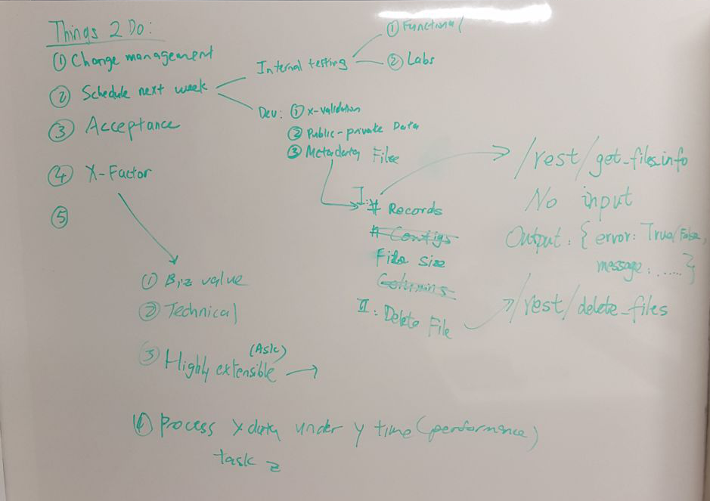
Others
- Bowen to do public – private data set feature & meta data file
- Next week group will go into full debugging and testing mode in preparation for Acceptance
- Bowen will not be around from 11th Aug – 17th Aug
Prepared by,
Jeremy Lee

