Hey Guys,

Things are starting to move again positively. However there is still a need to really pick up speed to make integration work.

Sprint Velocity Chart
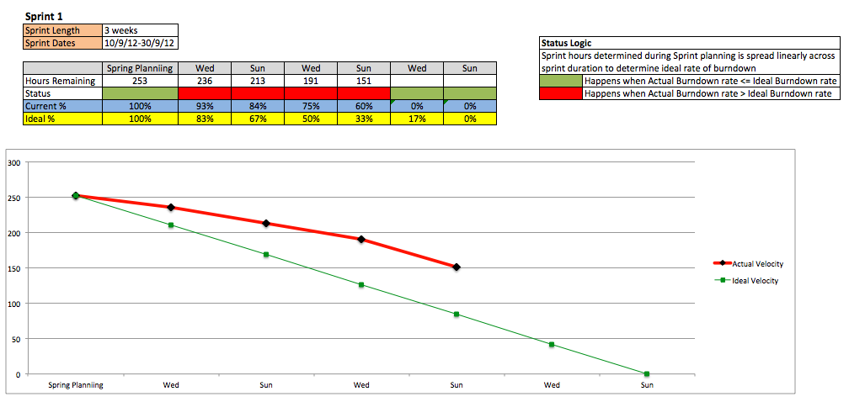

Current Status: As you can see, we are 50% behind time. Usability Testing, so lets get it to work guys.

Individual Tasks Progress & Daily Scrum
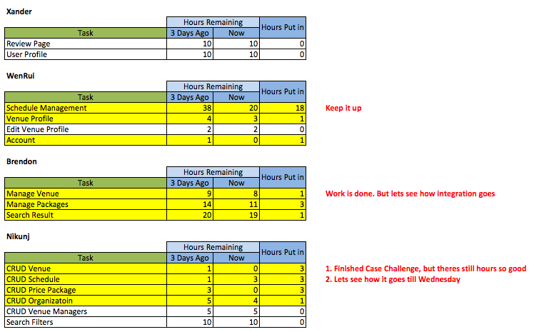
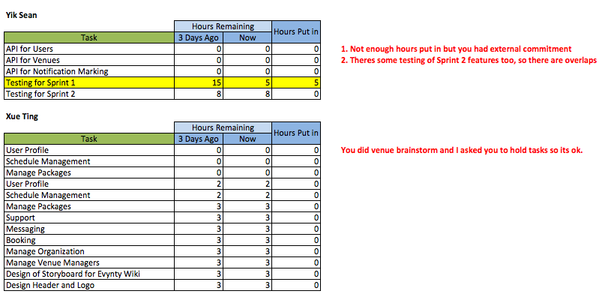

Best Regards,
Xander
Your Friendly Project Manager

