Team Meeting Minutes # 7

Date: | 15th June 2012 (Friday evening)
Time: | 8:45pm to 10:15pm
Venue: | Skype Conversation (Singapore & Beijing, China)
Attendees: | Yingyue, Kevin & Jeffrey
Absentee: | Keli, Larry, Yi Zao
Agenda: | - Discuss flow of all consolidated ideas  - China Charitable Organization’s interest to collaborate with B1G1  - Comments for Keli’s Storyboard

No. | To-do List | Person I/C | Due Date | Remarks
1. | Project Proposal | Kevin & Yingyue | 18th June 2012  (Advanced submission to Debin Gao) | It’s good that we send in our proposal first to Debin GAO, get his feedbacks before submitting on 20th June to Prof Benjamin
2. | Update Prof Benjamin Gan with an updated Project Synopsis | Keli & Yi Zao | 19th June 2012 | For Wiki main page update purposes  We can use the description mentioned in the recent Review document sent to Masami on 15th June.
3. | Meet with Prof Benjamin Gan to get comments on our project depth | Jeffrey & Larry | Tuesday, 19th June, 7.30pm in his office | Confirmation email hasn’t been sent to Prof Ben

Content for meetings’ agenda |  | Action By
1 | Discuss flow of all consolidated ideas  (View workflow diagram at the end of this minutes)  Step 1: Capture and record photo into a Cloud/ physical database  Where it is featured: B1G1 Capturing Moments app on the mobile phone  Who will use it: Worthy Cause Volunteers  Main functions:  - Capture & upload photo, along with GPS tracking location, input of Volunteers’ emotion icons and a main description of the photo into B1G1 Website (Media mgmt. feature & Blog post feature)  - Sharing of photo captured to B1G1 Facebook  Reference: Keli’s storyboards for B1G1 Capturing Moments app  Step 2a: Media Management Feature (MMF)  Where it is featured: B1G1 Website  Who will use it: Worthy Cause Admins  Main function: To edit photos posted by B1G1 Capturing Moments app and it follows with a couple of actions -  - Reposting as a newsletter/newsfeed  - Submission to Photo Reward System to earn points (Ref: Reward system)  @Larry – Is the Jquery photo editor the tool for this Media Management feature?  Step 2b: Blog post feature (BPF) (grabbing information from photo upload)  Where is it featured: B1G1 Website  Who will use/view this: Business donors & Worthy Cause donors  Main Functions: During the process of uploading a photo, several information captured such as the photo, location tracked by the GPS, volunteers’ emotion, and main descriptions will be used to repost into a blog post format*  Blog post format:  <Keep in view, await format from Kevin/ Yingyue>  Step 3: Reward system for the Worthy Cause:  Where it is featured: B1G1 Website  Who will use it: B1G1 Moderators (Assessing photos contributed by Worthy Causes)  Main function: Encourage the Worthy Causes to be active in uploading the Cause photos. They will earn points when they upload very meaningful photos which popularity will be judged by voters (business donors) and B1G1 photo moderators.  Analogy drawn: Posting great photos in a Photo-taking contest and the judges will decide which are the winning photos and thus getting the reward. | Kevin, Yingyue, Jeffrey
2 | China Charitable Organization’s interest to collaborate with B1G1  - Yingyue’s friend’s mom is from a Charitable Organization and she wishes to collaborate with Masami’s B1G1  - Publicize B1G1 to China (Use of popular sports stars and figures)  - Charitable organisation in China do not have advanced IT support. | Yingyue
3 | Comments for Keli’s Storyboard  Kevin and Yingyue’s comment: Since it’s a mobile application, we should make the interface lesser wordy so as to cater for small screen smartphones. Focus more on the graphics. | Kevin, Yingyue, Jeffrey

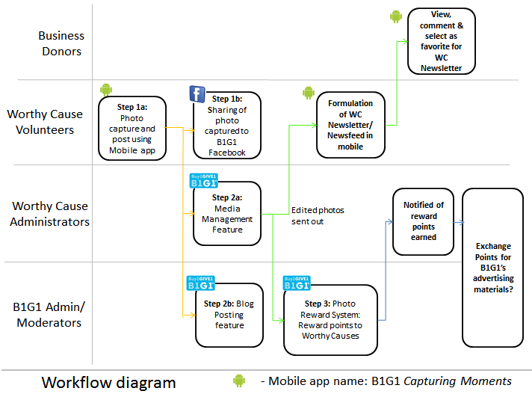

Prepared by,
Jeffrey Ng

Vetted and edited by,
Pending vet -Kevin and Yingyue

