Date: | 02/09/2017
Time: | 13:00pm
Venue: | SMU Library Project Room 3-1
Attendees: | Wang Shuwei, Tan Yong Siang Ivan, Teo Jin Yuan, Lyu Bowen, Jeremy Lee
Agenda: | 1. Internal meeting update

 | Actionable | Who | Due Date

Advanced Classification Module

- Ensemble node will take in multiple classification nodes (Decision Tree, SVM)
- Ensemble node will require voting classifier
- When ensemble node is run will produce decision tree graph, report, confusion matrix
- Voting classifier (Hard voting)
- Predict node / function to be used after ensemble
  - Can also be used with any node that produce a pickle file (Decision tree, SVM)
  - Predict node will only be connected by all the classifier
  - Predict node has an output (Data frame , report) * Report will come out only if user provides y values
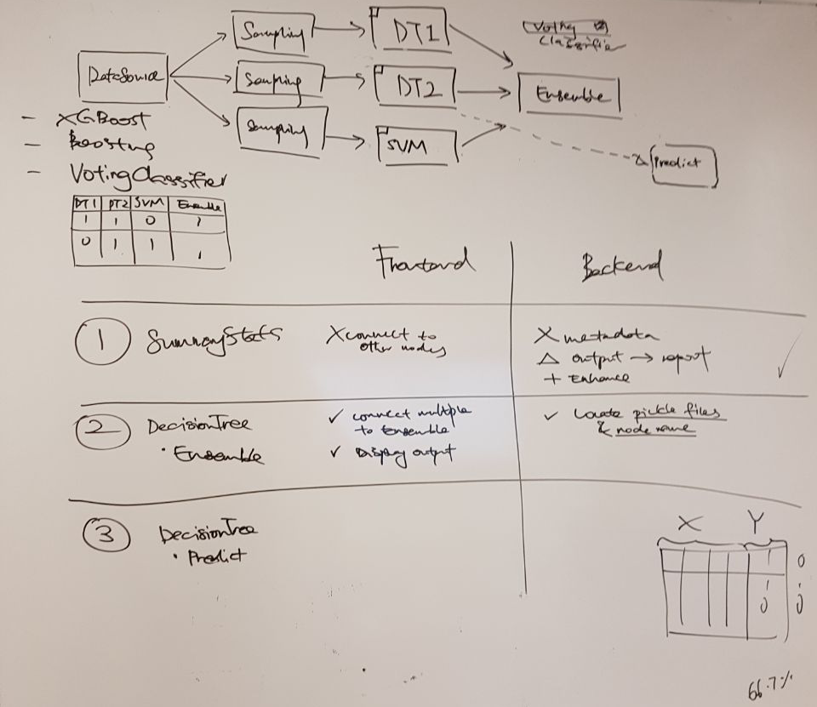

Others
- Functionalities to be ready for lab 1 then merge back
- Schedule to be rescheduled to fit lab exercises
  - Move advanced classification to iteration 8
  - Clustering module to iteration 9
  - User Access Control to iteration 10
  - Data Association module to iteration 11
  - Data source management to iteration 12

Prepared by,
Jeremy Lee

