AlterSense Deployment Manual

Hardware Pre-Requisites
- Intel i7 CPU or higher
- 4GB RAM or higher
- 128GB hard disk space or higher

Install Software
- Microsoft Windows 7 or newer
- .NET Framework 4
- Kinect for Windows Runtime Environment v1.6 or newer
- ADO.NET Driver for MySQL 6.5.4 or newer
- WAMP Server 2.2E or newer
- Microsoft Visual C++ 2010 SP1 Redistributable Package

Configure Database
- Click WampServer > phpMyAdmin
- Click SQL
- Open “AlterSense\trunk\Database\altersense.sql” in a text editor
- Copy and paste the contents of the database script into the box below “Run SQL query/queries on server “127.0.0.1”:”
- Click Go

Configure Advertisement Management System

Deploying the backend database
- Ensure WampSever is ready (which will display a green icon), click on the icon and select phpMyAdmin.
- Select the import tab
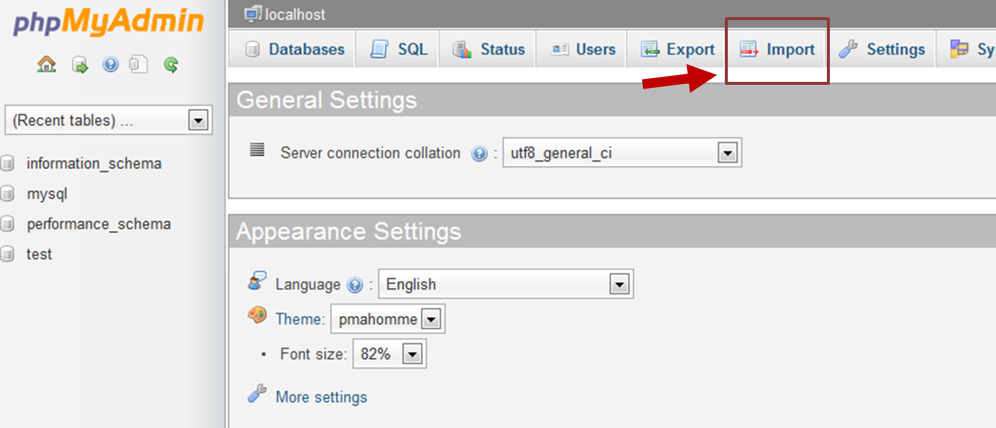
- Click on the browse button and navigate to Deployment\AMS\AMS.sql and select the file to import
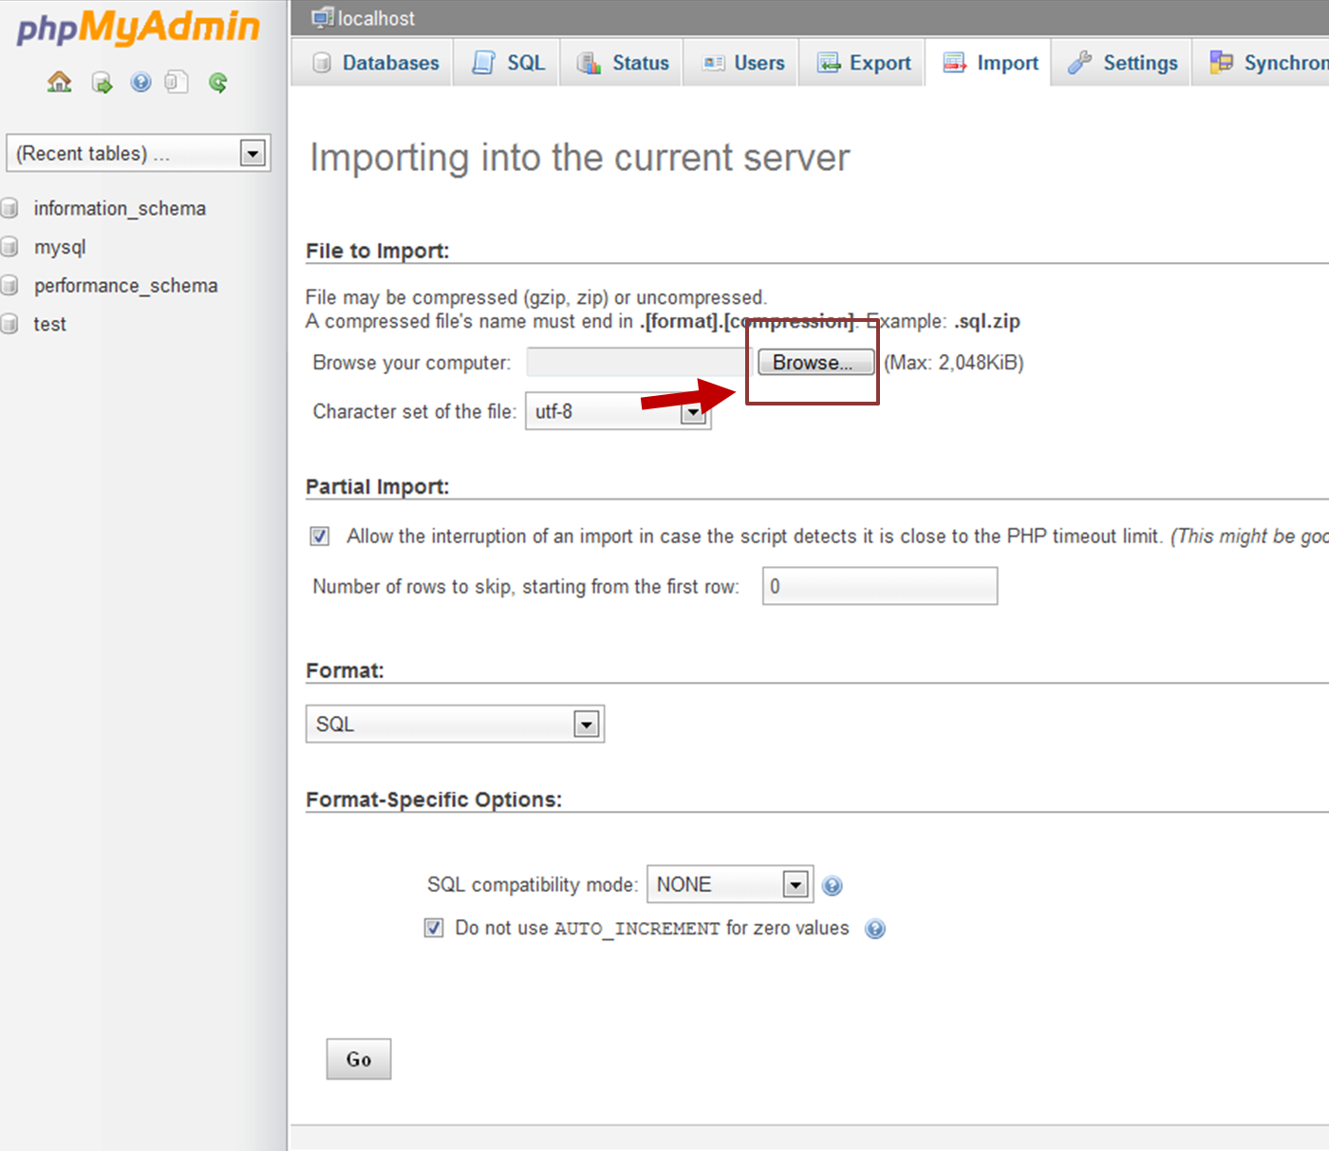

Deploying the AMS frontpage
- Ensure that port 80 is available free for Apache server to deploy.
- Once the WampSever is ready (which will display a green icon), click on the icon and select www directory to access the root folder.
- Unzip the entire folder from AMS to the root folder
- Go to your web browser to key in http://localhost/AMS/display.php

Configure AlterSense

Run AlterSense Manually
Please ensure that environment has been properly configured.

- Start WAMP Server and Start all services (Database, PHP)
- Open the contents of the DVD under “Deployment\AlterSense\ Runtime\”
- Extract the compressed archive AlterSense.zip to a designated folder in the deployment machine e.g. “C:\AlterSense”
- Navigate to the designated folder
- Run Altersense.exe
Note: Altersense would take up to 5 minutes to perform training

Run AlterSense Automatically On Startup

- Create a shortcut to AlterSense.exe
- Place it in the startup folder of the user logged in. e.g. <User1>
e.g. C:\Users\<User1>\AppData\Roaming\Microsoft\Windows\Start Menu\Programs
- AlterSense should load automatically when the user logs in

