CODEZILLA MEETING MINUTES
Details of Meeting
Meeting Title |  | Iteration 2 – Internal Meeting 2 – Understanding Login and Registration
Date (DD/MM/YYYY) |  | 01/06/2017 |  | Time |  |  | 07:00PM – 10:00PM
Location |  | SMU SOE Level 1 Study Space
Minutes Prepared By |  | Edward Foo |  | Minutes Vetted By |  |  | Zul Yang
Attendees |  | Zul Yang  Edward Foo  Koh Xiao Wei  Nigel Goh  Amanda Lim |  | Absentees |  |  | Jolene Teo
Meeting Objective
Shared understanding of the functions login and Registration, and drafting the technology stack diagram
Meeting Agenda
- Technology Stack Diagram
- Understanding Login and Registration
Meeting Notes, Discussion
S/N | Topic | Details |  |  |  |  |  | To Note
1 | Technology Stack Diagram | -A draft has been created by our software architect  -The final draft once created will be uploaded shortly
2 | Understanding Login and Registration | -Refer to the diagram sketches (Figure 1 and 2) for an overview:  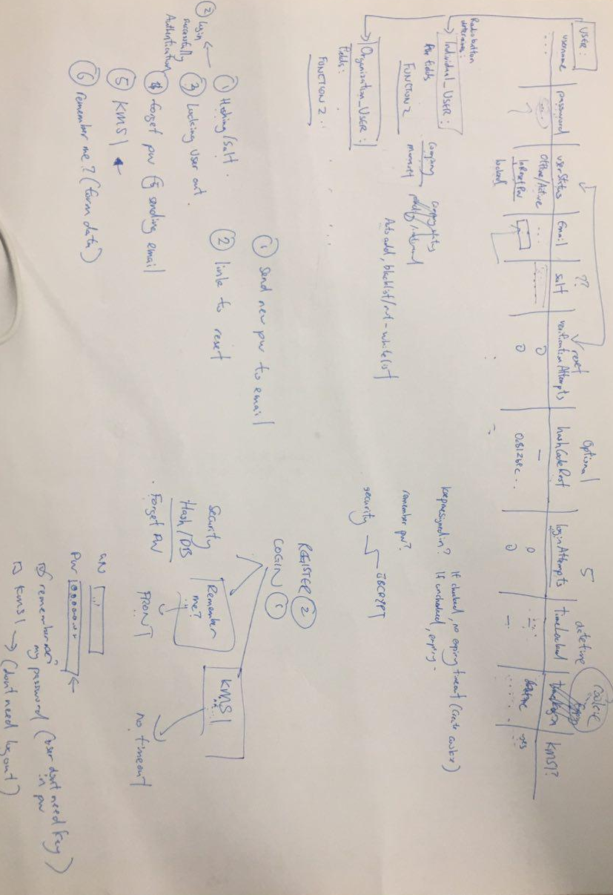  Figure 1: Overview of Login/ Registration  Figure 2: Forget Password (Entering of code into link in email)  -Below are several points to note:  - Login: Password Hashing  - Forget Password: An email will be sent to the user with a long random string/code and a link. The user should open the link and enter that string/code into the link to unlock and reset his/her password. Take note of time out session for this. (Refer to Figure 2)  - Remember Me: Upon entering the login page, the username and password should already be filled. The user does not need to key them in.  - Keep Me Signed In: No timeout, meaning the user will always be signed in and he/she will not be logged out
Actionable Items
S/N | To Be Done |  |  | Team Member(s) | Due Date (DD/MM/YYYY)
1 | Technology Stack Diagram |  |  | Koh Xiao Wei | 11/06/2017
Next Meeting (If Applicable/Discussed)
Date (DD/MM/YYYY) |  |  | 06/06/2017 | Time |  | 07:00PM - TBC
Venue |  |  | TBC | Objective |  | Understanding Spring

