Client Meeting Minutes

Date: | 10th July 2012 (Saturday)
Time: | 12pm to 1:30pm
Venue: | SKYPE
Attendees: | Masami, Keli
Absentee: | Kevin, Yi Zao, Jeffrey, Yingyue
Agenda: | - Comments about our B1G1 Capturing Moments Mobile App  - Walkthrough our project mobile and web portal features  - Account creation and validation for WC Volunteers/ Team members  - Team to consider the universality of our Mobile App  - Technical Components discussion

No. | To-do List | Person I/C | Due Date | Remarks
1. | Update the logical diagram about the database structure of our mobile application | Kevin | 15 July 2012
2. | Update the process diagram to current flow | Jeffrey | 15 July 2012
3. | Update user interface with changes suggested | Keli | 15 July 2012
4. | Use case description | Yingyue | TBC
5. | Minutes vetting | Jeffrey | 11 July 2012

Content for meetings’ agenda |  | Action By
1 | Comments about our B1G1 Capturing Moments Mobile App  - Make the Interface more interactive  Masami wanted a more user friendly interface with simpler designs and images in the background. She wants the wordings on the mobile to be inviting. She suggests to maximize the space usage of the mobile size.  - Focus on the Digital Diary Feature rather than the newsletter  She wants the photo capturing feature to be the main focus and will get back to us whether she thinks that the newsletter feature for the business donors and the worthy cause team members is feasible and practical. She explains that not every worthy cause administrator is willing and convenient to upload a newsletter.  - Adding a white background  She prefers a lighter background to the mobile application as the wordings are in grey which makes it hard to see.  - Adding a registration feature to the mobile  application on top of the login feature  Masami suggests that there is a need for the worthy cause team members to login using something more simple than the login database that they are using to ease the effort of creating a login for the rest of the team. Aside from learning how to code the login feature  - Adding a activity update in the Livefeed feature rather than a newsletter view option  Masami suggests that worthy cause team members might find it more interactive to push the update and se it later just like how twitter does it and this can hence increase more activity among the team members. She also suggests that the newsletter view option to be scrapped because it might not be feasible to ask the worthy cause team members to upload newsletters.  She suggests that the live update to be available both in the B1G1 Capturing moments and B1G1 web portal  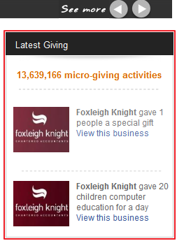  - Allow worthy cause team member to comment on each other’s live feed  To promote more interaction amongst the worthy cause team members, she suggests that they could comment on each other’s feed. | Keli

Prepared by,
Zheng Keli

Vetted and edited by,
Zheng Keli

