Meeting Minutes 23
Monday, 13 Oct 2018 (4:30pm-5pm)
Attendee: All Members
Objectives:
Updates regarding functionalities. Finals. PayNow.
Configuration is completed.
Proposal to Remove Features from Configuration Panel. Email sender, Number of points awarded in timeslots, Error messages are features not commonly used. Will not be as value adding. Focus on other aspects which will be used more frequently. Team also facing time constraint due to Mid Terms and Projects.
Advert/Banner/FAQ Remains
Analytics is being started.
Promotion code checks (async and sufficiency of Kredits) – verified by Cheryl
Printer resources: Possible Webprnt
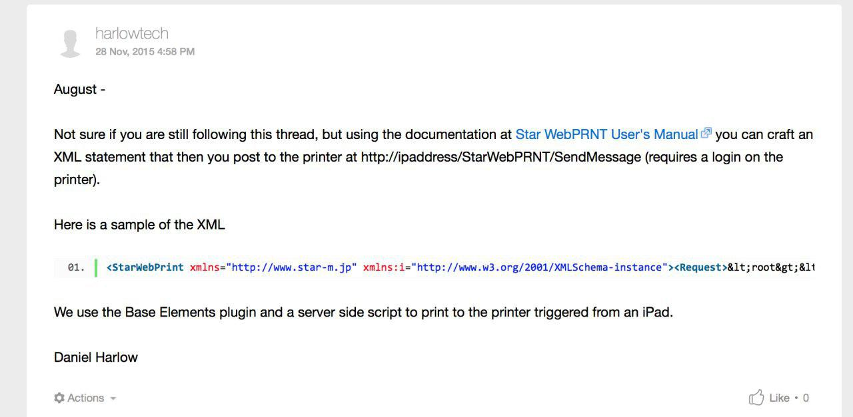
Finals Settled as 22 Nov 5-6pm
DBS hosting a PayNow API workshop. (Daryln and Cheryl attending)
https://www.meetup.com/API-Craft-Singapore/events/254840611/
