For default school views, can schools be displayed by level, and then in alphanumerica order?

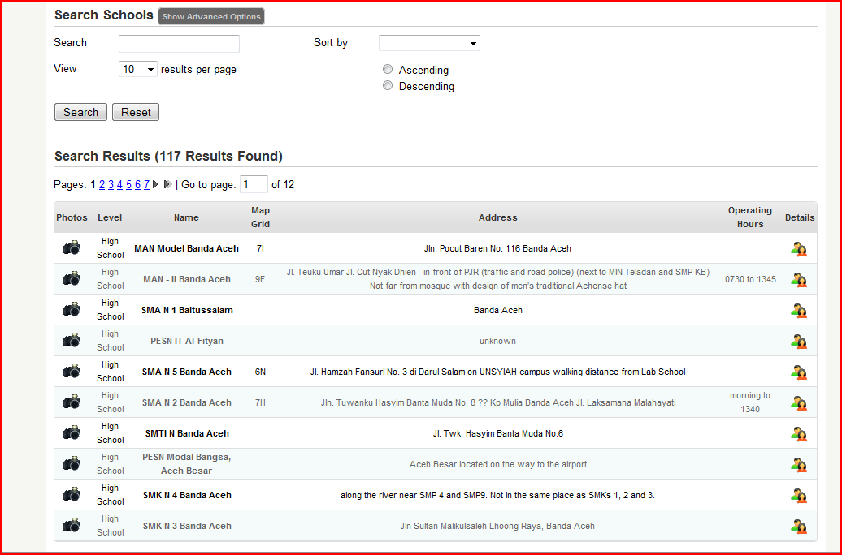

current text: | suggest replacing with:
Copyright © United World College SEA, Singapore. All rights reserved. | Copyright 2010 © United World College SEA, Singapore. All rights reserved. - should there be a year with your copyright? please verify
Site designed by Groupers, Singapore Management University. | Site designed by Groupers, SIS, Singapore Management University.

When entering phone numbers, after first four digits are entered, can the cursor jump to entry point for next digits without having to tab over?

Are there live links to schools from the student records?

Replace “More Comment Row” with “Add Comment”
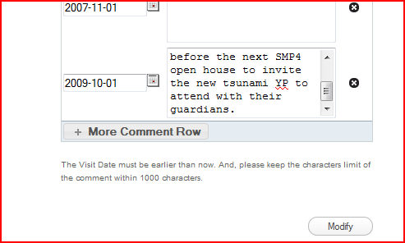

Pls add apostrophe: Educators’ Information
