Final Year Project Minutes 22

Date: February 7th, 2013
Time: 1530-2100
Venue: SIS GSR 3-4

Attendees: Sarah Chu Ting Fang
Goh Mei Zhen, Celestine
Wong Cai Ling
Cai Zejun
Quan Ke
Absentee : Liu Rongxuan

S/N | Agenda Discussion
1 | 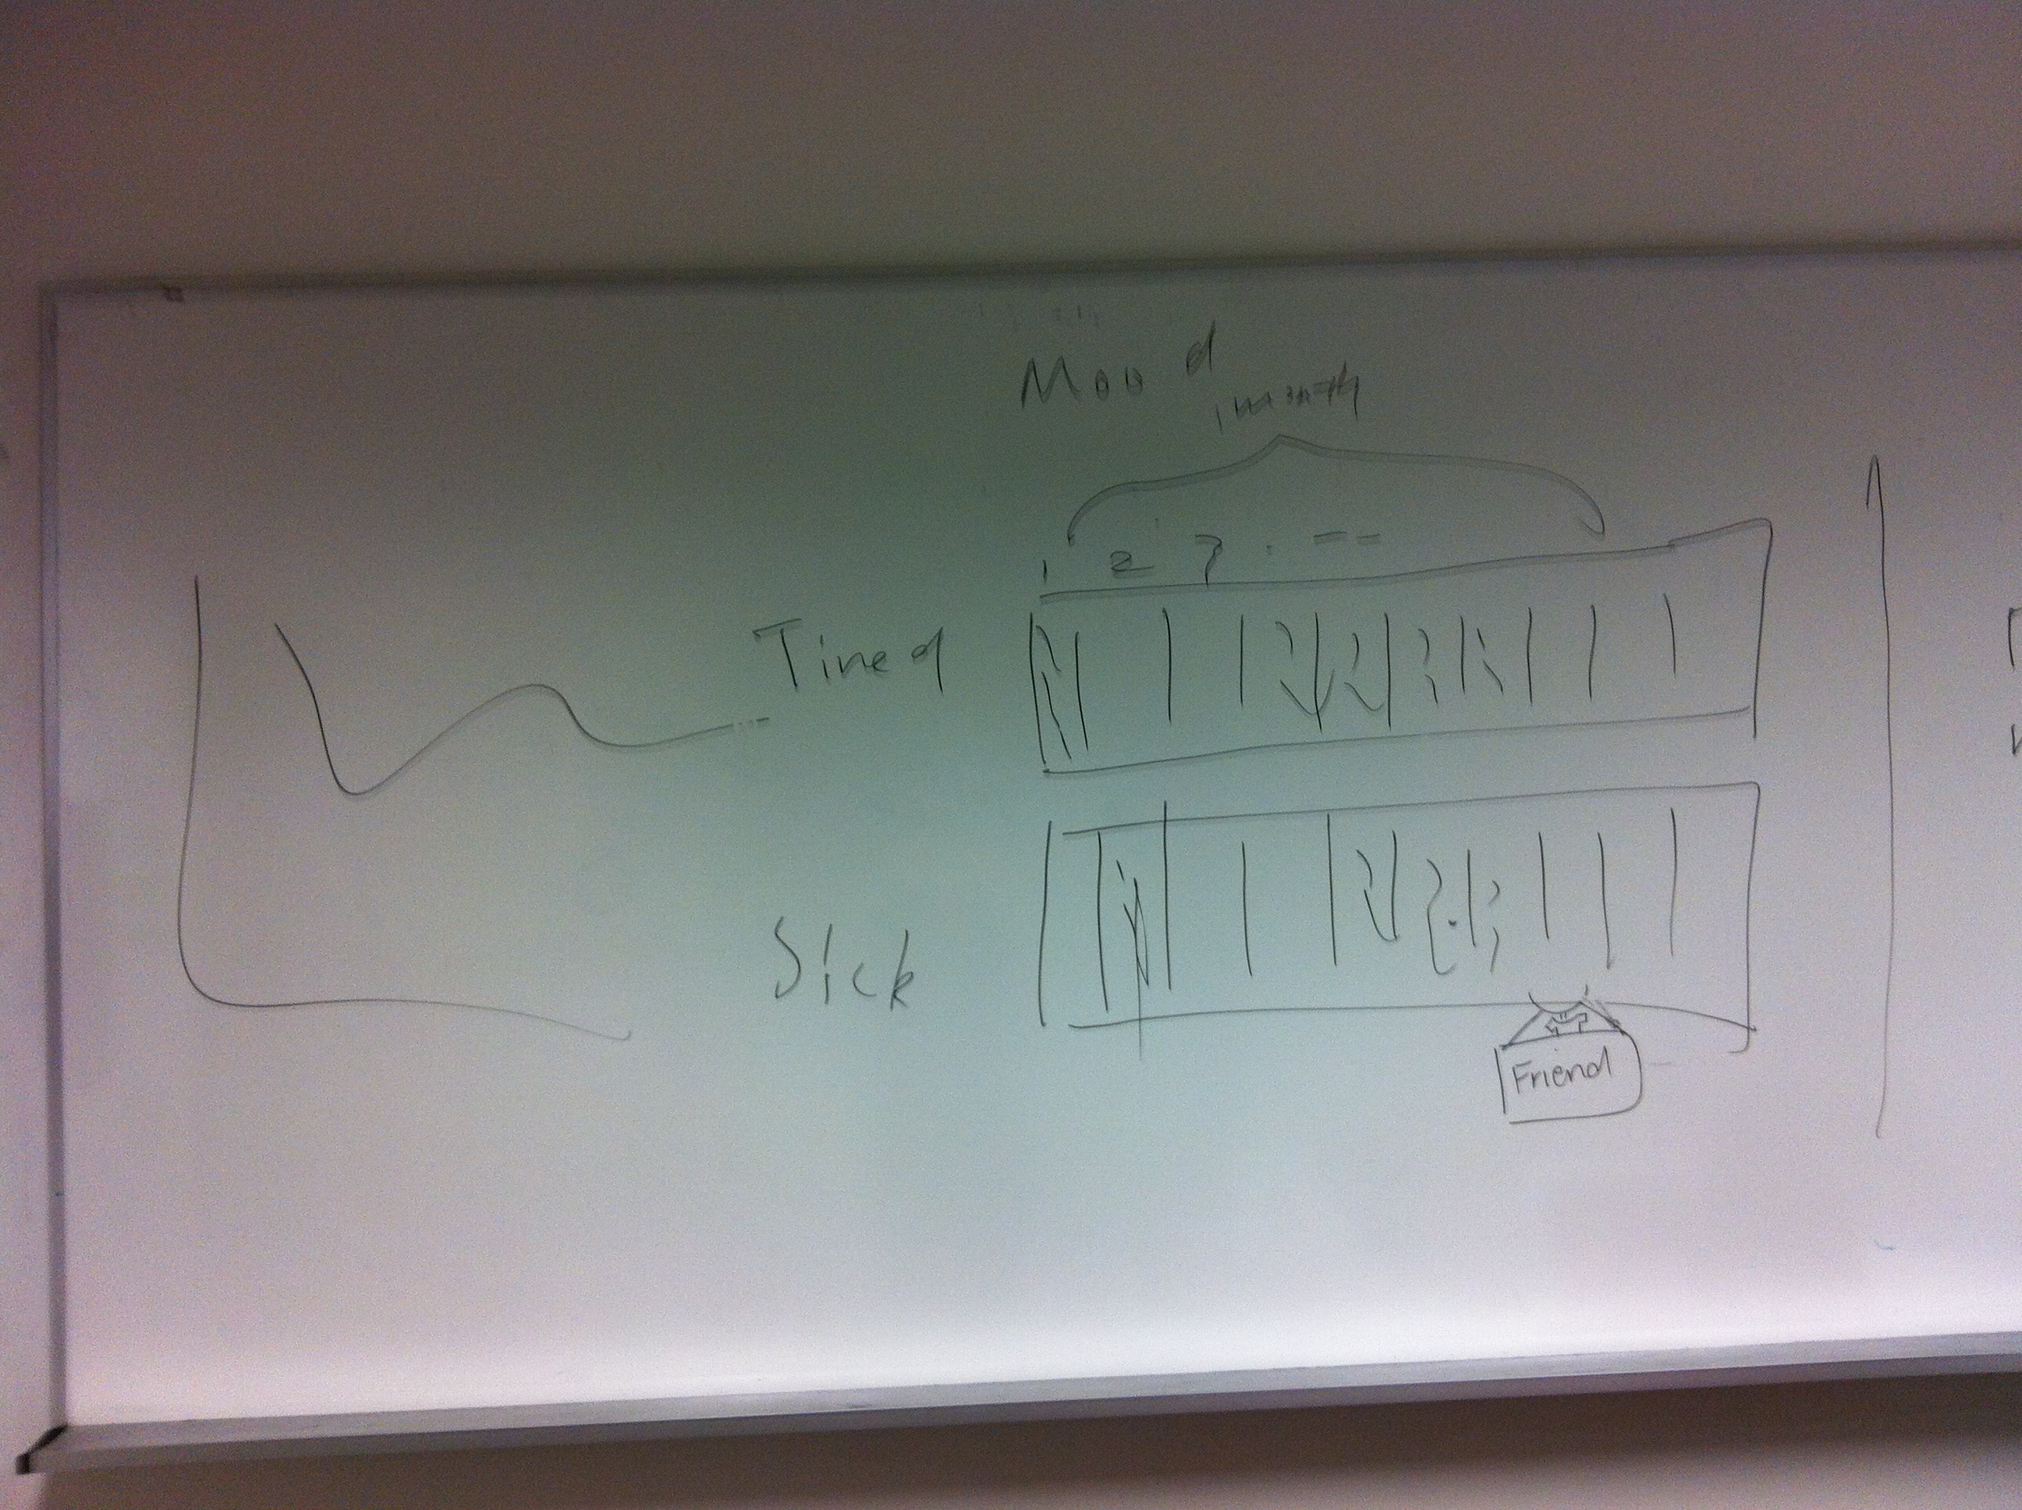  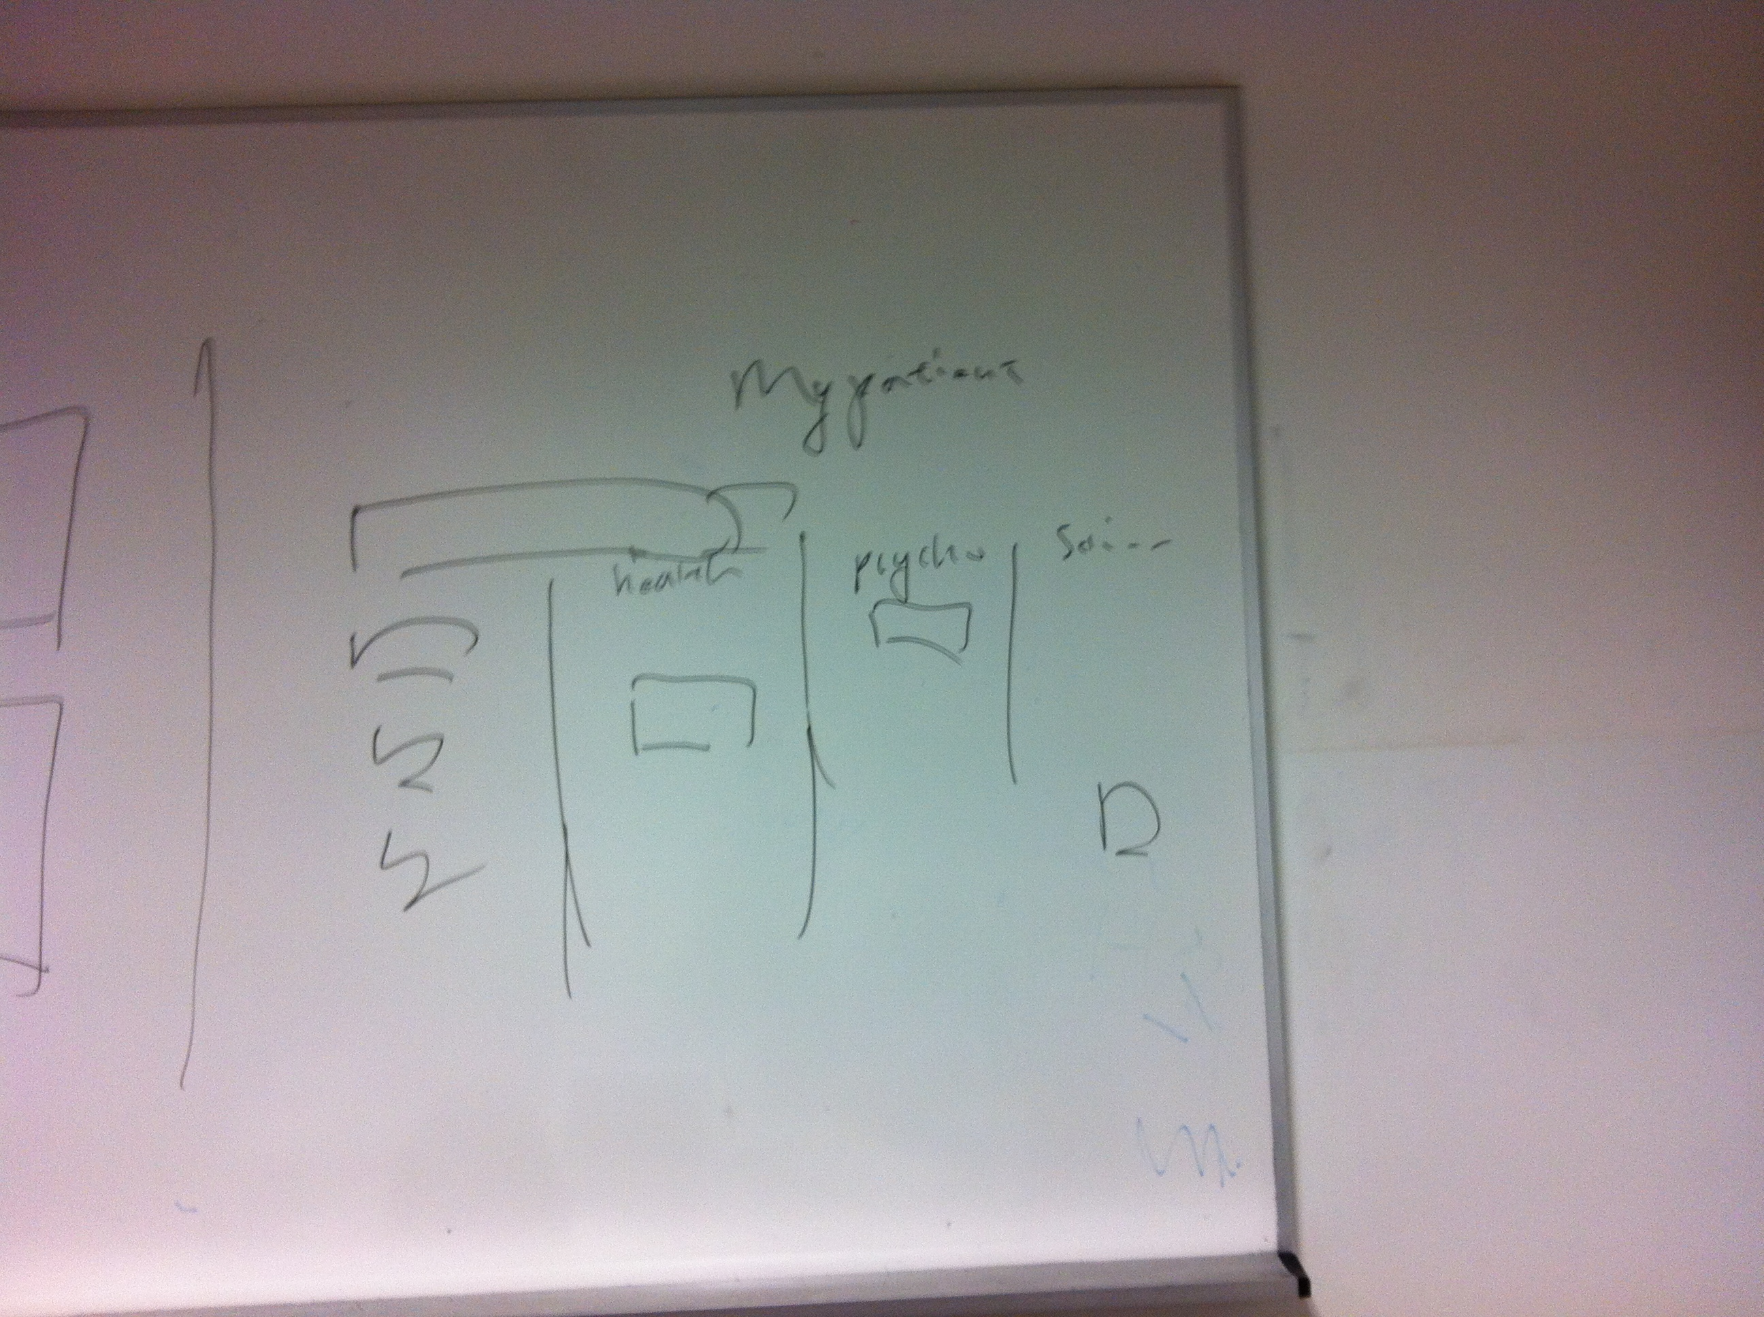

The meeting was adjourned at 2100hrs. The minutes will be circulated and adopted if there are no amendments reported in the next three days.

Prepared by,
Celestine Goh

