INTERNAL MEETING 5
Date | 18th Aug 2017
Time | 1pm
Venue | SIS GSR 2.8
Attendees | Amelia Lee  Chew Chin Rui  Ervin Chong  Huang Mingrui  Ricky Putra Franslay  Wang Qimin
Absentees | -
Agenda | - Share research on similar apps  - Start working on wireframes  - Start drafting proposal

AGENDA
No. | Task | Follow-Up
1 | Share research on similar apps  We found a website, http://www.prognosisapp.com/, that contains a gamified medical diagnosis process and has over 600 case scenarios. However, the website does not allow adding of new cases and is limited to just simple MCQ questions.  Example of case management on Prognosis:  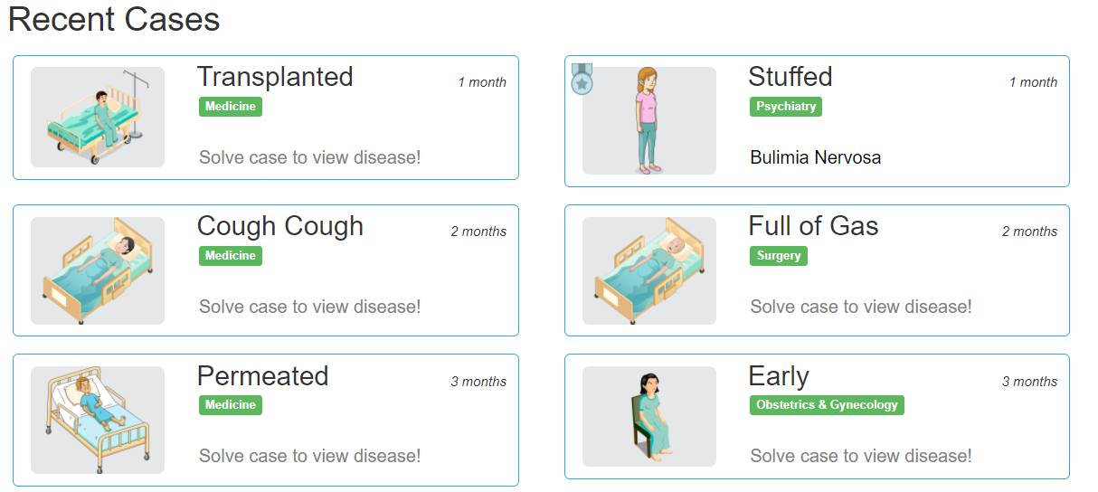  Example of gamification  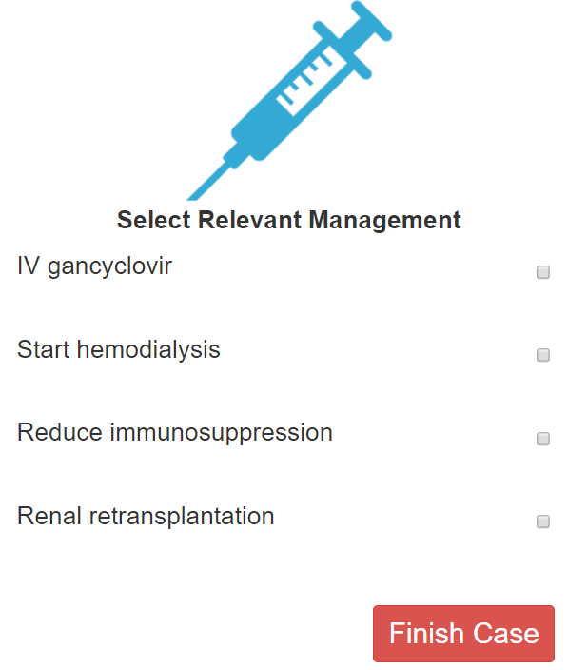 | NA
2 | Start working on wireframes  - Login/Signup pages  - User profile page  - Case Uploading  - Case Vetting  - Game  Pairing for wireframes:  Amelia and Ervin – Dicussion forum + case loading and vetting  Ricky and Qimin – Gamification and Analytics Dashboards  Chin Rui and Mingrui – Login, signup and user profiles  Tool to use for wireframes: https://moqups.com/ | Team to start drawing wireframes for next client meeting with Prof Tay
3 | Start Drafting Proposal  - Problem Statement  - Solution Statement  - Project description  - Project Schedule  - Project stakeholders  - Project Scope  - Risk Management | Amelia to start working on proposal
The meeting was adjourned at 5pm. These minutes will be circulated and adopted if there are no amendments reported in the next three days.
Prepared by,
Ervin Chong
Vetted by,
Amelia Lee

