- Name of Organization:
paymentinapp Inc. (Korea), PIAPP PTE. LTD.(Singapore)

- Brief Description of the Organization:
◦ Certified artificial intelligence in Korea, certified Fintech Company in Singapore
"We provide a smart city Mobility-as-a-Service to realize the concept of 'Cross-border seamless payment' that allows easy and convenient use of mobility services anywhere. In addition, we use artificial intelligence technology to analyze user demand and optimize supply such as dispatch and route to save time, cost and solve social problems such as traffic congestion and environmental pollution.”
The Singaporean start-up, PIAPP PTE. LTD. was established and certified as an EntrePass Innovator by the Singapore Ministry of Manpower in 2019 in recognition of the representative's expertise and rich experience. The Korean company, paymentinapp Inc. was founded in 2020 based on the field-proven Mobility-as-a-Service solution, and with the support of the Seoul Metropolitan Government, it has moved into the ‘Seoul Fintech Lab’ to develop professional capabilities. We will innovate our lives, with artificial intelligence and cutting-edge technologies.
https://www.paymentinapp.com
https://www.youtube.com/channel/UC0X3XNyuRVHX_h9LoIs2Rpw
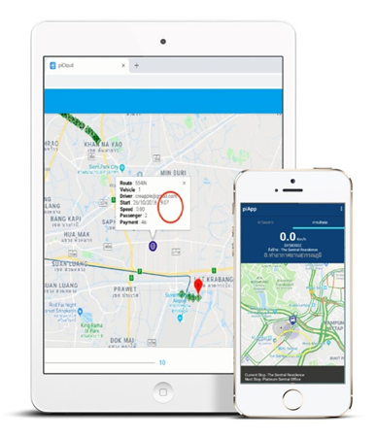

- Project Statement:
  - Introduction and a brief description of the current situation (what are the challenges you are facing/ opportunities you have identified?)
“We solve social problems such as traffic congestion and environmental pollution by providing Mobility-as-a-Service that reduces time and cost by analyzing mobility demand with artificial intelligence technology and optimizing supply such as dispatch and route.
We improve the service by scientifically analyzing the demand and supply of mobility by securing characteristic information such as gender and age of passengers and travel data with artificial intelligence computer vision technology.
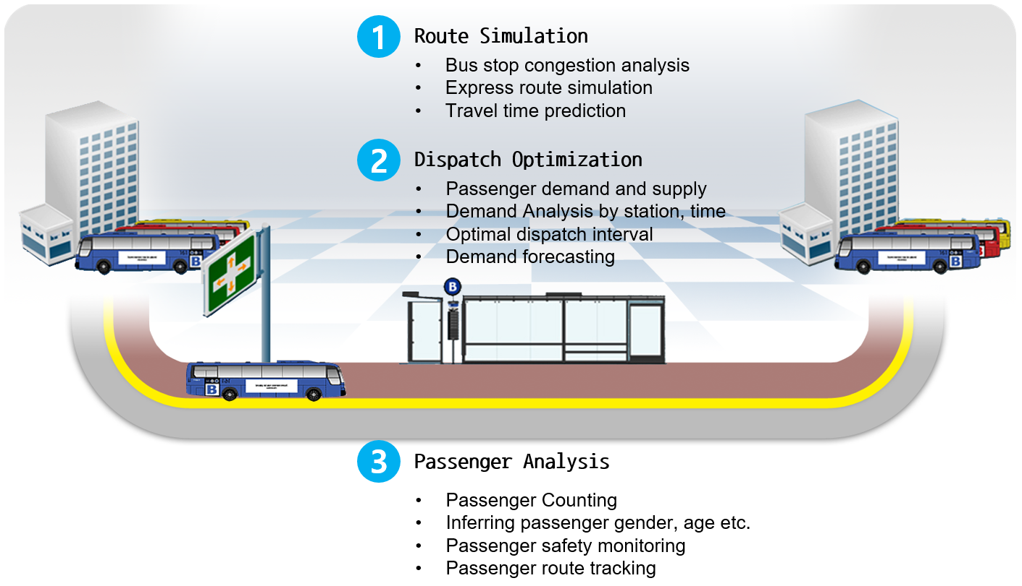

Route Simulation
The express route simulation technology proposes an efficient express route by selecting high-congested stops without changing the route itself. Through machine learning analysis, predict the congestion level and arrival time compared to existing routes and check the expected effect of improvement.

Dispatch Optimization
The bus dispatch interval optimization technology utilizes operation information for each route, such as passenger boarding and alighting, bus stop congestion, real-time traffic volume, operation speed by route, and route length. Machine learning analysis calculates passenger demand limit and bus operation supply limit, and derives the optimal dispatch interval for each time zone.

Passenger Analysis
We improve the service by scientifically analyzing the demand and supply of mobility by securing characteristic information such as gender and age of passengers and travel data with artificial intelligence computer vision technology.

  - The objective of the project (what do you hope to achieve with our students?)
◦ Vehicle/route congestion analysis and improvement simulation optimization provided
- Accurately analyze the congestion level in the vehicle up to the location of each passenger with an AI visual intelligence camera, and analyze the congestion level by collecting big data such as the number of people getting on and off, the number of people getting on and off again, and the time of getting on and off the bus.
- This technology collects and analyzes data on variable demand changes, such as congestion and demand for getting on and off, with AI technology, adjusts routes and dispatches with the same number of trips to ensure punctuality of services, and maintains a uniform level of congestion to prevent traffic congestion and air pollution. The goal is to solve the urban traffic problem
- In order to achieve the project goal, as a public transportation user, we would like to get fresh ideas from students, analyze advanced cases and AS-IS of Singapore's central public transportation system, and design a specific TO-BE model. This project is jointly supported by the Korean government and Nvidia, and is used for designing and building the core logic of piRide Mobility-as-a-Service.

  - Target Audience (who are the people you are targeting for the project? For eg B2C or B2B / millennials & Gen-Z or Baby boomers)
The target audience is small and medium-sized transportation companies with 300 buses (B2B), and it can also be government agencies such as LTA that design and operate public transportation (B2G).
① Concentrate on the bus market with the highest share of each mobility mode of transportation at 41%
If the mobility market is analyzed based on the share rate by means of transportation, buses account for 41% of the total and 65% of public transportation, so we focus on the bus market as it has the highest share. Compared to the 6.5% share of taxi mobility services such as ‘Uber’ and ‘Grab’, the bus mobility market is 41%, which is a promising market with potential and barriers to entry.
② For small and medium-sized TOs with less than 300 units, which account for more than 70% of the total
More than 70% of cities with public transportation are operated in small and medium-sized businesses with less than 300 buses centered on buses and do not have an independent mobility payment system. Mobility-as-a-Service made with international standards and domain expertise provides a solution that meets the needs of small and medium-sized TO.

  - Country of focus (eg. expansion into Thailand or just Singapore)
③ Focusing on ASEAN countries with high potential but lack of momentum in local governments
The population of the ASEAN market is approximately 650 million, making it the third largest in the world. Among ASEAN countries, Malaysia, Indonesia, Singapore, Thailand, the Philippines, and Vietnam had a GDP growth rate of 5.2% between 2018 and 2022, and young people between the ages of 20 and 49 accounted for 45.3% of the population, providing a well-established economic foundation. The representative focuses on the ASEAN market by utilizing the local corporation established and operated by the Singapore government's EntrePass Innovator Startup Support Program. In order to commercialize the start-up item, we have already carried out a project with Premium Bus in Thailand, and additionally signed a business agreement with Handal Indah in Malaysia in January 2022.

A reasonable business model, ‘Pay As You Go’, that minimizes initial investment and pays for what customers use for the service. piRide Mobility-as-a-Service, which has been verified in the field by carrying out projects, Thailand Premium bus in 2019.
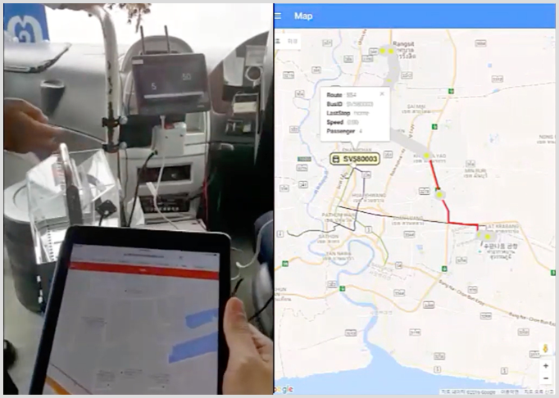

  - Expected deliverables for the students (eg. SWOT analysis, pitch deck, prototype, business proposal, etc
◦ We look forward to doing everything to achieve the goals of the project and improve the services of piRide Mobility-as-a-Service.
- Business and technology ideas
- Advanced case studies
- Market status research and strategy establishment
- AI and machine learning algorithms for optimizing public transportation
- If possible, you are also welcome to participate in project development.
(Android Edge device, Python Cloud Service, HTML5 Web service)

