Team Logo/Graphics

IS483 (SMT Application) Project Proposal
Project Title

Team Name

Version Number
Date

Team Members:
- Name (email address) – Role
- Name (email address) – Role
- Name (email address) – Role
- Name (email address) – Role
- Name (email address) – Role

Sponsor:
Organisation Name
- Dr xxx, Role, Organisation
- Mr yyy, Role, Organisation

Project Overview
Please include all necessary information you know to help us evaluate the scope, viability, plan, risks, etc.

Project Description
Motivate your project. What is the problem that needs to be addressed?

How are you going to solve the problem? In particular, what are you actually going to build (be specific), and how will you evaluate your solution?

What is the potential societal impact of your project?

Stakeholders
Sponsor | Who initiated the project? Be specific about any relationship between the sponsor and the team. What is your contact person’s role in the organization? Is it a faculty member, CEO, manager, liaison, etc.
User | Is the user different from the sponsor? Who is your user? If it is not a person you know, describe the user persona for each user role (e.g., admin, buyer, seller).
Advisors/Practitioners/Mentors | Are there other parties involved in the project? What is their relationship to the project? What interest do they have to the project? Remove this row if not applicable.

Deliverables
Outcomes: What is delivered (deployed) to the sponsor? Is it a proof of concept? Or a release for live usage?

Value Statement: What does the sponsor get out of this? What societal problem/challenge does it address?

Scope
Briefly explain the scope of your project. What are the core features / functions required by your sponsor? Consider prioritising your planned features using a diagram similar to the below (from team Carpe Diem):
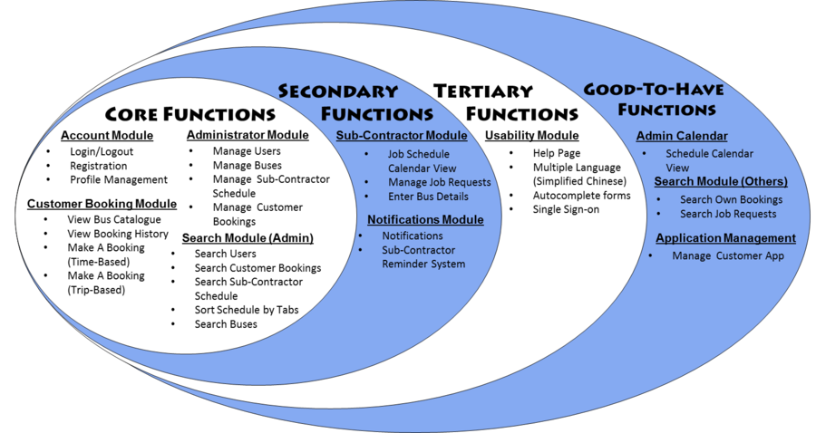
What are the constraints (e.g., hardware, budget) your project must work within? Are there any assumptions (e.g., of users) that you plan to make?

If it helps to explain the scope of your project, please feel free to include relevant diagrams (e.g., storyboards, use case diagrams, process diagrams, low-fidelity UI mock-ups, design diagrams).

If your system needs to interface with third-party tools or existing system APIs, consider including an architecture diagram to clarify this. The “C4 model” (https://c4model.com/) may be helpful.

Project Plan
The plan should convey to us that the goals of your project are achievable by proposing a realistic schedule of milestones, how you plan to work together, and by demonstrating that you have taken into consideration any major risks.

Project Milestones & Schedule
Based on your current knowledge of the project, break down the required work into key milestones. Each milestone should have clear goals / functions.

Propose a schedule for completing these milestones, e.g., using a Gantt chart or project timeline diagram:

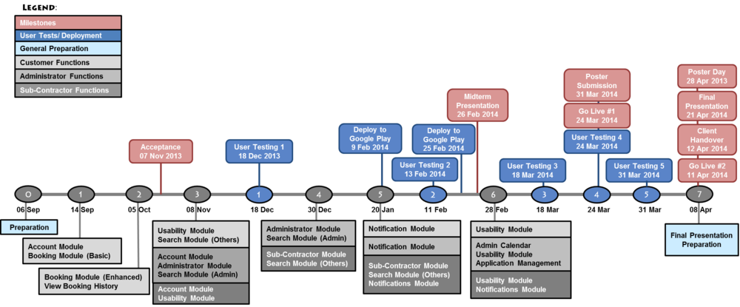

Be as specific as you can at this stage (e.g., by listing specific features and dates). Remember to include activities such as user acceptance testing in the plan.

You should also plan to demonstrate your system during the mid-term and final presentations.

Team Conduct
Are you planning to utilise any project management frameworks to help your team coordinate (e.g., scrum, Kanban)? Are you planning to utilise any productivity tools (e.g., Slack, Jira, Trello)?

Resources:
What resources do you require to be able to complete the project? Do you require any data, and if so, where will it be coming from?

Describe the technology that you will be using (e.g., programming languages, frameworks, APIs, platforms)? Will you be using any proprietary technology from the sponsor? Do you need to utilise cloud providers?

What will you use for training / self-learning? List any relevant books, webpages, contacts, courses, etc.

Risks:
Identify major risks particular to this project, stakeholders, schedule, team, technology constraints, and so on. What are your planned mitigation steps should the worst happen?

For example, if your project relies on the sponsor providing some data, what would be your backup plan if the sponsor is unable to provide it? Do not put generic risks, such as “requirement may change”, unless it is specific to the sponsor.

Team without a name will be given a horrible name such as NoName1 and you will not be able to change your team’s name. 😢

