Team Logo/Graphics

IS483 Project Proposal
Project Title

Team Name

Track

Version Number
Date

Team Members:
- Name (email address) – Role
- Name (email address) – Role
- Name (email address) – Role
- Name (email address) – Role
- Name (email address) – Role

Faculty Supervisor:
- Name

Sponsor and/or Clients (if any):
Organization
Department
- Contact (email address) - Role
- Contact (email address) - Role
- Contact (email address) - Role

Project Overview
Please include all necessary information you know at this time to help us evaluate the scope, viability, plan, risks, etc. Do NOT exceed 2 pages excluding the front page. No appendix.

Project Objective:
Summarize the system you are to build. What is the application? What are the security problems the project will deal with? What is the expected security objective?

Motivation:
Explain why there is a need to build such a system? How do companies or government agencies or individuals benefit from the technology your team developed?

Stakeholders:

Sponsor | Who initiated the project? Be specific about any relationship between the sponsor and the team. What is your contact person’s role in the organization? Is it a faculty member, CEO, manager, liaison, etc.
User | Is the user different from the sponsor? Who is your user? If it is not a person you know, describe the user persona for each user role (e.g. admin, buyer, seller). Projects with no sponsors require a listing of the targeted users for beta testing.
Advisors/Practitioners/Mentors | Are there other parties involved in the project? What is their relationship to the project? What interest do they have to the project? Remove this if not applicable.

Deliverables:
Outcomes: What is delivered (deployed) to the sponsor? Is it a proof of concept? Or release for live usage?

Approach and Scope:
Explain the project scope including constraints and assumptions here. Specify the programming language, software toolkit and third party libraries used in the development. Explain how you tackle the security problems described in Section 1.1 “Project Objective”.

Project Plan
This plan describes the resource, schedule and major risks. The plan provides a basic execution description of the project based on current knowledge of the project.

Project milestone:
Define the work breakdown structure with key milestones. Use a project timeline.
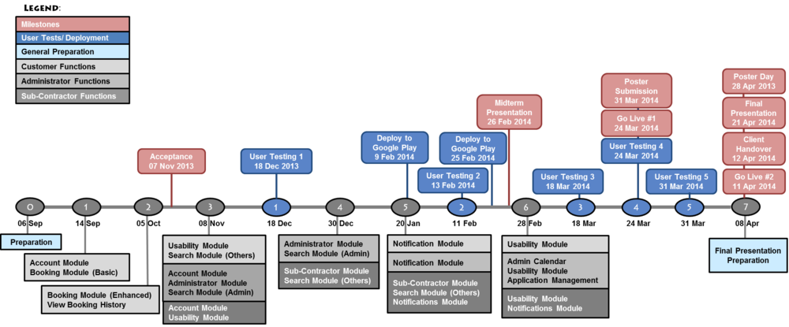

Define the iteration breakdown with functions/features list and user testing. List specific dates for your milestones! You should plan to demo your system during project acceptance, midterm and finals, include user testing, deployment and releases. Each milestone should have clear goals/functions. Note that each module should map to the priority scope

Risks:
Identify assumptions and risks particular to this project, stakeholders, schedule, team, technology constraints, etc. Do not put generic risk, such as “requirement may change”, unless it is specific to the sponsor. List mitigation steps.

Resource and reference:
What do you need? Training on programming (list books, web pages, hardware, software, gadgets, contact, client time, tester time, supervisor time, training course, money, trips), etc. Described the technology that you will be using (programming language, frameworks, APIs, platforms, OS, etc).

Team without a name will be given a horrible name such as NoName1 and you will not be able to change your team name.
To be assigned by course coordinator

