Team Logo/Graphics

IS483 (FT track/major) Project Proposal
Project Title

Team Name

Track

Version Number
Date

Team Members:
- Name (email address) – Role
- Name (email address) – Role
- Name (email address) – Role
- Name (email address) – Role
- Name (email address) – Role

Faculty Supervisor:
- Name

Sponsor and/or Clients (if any):
Organization
Department
- Contact (email address) - Role
- Contact (email address) - Role
- Contact (email address) - Role

Project Overview
Please include all necessary information you know at this time to help us evaluate the scope, viability, plan, risks, etc. Do NOT exceed 2 pages excluding the front page. No appendix. Any diagrams, schedule, learning outcome, etc. must be placed in the IS483 wiki. Do not write anything in this section.

Project Description:
Summary of the goal: What are you building {brief, about 3 sentences}? For the FT track/major, your application must be related to financial technology. You will be building an application for a traditional financial services provider, or for a FinTech alternative company which intends to disrupt traditional financial services providers. Be SPECIFIC. Don’t just say you are going to build a FinTech app. What FinTech app?

You should describe your proposed new innovations, for example; new innovations in the use of technology (blockchain, AI, microservices architecture, etc.) applied to financial services.

Put the details in the IS483 wiki.

Motivation:
Why? What is the reason for doing this? This section could be merged with project description. Do not repeat the description; do not use vague adjectives (best, user friendly, commercial quality, scalable, interactive, one stop, efficient, improve productivity, etc.). Each of these adjectives must be quantify, otherwise, you will lose credibility. Do not claim everything, it does not solve all problems.

Stakeholders:
Sponsor | Who initiated the project? Be specific about any relationship between the sponsor and the team. What is your contact person’s role in the organization? Is it a faculty member, CEO, manager, liaison, etc.
User | Is the user different from the sponsor? Who is your user? If it is not a person you know, describe the user persona for each user role (e.g. admin, buyer, seller). Projects with no sponsors require a listing of the targeted users for beta testing.
Advisors/Practitioners/Mentors | Are there other parties involved in the project? What is their relationship to the project? What interest do they have to the project? Remove this if not applicable.

For the FT track/major, your project sponsor should be (1) any FI sponsor or (2) any sponsor / any industry, described as follows:

(1) Any Financial Institution as project sponsor, including:
- Traditional bank (DBS, JPMC, etc.)
- Traditional payments system (VISA, Mastercard, etc.)
- FinTech alternative financial services provider (TransferWise MoolahSense, etc.)
- Faculty sponsor (eg; build an application for SMU tBank)
- Self-sponsored - for your own FinTech startup company (external Mentor required for this)

OR
(2) Any sponsor (any industry), where the project scope implements technologies covered under the FT track courses, including:
- Service-oriented Architecture (SOA)
- Microservices-based architecture (MSA)
- Business Process Management (BPM) engines
- Business Rules Management (BRMS) systems
- Enterprise Data Warehouse (EDW)
- Master Data Management (MDM)
- Low-Code Development Tools
- Blockchain
- Financial Analytics (e.g. for corporate finance)

Deliverables:
Outcomes: What is delivered (deployed) to the sponsor? Is it a proof of concept? Or release for live usage?
Value Statement: What does the sponsor get out of this?

Scope:
Place the priority scope in the following format. This example is from team Kinetic.
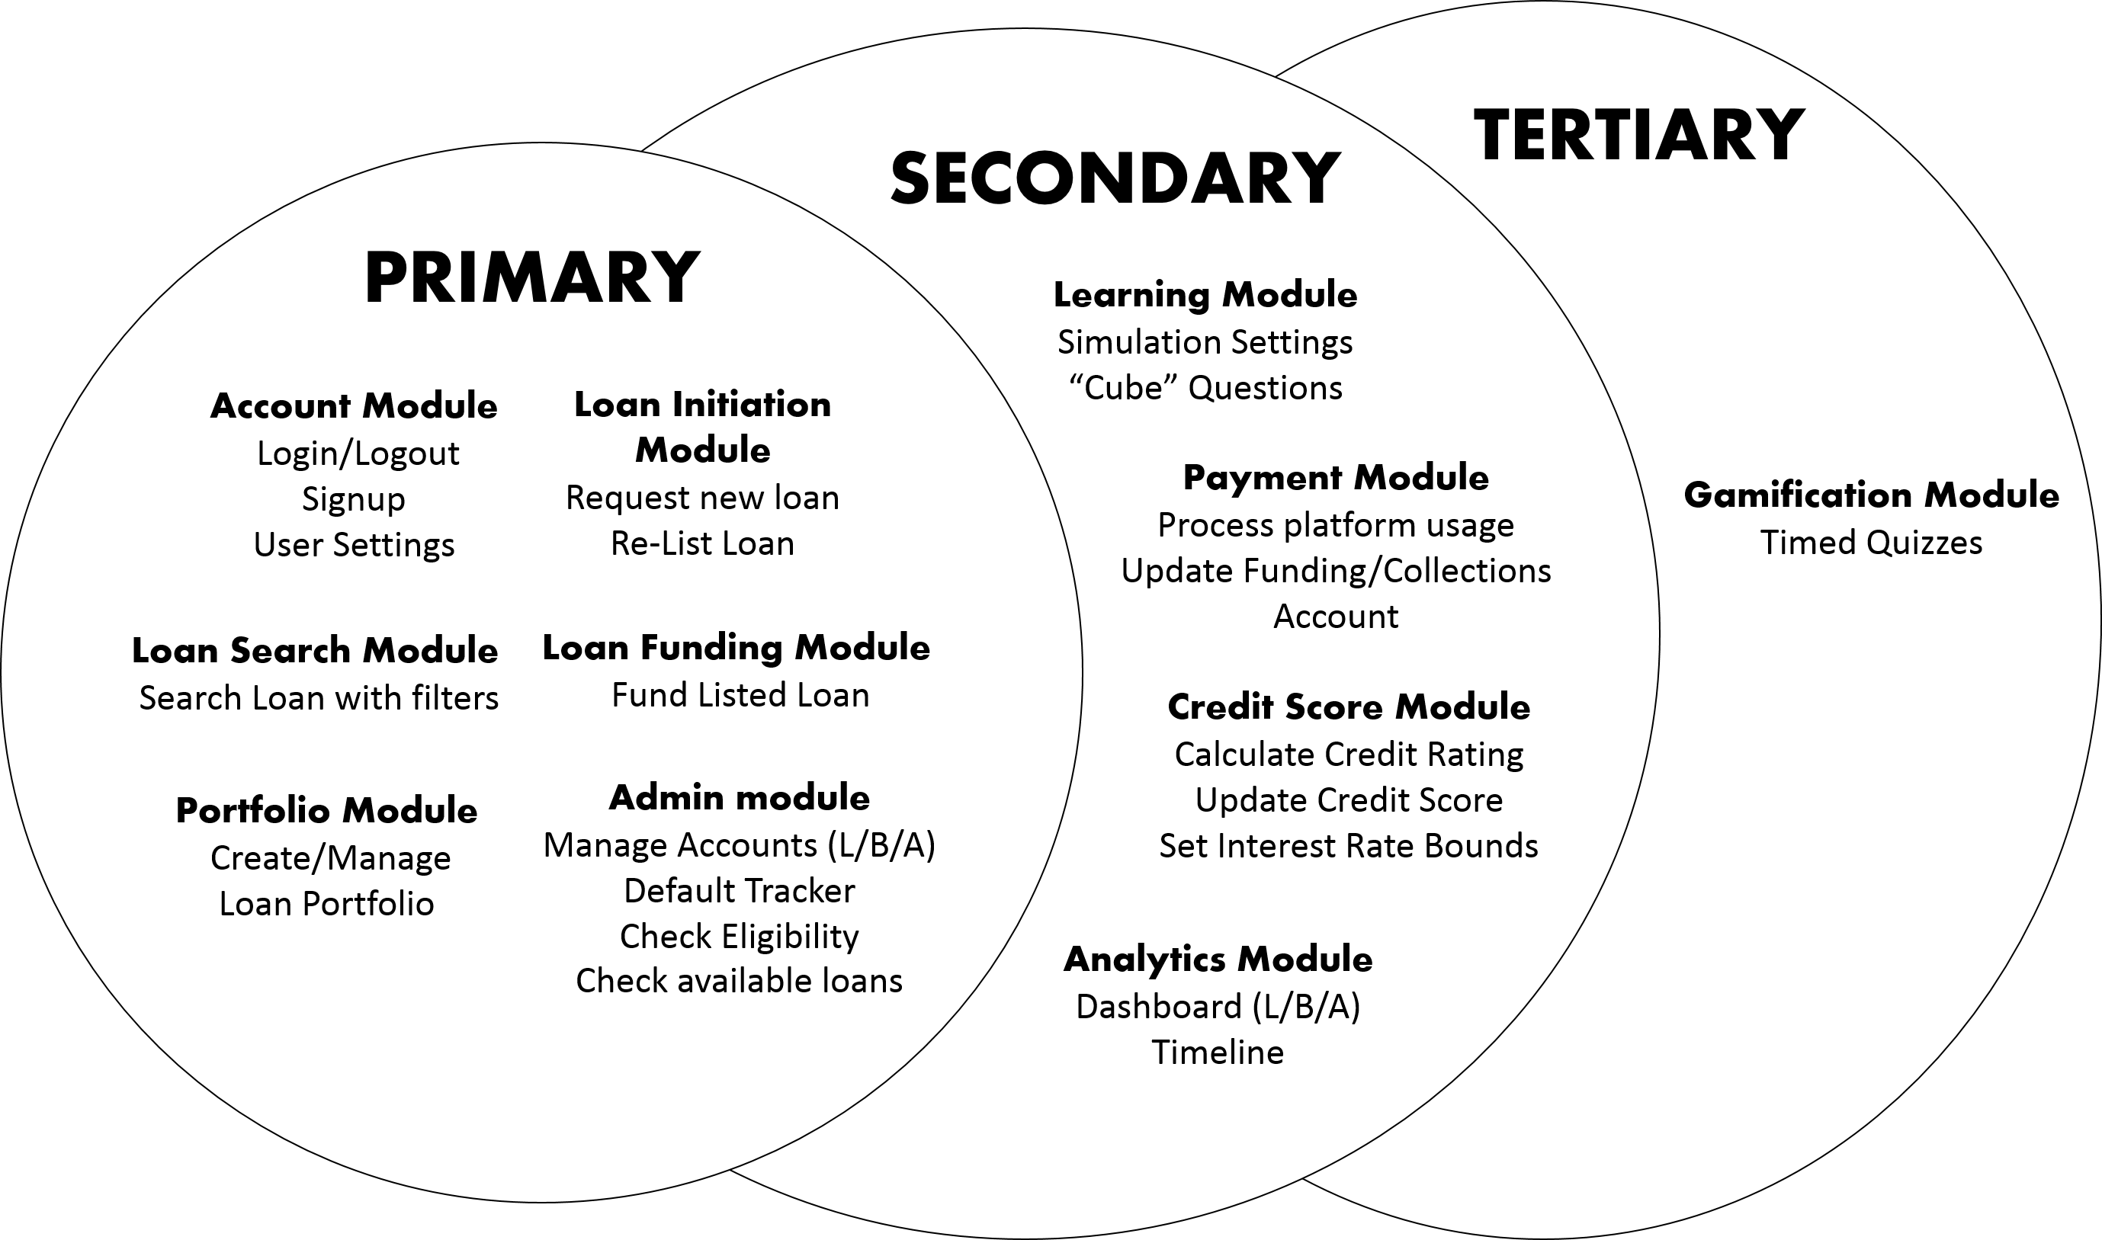
Briefly explain the scope, constraints and assumptions here.

List the functions; storyboard, use case diagram, process diagram, UI mockup/paper prototype, design diagram in the IS483 wiki. Use the diagrams only if it helps explain the scope. Use architecture diagram if necessary to show interface to 3rd party tools/frameworks, existing system API, concurrent team dependencies, etc.

Project Plan
This plan describes the resource, schedule and major risks. The plan provides a basic execution description of the project based on current knowledge of the project.

Project milestone:
Define the work breakdown structure with key milestones. Use a project timeline.
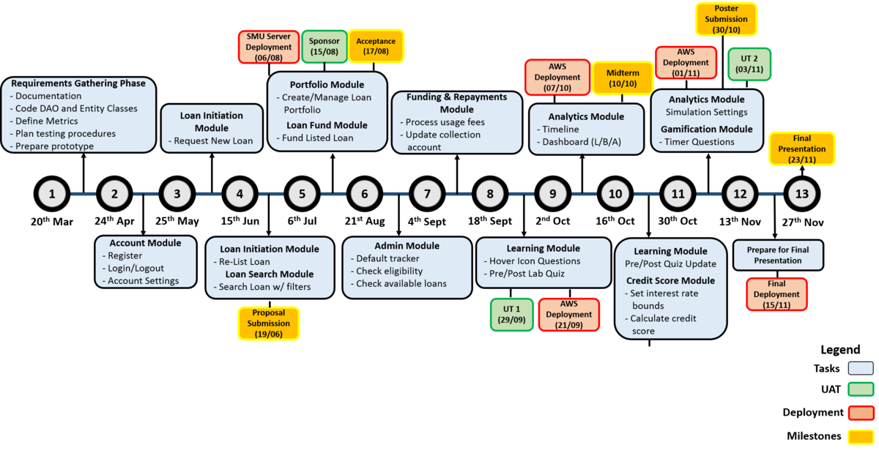
Define the iteration breakdown with functions/features list and user testing. List specific dates for your milestones! You should plan to demo your system during project acceptance, midterm and finals, include user testing, deployment and releases. Each milestone should have clear goals/functions. Note that each module should map to the priority scope

Risks:
Identify assumptions and risks particular to this project, stakeholders, schedule, team, technology constraints, etc. Do not put generic risk, such as “requirement may change”, unless it is specific to the sponsor. List mitigation steps.

Resource and reference:
What do you need? Training on programming (list books, web pages, hardware, software, gadgets, contact, client time, tester time, supervisor time, training course, money, trips), etc. Described the technology that you will be using (programming language, frameworks, APIs, platforms, OS, etc).

Learning outcome:
The team is responsible for defining the learning object in the IS483 team wiki pages. This section is not required in this proposal.

Team without a name will be given a horrible name such as NoName1 and you will not be able to change your team name.
To be assigned by course coordinator
A team wiki will be provided once the team name is provided to the course coordinator

