Team Logo/Graphics

IS485 Research Project Proposal
Project Title

Team Name

Track

Version Number
Date

Team Members:
- Name (email address) – Role
- Name (email address) – Role
- Name (email address) – Role

Faculty Supervisor:
- Name

Project Overview
Please include all necessary information you know at this time to help us evaluate the scope, viability, plan, risks, etc. Do NOT exceed 3 pages excluding the front page. Appendix can be used for preliminary findings or diagrams.

Project Description:
Abstract
Summary or abstract of the project. What research problem and sub-problems do you intend to solve using your solution? Take each problem and elaborate. Each student in the team must be responsible for one research sub-problem. You can have research questions for each sub-problem.

Motivation
Background of the topic.
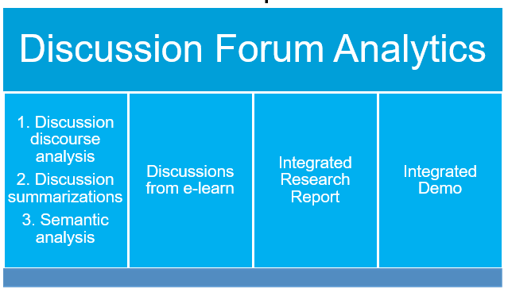
What is the problem? What is the reason for solving this problem? Describe the sub tasks and challenges to the problem. What are the current approaches if any to solve this problem? What are the limitations with the current approaches? What challenges the RQ poses? What is the related work? How you are using these related works for your problem? Indicate the research questions or hypothesis clearly in this section.

Research Methodology
Details of procedures, method, data collection, data analysis etc.
What methods should be used to conduct the research? Why you choose this methodology? How the data collection is done? What are the limitations or challenges with the data? What solution models or approaches you propose for such problems? Is there any IRB requirements? If you already have the data, describe the data.

Preliminary findings
What is the exploratory analysis of the data? What is analysis of the experiment settings? New findings on the analysis

Deliverables
Research final integrated report and demo are compulsory deliverables. Apart from that, what else you intend to deliver at the end of the project? Industry papers? Code for public?

Project Plan
This plan describes the resource, schedule and major risks. The plan provides a basic execution description of the project based on current knowledge of the project.

Task | Elapsed Time (in days) | Start Date | End Date
Literature Review
Data Collection
Data Preprocessing and Cleaning
Labeling of Dataset
Analysis and Solution design x
Coding and Experiments
Evaluation Results
Dashboard development/Testing
Report
Integrated Dashboard (demo)
Final Integrated Report and Poster
Figure: Example timeline

References
List of references

Team without a name will be given a horrible name such as NoName1 and you will not be able to change your team name.
To be assigned by course coordinator

