MEETING MINUTES #4– INTERNAL

Date/Time
Venue
Meeting with
Attendees
18th January 2017 – 2 hours
Library P.R 4.3
Internal
Akshita Dhandhania, Aayush Garg, Prekshaa Uppin
Agenda
- Discuss more survey questions to add
- Read research paper provided to us by our project supervisor - Prakash

Point made by | Notes | Follow – up Action
 |  | Task | Person(s) Responsible | Due Date
All | 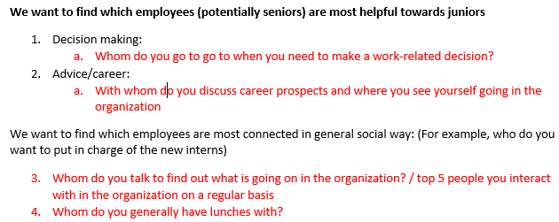  - In the previous meeting we came up with a few additional questions based on the sample survey provided by the client. For e.g.  Link to sample survey provided by client:  https://qtrial2016q3az1.qualtrics.com/SE/?SID=SV_0NvxXOLJzQzYCZn  This meeting, we thought the questions we had come with overlap each other in certain ways, or provide information that are unrelated to each other.  Instead, based on the 5 main topics provided to us by our client, we decided to divide up our questions under each category and then assess how well the questions are structured.  - Make notes on what could be applied to our project from the studies we were reading, especially regarding sentiment analysis for our subject line analysis and text mining. Further research. | Continue reading the papers and check if similar methods could be applied to our analysis | All | 22nd January 2017
 |  | Read Rob Cross’s and Karen Stephenson’s works – understand what’s been done in the field, and we could learn from them | All | 26th January 2017
Meeting minutes prepared by Prekshaa Uppin
Minutes has been vetted by Akshita Dhandhania, Aayush Garg

