Week 5

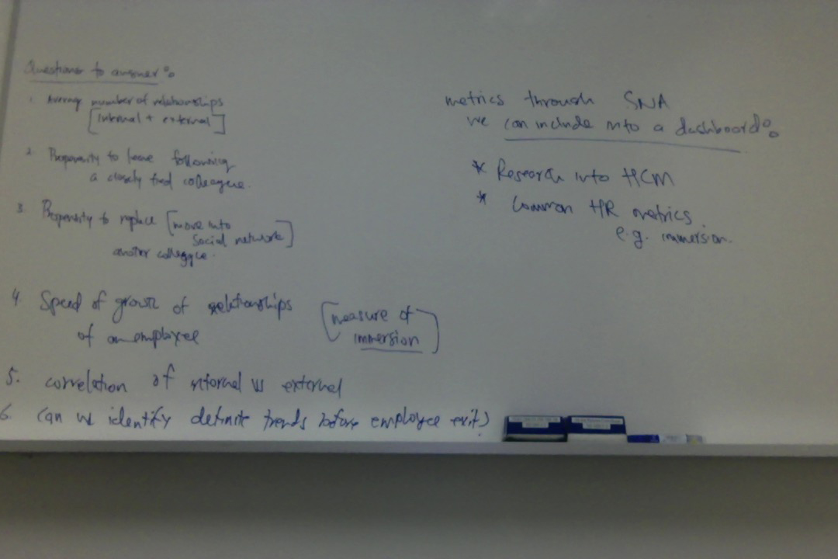

-Conducted secondary research to learn more about terms and processes involved in social network analysis and other advancements in the field.

Degree
Degree is the simplest of the node centrality measures by using the local structure around nodes only. In a binary network, the degree is the number of ties a node has. In a directed network, a node may have a different number of outgoing and incoming ties, and therefore, degree is split into outdegree and indegree, respectively.

Betweenness centrality
Betweenness centrality is an indicator of a node's centrality in a network. It is equal to the number of shortest paths from all vertices to all others that pass through that node.
A node with high betweenness has great influence over what flows -- and does not -- in the network.

Closeness
Closeness is defined as the inverse of farness, which in turn, is the sum of distances to all other nodes (Freeman, 1978). The intent behind this measure was to identify the nodes which could reach others quickly. A main limitation of closeness is the lack of applicability to networks with disconnected components: two nodes that belong to different components do not have a finite distance between them. Thus, closeness is generally restricted to nodes within the largest component of a network.
- Considered the use of R (library: igraph): Used to create routines for simple graphs and network analysis. It can handle large graphs very well and provides functions for generating random and regular graphs, graph visualization, centrality methods and much more. We considered using this because our analysis requirements fit well into what igraph has to offer.
- Looked at online resources to learn how to use R
- Constructed a few graphs on the library
- Even though these graphs have an interactive feel, they don’t really tell you much. Getting the network statistics out was also a big challenge for us. Over and above all of this, the graphs looks really bad.

