Internal Meeting Minutes 5
Date: 11th February 2018
Present: | Russell, Weilun, Jing Ying
Venue: | Russell’s Place

Agenda
- Basic Exploratory Data Analysis on Inbound and Outbound reports
- Understand and compare our dataset with Team Skulptors’ dataset by looking at what they have done previously
- Update Wiki
Time | Details | Person In Charge | Status
15:00 | Met at Russell’s place and split up the agenda for today amongst us such that Weilun will focus on EDA for Inbound reports and Outbound reports by using Python while Russell and Jing Ying will focus on understanding Team Skulptors’ project, including their data, visualizations etc. and see how similar or different is their project from ours. This can also help us find out questions to ask our sponsor as well.
16:30 | Found out that there are duplicated data for Inbound report and missing data for Outbound report. Also, we have some questions regarding some of the columns e.g. Trans Code and SO Post Date. Also, the column ‘no. of lines’ is much more in 2015 than in 2016 and 2017 so we were wondering if there are changes in the way data is stored after 2015. All the questions which we will ask our sponsor will be stated at the end of this minutes. Also, there are data with 2018 under DP Created Date and other columns as well which we are intending to remove as it is irrelevant to our project.
18:30 | After continuing to write our proposal, we also started to update the Wiki page regarding our data, work plan, change management etc.  We also discussed about the limitations which we felt that the dataset given by our sponsor.

Questions to ask our sponsor:
1. Why would there be more than 1 no. of lines in inbound report per row of data? This is because in the inbound report, there are cases where there could be 4 line items?
2. Outbound QTY is quantity per carton or quantity per order? means if QTY 500, cartons 10 means total 5000 products or 500 products only?
3. Was there a change in the process of how the number of lines is being recorded? This is because in 2015, there were many cases where the number of lines is greater than the max of 2016 and 2017. There are some charts below to show the trend.
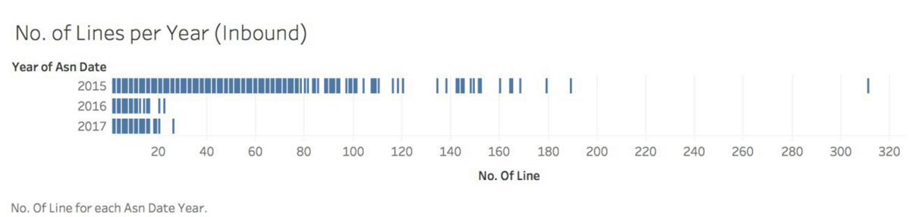
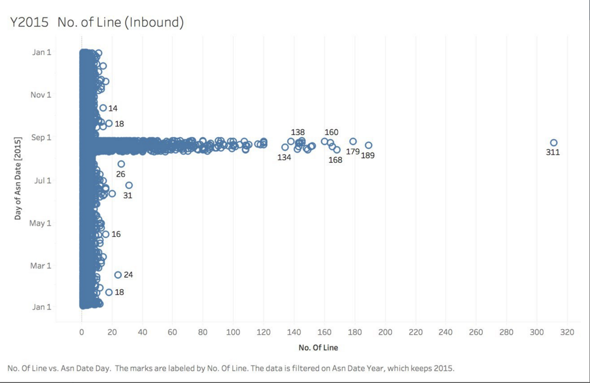

4. Where are the outbound trans code definition for: OOT, OTA, OVT and SO Post Date?
5. When did you move from the old operations to the new operations?
6. I have attached 2 files,
- one which has all the duplicates over the 3 years, the previous team that did the ABC project said it could be due to double scanning. Is this true?
- one which has the missing data over the 3 years, I am unsure of why there would be missing data so it would be good if you can help shine some light on this matter.

Upcoming To-Dos:
1. Do more EDA for Inbound and Outbound reports to clearly understand each column of the data, and update Wiki on that
2. Update Wiki for Project Management
3. Discuss on possible Visualizations after we understand more about the data
4. Meet up with sponsor to discuss more after we have a clearer understanding of the data to see if what they want to be done can be done

