ANLY482 – Analytics Practicum
Proposal Report

14th January 2018

Prepared for Dr. Kam Tin Seong

Group 22: DHL Freighters

Dong Ruiyan
Nicholas Teo Pei Sheng
Zhang Qian

Contents Page
Table of Contents
Overview 3
Sponsor Background 3
Project Introduction 3
Motivation 3
Objective 4
Data 4
Bid Information 5
Shipment Information & Transit Time 5
Methodology 6
Literature Research 6
Analysis 6
Scope of work 7
Work plan 8
Milestones 8
Gantt chart 8
Reference 9

Overview

Sponsor Background
DHL is one of the largest logistics and transportation companies in the world, providing international express, freight transportation, e-commerce and supply chain management services to over 220 countries and territories worldwide, and employing approximately 510,000 employees. In the fiscal year of 2016, DHL’s revenue was over 57 billion euros. A key part of DHL’s business relies on the success of its freight transportation, delivering shipment via various modes of transportation through the air, ocean and road.

Project Introduction
This project aims to study into a critical factor behind DHL’s success as a freight transportation service provider: the price of its corporate shipping contracts. Contract bidding refers to the process of DHL submitting a tender to secure a corporate contract in order to provide its freight services to a company. To secure its shipping contracts, DHL has to go through several bidding rounds with competitors, which include major players such as UPS, Fedex and other companies in the same region. By discovering insights into the factors affecting the bidding price for its shipping contracts, this better allows DHL to understand the thought process and motivation behind the bidding results of its customers, across various industries as well as different countries, and potentially better prepares them for negotiation with their customers for future contract bidding rounds by offering better terms which are of greater concern specifically for different types of customers, thus enabling them to have a higher chance of earning contracts and reaping more profits.

Motivation
Logistics has always been a huge industry, and even more so with rapid technological advancements since the 21st century.

Given DHL being one of the largest companies in the logistics and transportation industry, it faces stiff competition from its competitors from other major companies such as Fedex and UPS, as well as local and regional companies who are more price-competitive in their region of expertise. Contracts with corporate companies in particular, take into account several factors when choosing their shipping partner, such as efficiency of delivery in terms of time taken, and this in turn includes other factors such as the ports which DHL will use for the delivery and the mode of transportation, such as air, ocean and roads.

Being students in the Analytics track, this project provides us the opportunity to utilise the skills learnt from the theory taught in school and practice them from an actual dataset out in the industry. We hope to understand and gain insights into how DHL maintains its competitiveness, with factors such as service, competitive pricing and brand power affecting the bid price of its contracts, which in turn affect its revenue and profit.

Objective
The main objective of the project is to help DHL better understand the various reasons behind the final bidding result for their contracts. We aim to explore and determine trends behind the bidding prices at different times of the year, and identify factors behind the differences in pricing, by analyzing into factors such as seasonality, different bidding habits of companies in different industries, differences between customers’ expected prices and actual bid prices, differences in expected and actual shipping times and so on.

Some of the salient questions we have include:
- What determines DHL’s winner ability in the market? Apart from competitive pricing, to what extent do factors like service reliability (in terms of speed of delivery), expertise (varying in different countries and territories) affect the overall revenue?
- Many different sectors of customers are involved, such as Technology, Life Sciences, Retail and more. How do the different sectors decide on their buying criteria? What is the difference in price sensitivity across the different sectors?
- To what extent external, uncontrollable factors such as seasonality, natural disasters or big events affect the sales?
- Does the location which the company resides in allow them to exhibit stronger brand influence in the region? (Differences between DHL Singapore, DHL China, DHL USA and so on)

Our main objectives are:
- Identify possible clusters based on sectors of customers or requirement of customers in terms of speed of delivery or special services.
- Identify possible seasonal patterns of customer target price and bidding results using time series analysis.
- Identify possible relationships between customer’s sector, speed of delivery and other factors which affect the bidding results.
- Identify patterns of the difference between customer target price and bidding results, and patterns of the difference between customer required transit time and DHL provided transit time.
- Provide meaningful visualizations which explain and account for the bidding habits of different customer profile groups。
- Develop a predictive model for DHL to be better prepared for future contract bids and optimize their pricing strategy for greater profit.

Data
The dataset is provided by DHL in excel format. Each excel file contains the bidding price and bidding result for one customer. Each row represents a shipping Lane. It contains bid information, shipment information, transit time, origin charges, main leg charges and destination charges. Usually, the total bidding price for that lane will be the sum of origin charges, main leg charges and destination charges.

Some relevant columns are listed below:

Bid Information
- DGF Lane ID: ID of the lane
- Award Status: Whether or not this lane is awarded
- Level of Award Status
- Start Date of Rate Validity
- Expiry Date of Rate Validity
- Pricing Round
- Target Lanes (yes/no)
- Customer target rate level
- Existing lane (yes/no)
- Origin Region
- Origin Country
- Origin Customer POL: Origin port of loading specified by customer
- Origin Port (To be used for pricing): Origin port used by DHL
- Destination Region
- Destination Country
- Destination Customer POD: Destination port of discharge specified by customer
- Destination Port (To be used for pricing): Destination port used by DHL

Shipment Information & Transit Time
- Frequency per year
- Total TEUs: Quantity of goods transported
- Customer Requested Transit Time in Days
- Transit Time Total in Days: Total transit time offered by DHL
- Shipping Terms
- Equipment type: Type of container

Origin Charges | Main Leg Charges | Destination Charges
Origin Pickup Charges | Freight | Delivery Charges
Origin Fuel Surcharge | Bunker Adjustment Factor | Destination Fuel Surcharge
Origin Chassis Usage/Rental Fee | Currency Adjustment Factor | Destination Chassis Usage/Rental Fee
Origin Administrative Handling | Low Sulfur Fuel Surcharge | Destination Administrative Handling
BL Charges | Port Congestion Fee | Destination Document Handover Charge
VGM Administrative Fee | Piracy Risk Fee | Destination Demurrage Fee
Export Customs Clearance | Canal Surcharges | Import Customs Clearance
Origin Security Filing Fee | Main Leg Other Charges | Destination Security Filing Fee
Origin Seal Fee |  | Destination Detention Fee
Origin ISPS Fee |  | Destination ISPS Fee
Origin Wharfage Fee |  | Destination Wharfage Fee
Origin Terminal Handling Fee |  | Destination Terminal Handling Fee
Origin Other Charges |  | Destination Other Charges

Methodology

Literature Research

To attain more knowledge into the factors affecting freight prices, we first did general research to understand the different causes. An article in the Journal of Air Transport Management (Hsing-Chung Chu, May 2014) stated that “due to the increase in supply chain management and e-business practices, forwarders must handle tight schedules with frequent unplanned changes, non-fixed origins and destinations, along with special requests from shippers and consignees”. The most important factors when selecting the forwarding companies included expertise, reliability, ability to provide relevant information, company’s reputation and financial condition and price. This highlights our objective to discover from the data which of these factors are more important, and to what extent do they vary based on the customers’ profile.

Protectionism policies for domestic companies further increases the cost for foreign companies, which applies to DHL’s situation out of Europe. Another factor causing volatility is fuel prices, in which freight price is directly affected by. When commodity fuel prices are lower, freight prices are reduced as well.

Analysis

Exploratory Analysis
An exploratory analysis will be conducted to help us understand the shipping patterns and bidding results of different customers.
- Identify the major inbound and outbound region, country and city for each customer.
- Understand which transportation mode customers prefer.
- Identify patterns of the difference between customer target price and bidding results.
- Identify patterns of the difference between customer requested transit time and DHL provided transit time.
- Study the relationships between different factors and the bidding results.

Customer Analysis
We plan to categorize customers into different groups based on the relevant variables identified in exploratory analysis (referring to exploratory analysis point 5). Each customer will be assigned to a cluster based on this analysis and we attempt to have a better understanding of the buying behaviour of the customers.

Time Series Data Analysis
Because each excel file is only valid for a certain time period, time series data analysis could be conducted to discover the underlying seasonal trend in customer target price and bidding result. (Mark A. Anawis, June, 2014)

Scope of work

Phase 0: Understanding Data & Logistics Context
Metadata has been provided by our sponsor. We will firstly understand the data based on the DHL’s storage of information in its system. Besides, we will figure out the logistics terminologies that DHL uses and its business model to gain a better understanding of the data.

Phase 1: Data Cleaning
Upon gathering the data from our sponsor, we realized the complexity of the data.
- The data provided in excel format is lack of standardization. Data points for one field could have different data types. For example, the customer requested transit time is stored in number format while some records are stored in string format.
- There will be some excel formula error in the data file, such as “#VALUE!” and “#REF!”. It could be due to the broken link with reference file or not proper copy and paste.
- Some records in the excel file are incomplete.

We need to clean the data before exploring and analyzing the data. This may include but not limited to the following steps:
- Checking for outliers
- Dealing with missing data
- Removing duplicates
- Standardising and normalising data
After cleaning the data, we will be able to explore the data and conduct preliminary analysis to study the variables.

Phase 2: Data Modelling
- Exploratory Analysis
- Customer Analysis
- Time Series Data Analysis

Phase 3: Creating of Application
Once we have conducted data modelling, we will proceed to develop an application which enables users to upload data sources and provides users visualization of the customer profile based on the data provided to help them gain a deeper understanding of the customer’s bidding habits.

Work plan

Milestones
- Proposal Submission (7th Jan 23:59)
- Interim Submission (25th Feb 23:59)
- Interim Presentation (26th Feb - 4th Mar)
- Abstract Submission (1st Apr 23:59)
- Final Paper Submission (8th Apr 23:59)
- Conference Day (14th -15th Apr 9AM - 6PM)
- Final Submission (22nd Apr 23:59)

Gantt chart
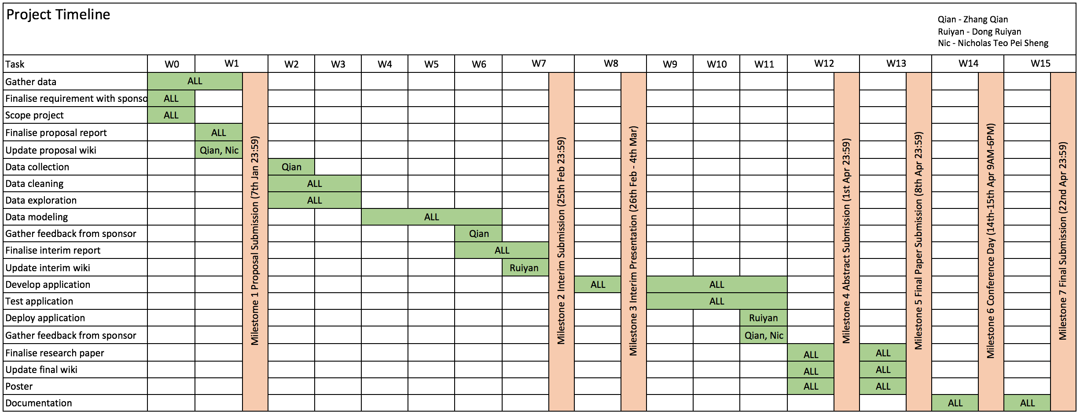

Reference

Exploring preference heterogeneity of air freight forwarders in the choices of carriers and routes, Hsing-Chung Chu, May 2014, Retrieved from
https://pdfs.semanticscholar.org/2d74/cba91d9805f8b5083ba071f908781e4e59ed.pdf

Time Series Analysis: Identifying Underlying Patterns. June, 2014, Mark A. Anawis. Retrieved from
https://www.scientificcomputing.com/blog/2014/06/time-series-analysis-identifying-underlying-patterns

How to Conduct Customer Analysis and Customer Segmentation, November, 2016. Kit Smith. Retrieved from
https://www.brandwatch.com/blog/how-to-write-customer-analysis/

