Meeting Minutes (Group Discussion #2)
Date: 03 November 2017
Venue: Skype meeting (2 members on exchange, 1 on LOA)
Participants: Aaron Poh Weixin, Leong Jia Min, Shereen Teo Boon Khee
# | Discussion Content | Purpose | Action Taken
1 | TLDR:  We can consider narrowing down to the scope of visual arts, focus on:  (A) building a channel funnel on the visitor journey for visual arts  (B) building a metric system on retention of customers  SHORT SUMMARY:  - The ultimate goal of any country to become an arts scene epicentre is to build an environment for a thriving world-level arts auction event! (taken from articles online)  - This would answer the question on how to uplift the maturity of singaporeans towards art pieces because it directly targets foreigners especially entrenched in the culture and brings them to SG. Creates hype around it which raises awareness overall as well —> similar to F1 pit event/Youth Olympics status  - This links up to SG's visual arts scene which is one of the art forms covered by NAC —> choose to look indepth at this area  There are the following categories for ‘arts and cultural events and activities’: Theatre Performances, Music Performances, Dance Performances, Visual Arts Events & Exhibitions, Literary Arts Events, Craft Events, Film, Heritage related events & activities, Community Arts events (Eg. PAssionArts).  Possibilities from new perspectives  - Looking at Population Survey, interesting questions are as follows:  - Section C (Past Attendance Patterns)  - C2. Of these, how many did you pay for entry?  - C5. Important reasons for you to attend  - C7. Whom do you usually attend arts and cultural events and activities with?  - C12. Among those that you are aware of, which of these do you identify with as arts and cultural areas  - Section D (Arts and Cultural Participation)  - D2. Which art form did you take part in  - D8. How much money did you spend on arts events?  - D10. 3 most important reasons for you to participate  - D11. Thinking about your childhood, which arts events did you attend/visit?  - Section E (Perception of Arts)  - E1. What do you think about the arts and culture scene in SG  - Section F (Lifestyle)  - F1. What are the top 3 activities that you spend most of your leisure time on?  Themes of Loyalty, Conversion of non-paying to paying, Participation rather than Attendance, How to change Consumer Behaviour wrt Arts scene in SG | One potential analysis avenue | -
2 | Art Wars (Hong Kong vs Singapore) 2009  https://www.wsj.com/articles/SB125678376301415081  Why is it so important for Singapore to become Asia’s regional arts hub? To build a super-competitive, super-productive society that can attract the world’s best and brightest professionals from an array of industries, they need a world-class arts and culture scene, says Richard Florida, who studies global competitiveness and urban development at University of Toronto.  Top cities in the world are Milan, Paris, New York and London, this edge makes the cities so robust that even at times of economic crisis, anyone in the worlds wants to go there to work. Ultimate goal for SG, who is competing with HK for the prize position.  But there's a key ingredient that Singapore so far hasn't been able to create: a big art-auction market. Some smaller art-auction houses hold sales in Singapore, but the big ones -- Christie's and Sotheby's -- have pulled out and moved their Southeast Asian art auctions to Hong Kong, the former British colony that is home to seven million people and became a Chinese territory in 1997.  For a city, having the ingredients for a thriving art market creates a virtuous circle. The powerful marketing machines of the big auction houses, including public previews of coming sales, raises awareness and appreciation of art in the community. All this encourages local artists to create more art. And that momentum, in turn, contributes to the development of a city's broader cultural scene, including music, theater and design.  "We are a financial city, so people understand money but don't always understand art," says Claire Hsu, executive director of Asia Art Archive, a Hong Kong-based regional culture think tank. "People pay attention to prices, thinking in terms of investment," she adds, so "people have become interested in art."  In 2007, Hong Kong became the world's third-largest auction market after New York and London, partly because of its proximity to mainland China and the emergence of China's deep-pocketed collectors. That put Hong Kong firmly on the global art-commerce map. The point is "about attracting the people who make it matter -- artists, critics, curators and collectors," says Eugene Tan, formerly head of Singapore's Institute of Contemporary Arts and a high-profile personality on the Singapore arts scene who recently relocated to Hong Kong. "Hong Kong has that advantage" of a collector base that "Singapore has always lacked."  Is Singapore an Arts Hub Yet? (Jan 2015)  http://thepeakmagazine.com.sg/lifestyle/is-singapore-an-arts-hub-yet-2/  After years of establishing ourselves as an urban infrastructure and business powerhouse, Singapore has a bigger aspiration: to join the ranks of the great arts epicentres of the world, such as London, Milan, Paris and New York where artists want to exhibit at and where connoisseurs go to grow their collections.  -- detailing of many efforts by NAC and Singapore Government to raise SG’s profile as a thriving arts scene → but they mention a lot of centralised planning surrounding events/ exhibitions/ museums. Just like the quote below, the government has attempted to attract the high profile artists from around the world to our arts scene to paint SG as a destination for the arts.  “While Singapore becomes a homing site for the arts, it is important that we do not just have a domestic mindset to the arts. (We should) look at how Singapore can play a role globally in the art world. Having Singapore artists, writers, curators and arts leaders working internationally as influencers of global cultural flow will help proposition Singapore as a site to learn from and be part of” – Venka Purushothaman, provost at Lasalle College of the Arts.  Beyond that, it is also important for SG to create CREATORS of art → to show that we have artitsts that work abroad (especially in countries with longer art history) to put us in the context of the world. SG therefore is interested in the ‘nurture’ aspect of arts, having an education system (etc. SOTA, LASELLE and NAFA) → there are grands, arts housing schemes and scholarships offered to help develop individual Singaporean artists. | Background Research on importance of art scene | -
3 | http://dexibit.com/  The market leader in musedata.  Over a billion people visit the world’s 75,000 museums each year. At Dexibit, our mission is to inspire more visitors to these and other cultural attractions by analyzing millions of experiences to arm cultural executives with artificial intelligence. We bring deep insight into visitor behavior with big data analytics.  Dexibit helps museums to increase revenue, decrease cost and maximize social value by using data to analyze the past, present and future. We’re here to change the way decisions are made, create value for visitors and relieve the burden of data administration.  Our team are data analysts, architects and scientists who understand museum transformation and the duties of cloud computing. We push boundaries and innovate using data. And just as a museum acts as a guardian of history, at Dexibit we take our responsibility of collecting and curating data very seriously  http://dexibit.com/home/resources/  Dexibit helps increase visitation, optimize exhibitions and maximize funding through data driven decisions. | Resource acquired online | -
4 | Based on the below screenshot email, NAC appears to reject extension of scope and prefer deeper analysis → Population Survey preferred  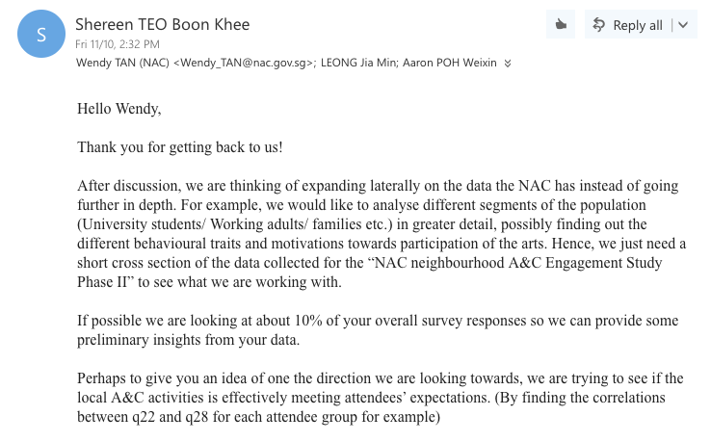 | Rejection of proposal #1 which is reflected on the left | Rethinking of project scope
