Team Meeting Minutes

Date: 3 March 2015
Time: 4pm
Attendees: Benjamin Tan, Sean Chua, Zoey Teo

Items Discussed | Action Items
Midterm Feedback
- Our motivation: dealing with temporal and spatial data and large datasets
- Include a review of the current work -- don't pretend that we are doing everything out of the box
- Findings -- quite a number of quite interesting findings. When we do our application, this is where the analytics will come in
- Our data visualization should have the kind of provision that allows us to transform the data or prepare in a different dimension -- like tableau -- provide client with an environment to compute and explore the data (not just plain display of data)
- There is clear potential for segmentation from our findings (so how are we going to multidimension segmentation using our visualization? like VA we combine box plot with parallel coordinate plot to do that) -- segmentation varies by time and country
- Just using a bubble chart is effective if you look at only one product. But if you look at all the products together then it's hard to do. Make sure this is addressed during the final presentation.

Areas where we can work on:
- Can have dynamic charts where we can define the possible choices of axes -- so they can have the choice of charts but at least it’s more controlled
- Allow user to change the data that is loaded
- End product is like educity style -- but we can also have multiple charts on a page (multi-linked)
- Can use a parallel coordinate together with cartogram

Dashboard design  Overview:  - Cartogram  - Size: market cap, population size  - Colour: value/volume & beer/packaged food/oral care…  - Can change between cartogram and choropleth  - Parallel coodinates  - Still need to have a country summary page to see the trend of each of the indicators  Components  By default we can show the consumption level by regions, the 6 boxes beside the choropleth allow users to select the specific region to zoom into  The side (population age) is for toggling the size (for choropleth) and colour (volume/value)  Toggle between choropleth and cartogram (the current map and scatter matrix)  Integration (making the charts talk to each other)  Bubble chart axes: we can choose the variables from dropdown box, x and y axis and size (total flexibility)  When the choropleth is clicked, the country will be highlighted in the bubble charts and parallel coordinate also  Keep the time bar  Story -- the same story control  Parallel coordinate -- think of how to solve the problem of outliers (e.g. China, US)  Default, show all countries. if you click on a region, the countries in the region are highlighted  Let them toggle between showing All, Economic or Demographic indicators  Histogram with the parallel coordinate  Take the Time Graph to use for country data  Reference:  http://mitweb.itn.liu.se/GAV/euro/#story=0  Our prototype picture:  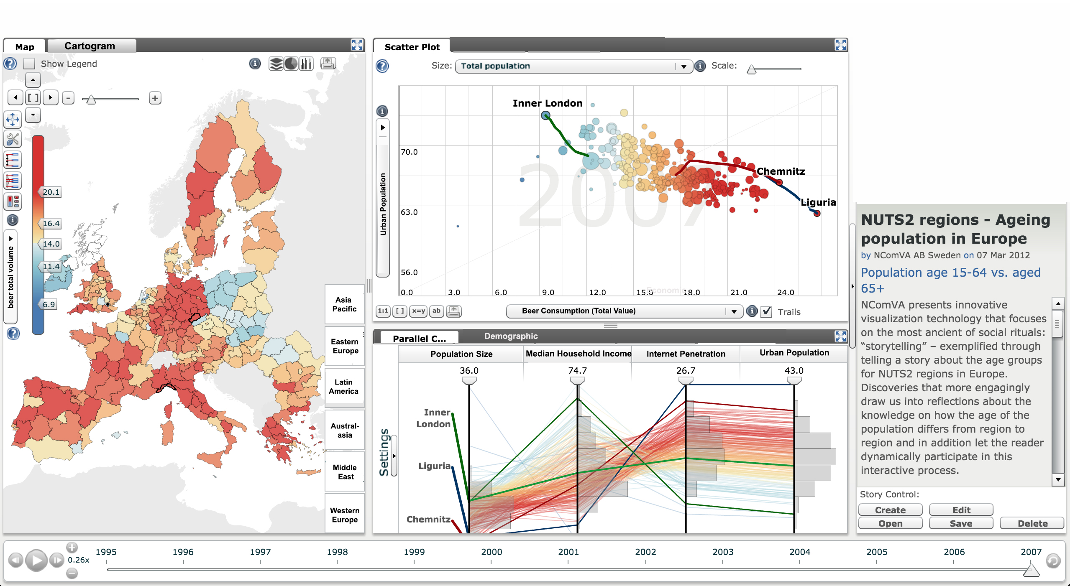 | sean - how to read the csv data into the crossfilter form  choropleth first  customizable bubble chart - ben  parallel coordinates - zoey  do up the charts first, one chart each  do the context last

