Internal Meeting Minutes 6
Date/Time | 20th Feb 2018
Venue | SIS GSR 3.4
Attendees | Eric, Ivan, Shing Hei
Agenda | - Slides Format  - Investigation on Facebook Algorithm Change

 | Task/Description | Person in Charge | Due Date
1 | Slides Format  - Introduction – Client / Business  - Data Sets (including crawled data)  - Tools used  - EDA  - Data Cleaning: For each platform:  - Data Clean  - Analysis  - Recommended biz objectives  - Analysis Result  - Biz Objectives  - Biz Objectives – List of Objective (based on discussion)  - Refined List  - LDA: why do we want to LDA – for cross-platform analysis (initial objective)  - Project Schedule, i.e. Gantt Chart  Refer to Figure 2 for slides outline.  Deadline for Slides: Monday (26th Feb 2018)  Deadline for Report: Saturday (24th Feb 2018) | All | Nil
2 | Investigation on Facebook Algorithm Change  - Only look at FB post and video files for comparison between Jan 2018 and the months in 2017  - Compare key metrics (likes, shares and comments) with 2017 and 2018 data; look at the percentage point of decline using calculated field in Tableau  (Refer to figure 1) | All | Nil

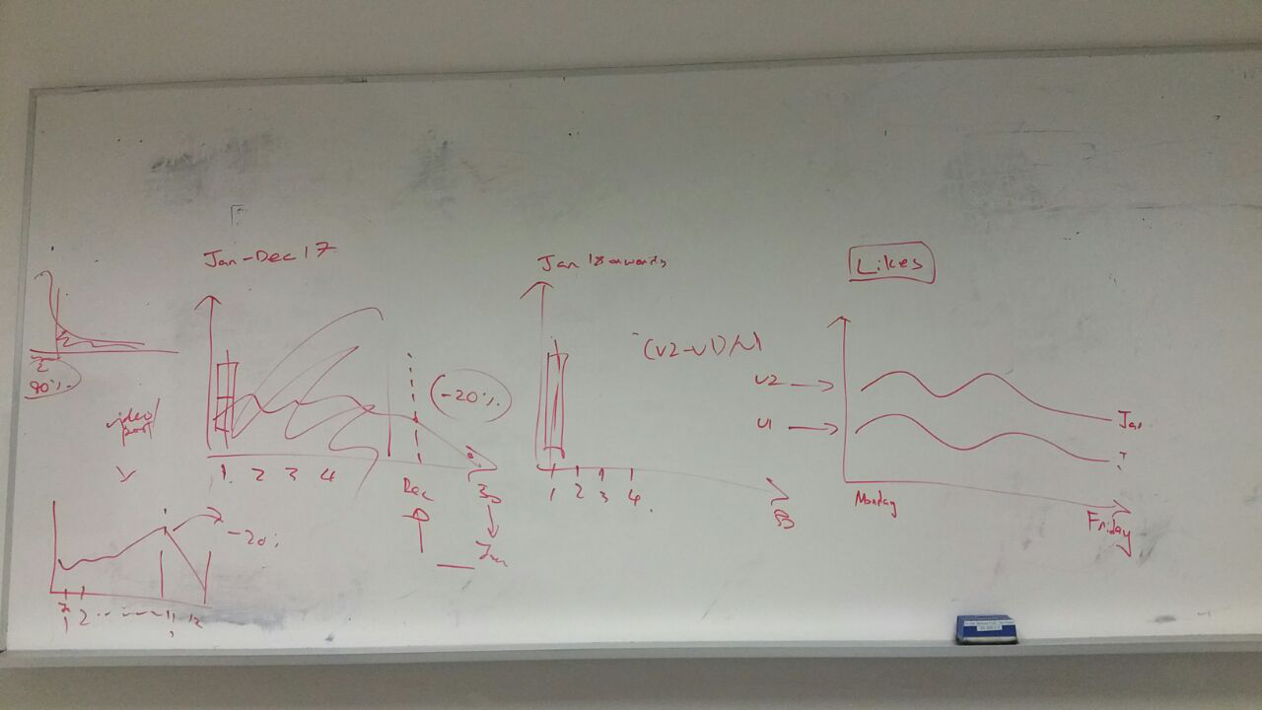
Figure 1: Facebook Algorithm Change
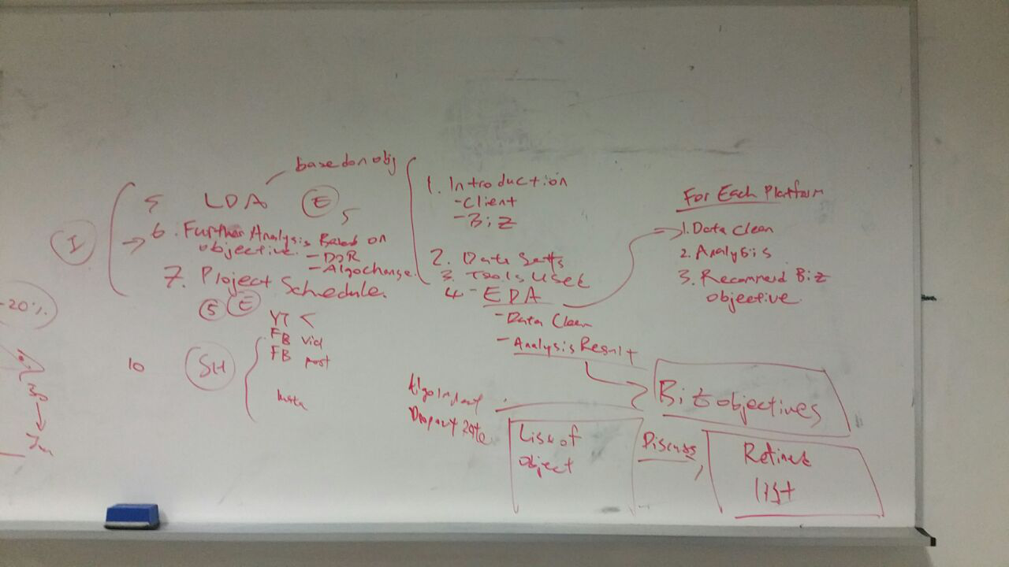Figure 2: Slides Outline

