3rd December 2016, 1.30pm – 3.30pm
SIS GSR 2-7
Agenda:
- Settle class scheduling and meeting schedules for AY16-17 Sem 2
- Understand sponsor data
- Plan proposal and split work
- Settle on software and core analysis methods
Agreed Action Plan
- Weekly meetings of at least 3 hours every Wednesday, fortnight meetings with Supervisor. Monthly meetings with Sponsor.
- Clarify with sponsor data related uncertainties
- Final Deadline for first proposal set for 23rd Dec (overseas after that)
- Core Analysis methods: Forecasting, Exploration, Geospatial, Clustering. To read up and familiarise with above methods and focus on one forecasting type
- Determined dashboard features per requested by sponsor
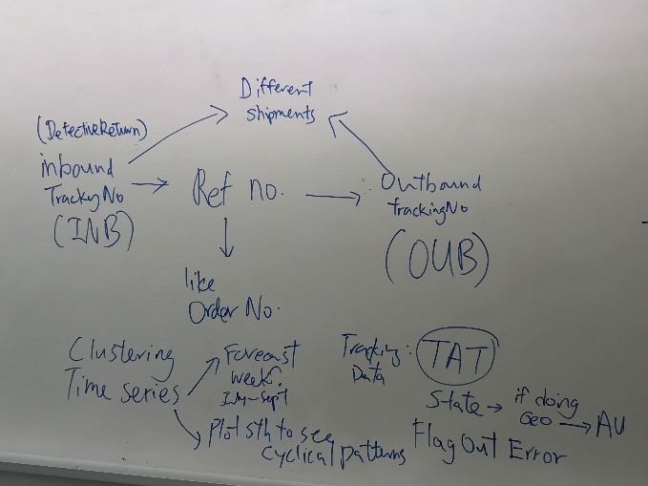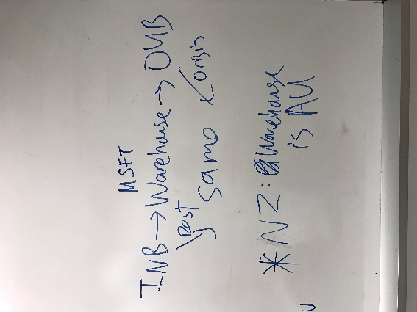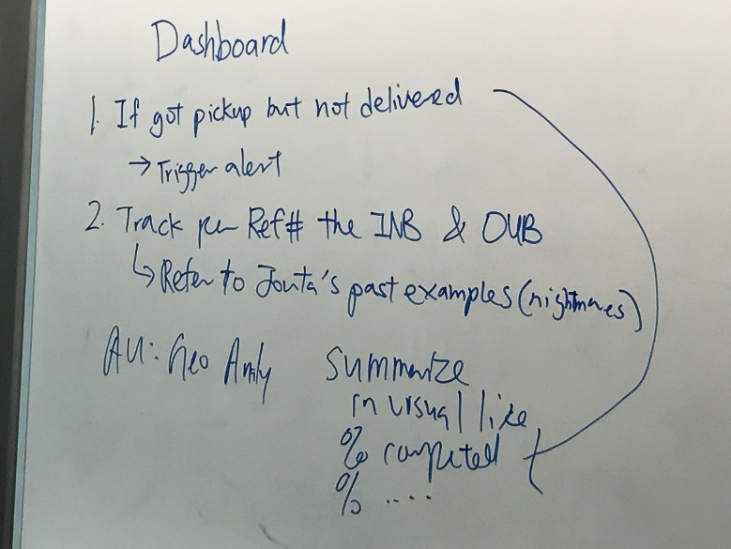
END

