MEETING MINUTES #5– INTERNAL

Date/Time
Venue
Meeting with
Attendees
22nd January 2017
Aayush’s House
Akshita Dhandhania, Aayush Garg, Prekshaa Uppin
Agenda
- Discuss the methodologies that we could use to approach the analysis of employees
- Go through previous group’s report to understand what they worked on
- SNA of email data provided – (not from API, but provided by the client earlier)

Point made by | Notes | Follow – up Action
 |  | Task | Person(s) Responsible | Due Date
All | - From the studies provided by Prakash, we discussed that one possibility would be to analyze the valence of the sentiment expressed in the subject lines of emails. However, we realized that we have a limitation of short text length with only subject line information and not the entire email text data.  So we decided that we will generate metrics to measure the different aspects our client wanted insights on such as collaboration, immersion and employee engagement.  - We went through the previous group’s report to understand what we could do differently. We found that a lot of the analysis the previous group had done was to look into strength of relationship within the company, especially of the Sales staff. They assessed their interactivity, and their relation with clients, or rather the impact of interaction on the number of successful sales activities.  If we were to also do a similar analysis, we discussed that the things we could consider would be:  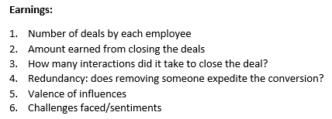  However, it is not the focus of our project.  - We decided to email the HR departments of some companies to understand what kind of insights on the employees are useful to them.  - As stressed upon by our supervisor from the previous meeting, we also did some SNA on the data we currently have. | Continue reading the papers and check if similar methods could be applied to our analysis | All | 22nd January 2017
 |  | Send out emails | Prekshaa | 23rd January 2017
 |  | EDA of email data | Aayush | 24th January 2017
Meeting minutes prepared by Prekshaa Uppin
Minutes has been vetted by Akshita Dhandhania, Aayush Garg

