Sponsor Meeting Minutes 6
Date: 27th March 2018
Present: | Russell, Weilun, Jing Ying(MC), Yen Ting
Venue: | Sponsor Office

Agenda
- Update Sponsor on progress
- Update Sponsor on the outbound volume levels of products and clarify on this
- Confirm the calculations for the ABC location calculations
- Clarify on calculation for warehouse inventory quantity with regards to the internal transfer information
- Show dashboard prototype
- Show MBA insights and see how we can work it into the dashboard.
Time | Details | Person In Charge | Status
10:00 | Russell started off by showing the mock heatmap and clarifying the logic of the ABC allocation. The initial plan was to follow the sponsors initial idea which was to use a triangle shape and just give a higher weightage to the Category A products, and then move down accordingly. A mock sample is shown below.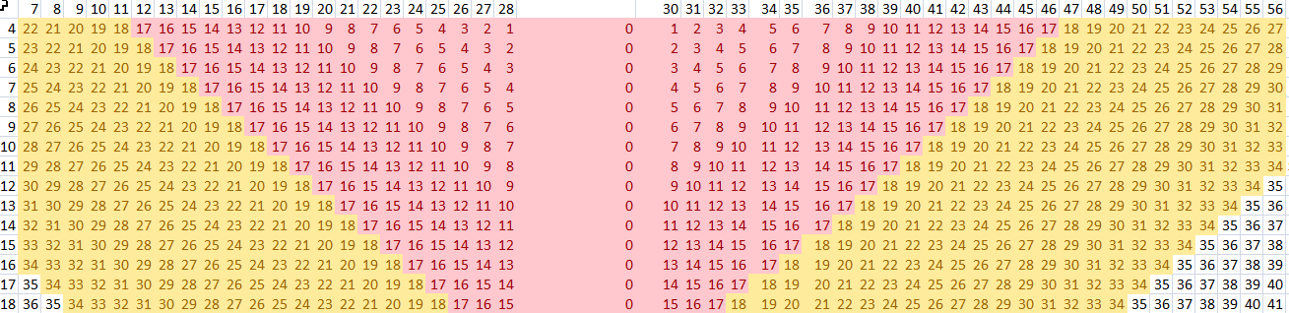  With Prof Kam's suggestion, we decided to link the proportion to the current data so as to have a data driven process in determining the exact proportion to assign accordingly. However, our initial findings were a bit off with the following findings.  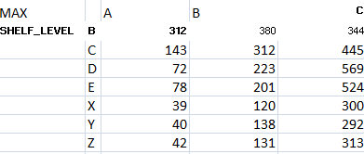  The number of unique locations used to service the operations for A,B and C products seemed way too small. Thus, we decided to look back at our data and we realized that there was an error in the way we did our ABC classification. After doing the change, we obtained a much more sensible result  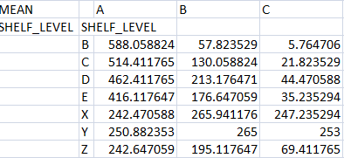  Using these figures, we will then use it to assign the ABC locations accordingly.  We decided to use the figure above which was calculated after removing duplicates as removing the duplicates would tell us the number of unique locations which were required on average to service the operations of the warehouse which would give us an close gauge of how much is required to satisfy the demand for each product category accordingly for each shelf level.
10:40 | Yenting noted that the M positions were absorbed into the original locations, meaning that the items in a location of 18X23M would be absorbed into 18X23M. However, she wants the M to be just another location.  Russell and Jing Ying to adjust their outputs to reflect the new rows accordingly.  Instead of just 7 to 56, there will be rows such as 26M and so on.  Weilun to do up the script to generate the new rows. | Weilun to use the script to generate the new shelves.  Russell to redo the allocation of the location to include the new M locations  Jingying to adjust the dashboard to reflect the new shelves accordingly
11:00 | Weilun clarified about the inventory report as he was still encountering negative balances which should not be the case.  Yenting said that the weilun should match the inventory data in order to obtain the snapshot data. Weilun has to match all the information from internal shifting, QA and damaged because the balance given to us includes all type of inventory. | Weilun to do up the changes accordingly and see if there are any changes.
11:20 | Russell went through the MBA analysis and discussed the findings accordingly. There were duplicates such as those shown below which resulted in very massive lift scores which were useless.  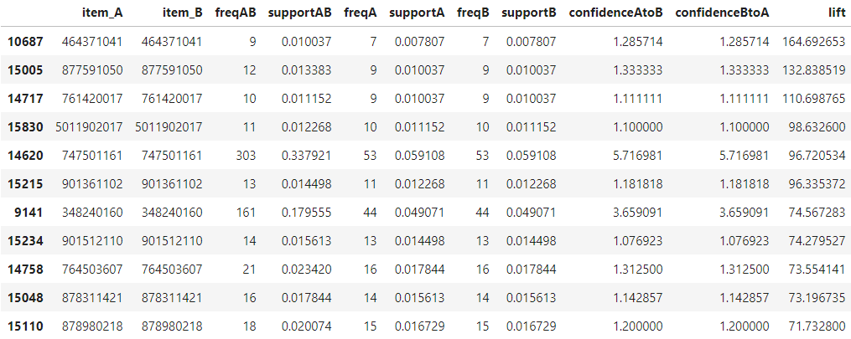  This was because for one order, the same product can be allocated to multiple places, therefore, it resulted in such a result. Russell is to remove the duplicates so that we can get a more accurate MBA analysis.  We told Yenting that we would incorporate the MBA into our recommendation model so that products which have high lift scores will be placed together.  We will also set an adjustable threshold level so that users will be able to tweak the MBA results accordingly to what they want. | Russell To implement
11:30 | Lastly, group is to take note that what happens if there are no possible location to place an item based on the ABC classification. We have decided to just overflow it to the next category. For example, if a Cat A product has no space in the A category location, it will then be placed in the B category locations and so on. If there is really no place, then it is up to human to make their own judgements. | Russell to implement.

