MEETING MINUTES #5– SPONSOR

Date/Time
Venue
Meeting with
Attendees
9th March 2017, 02:30PM
Phone call
Ridwan Ismeer
Aayush Garg, Prekshaa Uppin, Akshita Dhandhania

Agenda
- Changes to be made for the survey

Point made by | Notes | Follow – up Action
 |  | Task | Person(s) Responsible | Due Date
Ridwan | - Rephrase the questions for each network. Make it more specific and direct.  - Define the duration (time-frame) for which each question applies to  - Change question 4 in network to allow respondents to rate their communication level on a fixed scale rather than allowing them to provide the number of day  - Structure of survey | Change question 4 | Aayush, Akshita | 9th March 2017
Ridwan | - Remove question for ‘Strategic network’ as it seems overlapping  - Removing redundant questions that ask respondent’s location and department  - Update employee list to include recent hiring process and employees who recently left the company.  - Improve instructions to respondents on the scoring scale  - Include 4 main networks – e.g. questions: who do you work with, who do you to for expertise and knowledge/ test ideas/ guidance and advice.  Choose main network from the following. This is want our client wants us to observe from the survey:  - Daily Network (Work Network)  - Wider Social Network  - Innovation Network  - Expert Network  - Strategic Network  - Learning Network  We noticed that even within these networks, some aspect overlap. After discussion with the sponsor, we finally included the following -  Final questions:  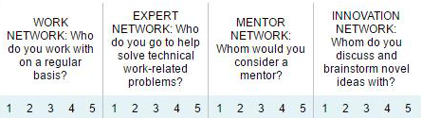 | Fine tune survey | Prekshaa | 13th March 2017 – release date

Meeting minutes prepared by Prekshaa Uppin
Minutes has been vetted by Aayush Garg, Akshita Dhandhania

