Meeting Minutes (Sponsor Discussion #2)
Date: 11 November 2017 – 8 Jan 2018
Venue: Email Correspondence
Participants: Leong Jia Min, Wendy Tan
# | Discussion Content | Purpose
1 | Hello Wendy,  I hope you are well and rested after your business trip!  After further discussion, we would like to present the following proposal. Given that we are still in the preliminary phase, our team would like to seek your comments on our current direction, especially in terms of relevance to National Arts Council and feasibility based on available data.  The following is a quick summary on our approach:  - Beyond using analytics to ‘watch’ NAC’s impact on a post-event basis, we are looking to use benchmarking analysis to forecast customer satisfaction and also, predictive analysis to drive customer loyalty.  - Focus on using data from the Population Survey (as per your suggestion)  - Forecasting Customer Satisfaction - (A) Engagement: How do we create experiences?  The value in building a channel funnel on visitor journey in art events/performances is to find out the strengths and weaknesses of SG’s arts scene. Using variables like “Whom do you usually attend arts and cultural events and activities with (C7)” (social factor) or “3 most Important reasons for you to attend (C5)” (code each variable as a different factor), we aim to formulate an in-depth analysis of expected versus perceived satisfaction by SG public on arts events.  To further add depth to analysis; we could benchmark against a world-class arts scene such as London/New York to draw inspiration in how the respective cities actually measure customer journey in terms of what metrics they use. To do this, we may possibly look into doing a focus group, followed by quantitative survey of SG students who went on exchange in Europe AND have also attended local arts exhibitions.  - Drive Customer Loyalty - (B) Retention: Creating a metric system to measure loyalty of customers  We are interested in building a holistic metric system/equation for the measurement of loyalty, with the key objective to understand what drives retention. Using the Population Survey, existing factors such as "how many did you pay for entry (C2)", "are you likely to increase, maintain or decrease the current frequency at which you attend… activities (C11)", "How much money did you spend on arts events and activities in total (D8)” are key variables to input within the framework. The general framework would be constructed by exploring the various ways to exhibit loyalty; some examples include repeat visits, participations in exhibitions, social media/monetary contributions.  Further avenues to explore are to use data mining to find out online social media buzz via access to NAC Facebook and Instagram analytics in an attempt to input real-time information/sentiment analysis within the equation.  - Potential Areas for Development - (C) In-depth Analysis  Given that NAC is currently host to several different arts and cultural events and activities, we may consider narrowing down scope to individual sectors or demographics as add-on analysis after developing A and B. For example, we may consider visual arts as a viable avenue for further development with the rationale of striving towards building an environment for a thriving world-level arts auction event:  - An art auction event creates hype around the SG arts scene and raises public awareness towards arts and cultural overall by drawing parallels to F1 Singapore Grand Prix event/Youth Olympic Games status  - Uplifts the maturity of singaporeans towards art pieces because it directly taps on the talent pool of foreign art enthusiasts/professionals especially entrenched in the art culture and brings them to SG  - An arts auction is a prime method to bring revenue/dollar value to arts in Singapore’s context, rather than associating arts with complimentary arts exhibitions or neighbourhood arts displays as SG traditionally promotes arts  - Request for Data Samples  - Section C and D (higher priority)  - Section E and F  In addition, we would also be glad to communicate with the team working with the NAC neighbourhood A&C Engagement Study to better understand the gaps in their analysis which we may be able to fulfill.  Thank you for your time and we look forward to your response.  Best regards,  Jia Min | Re-proposal of project scope
2 | 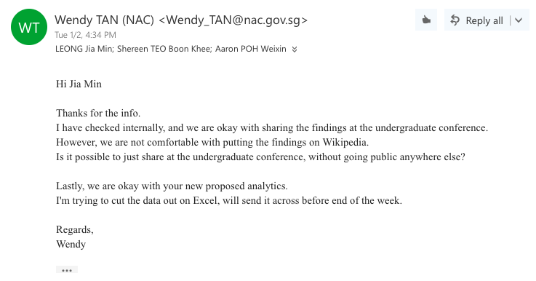 | Approval of new proposal on 2nd Jan 2018
3 | 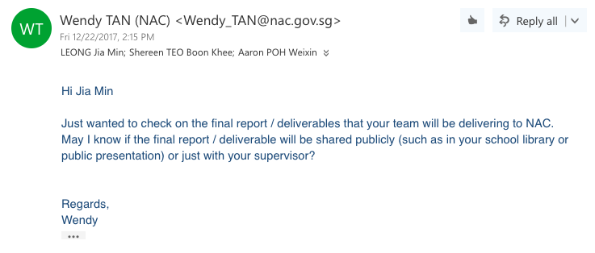  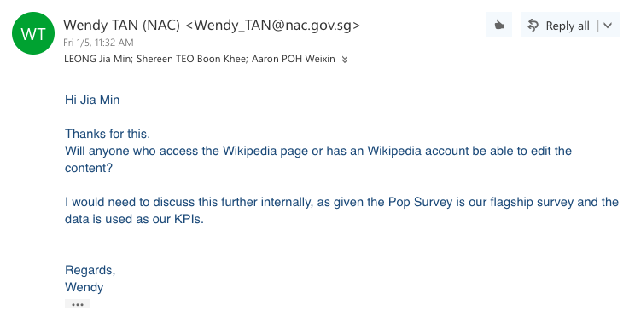 | Raising of concerns on Wikipage  Jia Min has responded mentioning that wiki-pages may be kept anonymous and only SMU students will be able to view/edit the content
4 | 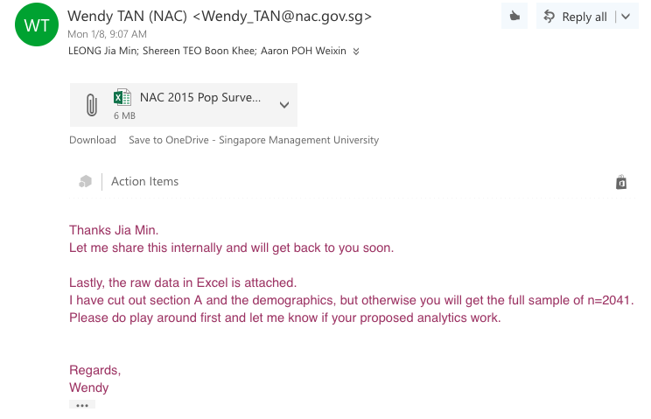 | Receival of sample data on 8th Jan  Awaiting confirmation of wiki-page approval

